The Influence of Metallic Biocide Concentration on the Deactivation Rate of Coliforms in River Water

*M. Erin Brett[1], Laura Lackey[2], Philip McCreanor3*

**Abstract** – The motivation for this project is to determine the most effective placement of a metallic biocide in a biological sand filter. The focus of the work presented here was to develop a relationship that describes coliform deactivation in river water spiked with a solution containing copper ions.  These results can be used to predict the effect of copper ion concentration on the viability of the biofilm layer in a point-of-use biosand filter. A method for measuring copper concentration in solution was established. Copper was mixed with deionized water until it approached saturation in solution.  Water was collected from the Ocmulgee River.  The copper solution was diluted with river water and coliform concentration was measured over time.  Six different solution concentrations ranging from 0.028 to 1.65  mg/L of copper were tested and it was determined that coliform deactivation was well characterized using a first-order kinetics model.  First order rate constants varied from 0.15 to 19.0 hr-1, respectively.

*Keywords:* Copper, Biocide, Coliforms, Deactivation, First-order

Introduction

**Metallic Biocides**

Copper has been used for centuries as a biocide. The ancient Greeks of 400 BCE recognized the effects of copper to purify drinking water. During the 1800’s as U.S. pioneers expanded westward, they placed copper coins in wooden water casks to provide them with safe water during their journey [1].

The antimicrobial properties of copper and copper alloys are well documented. Research has shown that copper ions and complexes in aqueous solutions inactivate a wide range of bacteria [2] including *Aspergillus niger*, *Bacillus subtilis* [3], *Escherichia coli* [4], and *Photobacterium phosphoreum* [5], and viruses including *Polio virus* [6] and the flu strain, H1N1 [7]. Contact with copper and copper alloy surfaces also promotes antimicrobial action; this development is relatively recent and has garnered much attention since 2008 when the Environmental Protection Agency registered five copper-containing alloy products as antibacterial (http://www.epa.gov/pesticides/factsheets/ copper-alloy-products.htm). When in contact with copper or one of its alloys, a variety of organisms including *Escherichia coli* [8; 9], *Staphylococcus aureus* [10], and *Mycobacterium tuberculosis* [11] are efficiently killed compared to inactivation rates observed with stainless steel surfaces.

Although not completely understood, there are several mechanisms generally highlighted to explain the antibacterial property of copper [2].

1. An increase in copper concentration inside the cell forces a non equilibrium condition of oxygen and its reactive forms. Although a number of mechanisms have been suggested, an increase in reactive hydroxyl radicals are often assumed to be formed through a Fenton-type reaction:

$$Cu^{2+}+H_{2}O_{2}↔{Cu}^{2+}+{OH}^{-}+{OH}^{∙}$$

With an increase in cellular copper concentration, the hydroxyl radical concentration is increased; the hydroxyl radicals oxidize cellular molecules including proteins and lipids [12; 13].

1. Copper can alter the 3-dimensional structure of proteins and enzymes such that they can no longer perform their functions. This loss of function results in the inactivation of the organism [14; 15].
2. Excess copper may interact with lipids resulting in a compromised cell membrane. The damaged membrane leaks essential nutrients that can lead to cell desiccation and death [16].

**Biosand Filters (BSFs)**

In 1991 Dr. David Manz of the University of Calgary proved the effectiveness of intermittently operated slow sand (IOSS) filters [17]. More commonly referred to as biological sand filters (BSFs), these filters can be an effective and appropriate technology for treating drinking water in developing countries. Palmateer et al. [18] observed removals of 100% of *Giardia lamblia cysts*, over 99.98% of *Cryptosporidium oocysts*, and 50-90% of organic and inorganic toxicantsduring laboratory testing of the Manz intermittent slow sand filter; and as high as 99% reduction in *Escherichia coli* has been recorded in BSFs during laboratory studies [19].

The majority of removal occurs in the schmutzdecke (German for dirt blanket) [17], also referred to as the biofilm layer. Two aspects of the BSF design were tailored to optimize the effectiveness of the biofilm layer:

1. The overflow pipe is designed to end 5 cm above the biofilm layer so that 5 cm of water can always cover the top layer of the filter.
2. A diffuser was added to the design to ensure minimal disturbance of the biofilm layer from the initial impact of the pouring of source water [20].

Current literature suggests that the use of metallic biocides in BSFs may reduce pathogen levels below those obtained through biosand filtration alone if the filters are used daily [21]. Design recommendations currently accepted suggest mixing the biocide over a 5 cm height in the 5-10 cm layer of fine sand located closest to the bottom of the filter [22]. It is thought that this placement ensures that the metallic ions have no biocidal impact on the biological layer located in the top 5 to 10 cm of the fine sands of the biofilter. If the copper ions reach the schmutzdecke in solution they will destruct the biofilm layer. This will result in a reduction in efficiency of the BSF.

The goal of this project was to simulate the effect of a metallic biocide on the Schmutzdecke by determining the effect of different copper concentrations on the deactivation rate of coliforms.

Methodology

Copper concentration was quantified using a colorimetric analysis (refer to Figure 1). Hach CuVer® 1 Copper Reagent and Hach Copper Standard Solution (10 mg/L as Cu) were used to develop a standard curve. For the concentration range tested, the standard curve of copper concentration vs. absorbance was modeled linearly as Cu(mg/L) = 7.93(Abs) + 0.0619 (R2=0.9998). Samples were analyzed using a USB 2000 spectrophotometer. Spectrophotometer results were stored and displayed graphically through Logger Pro 3.8.3.

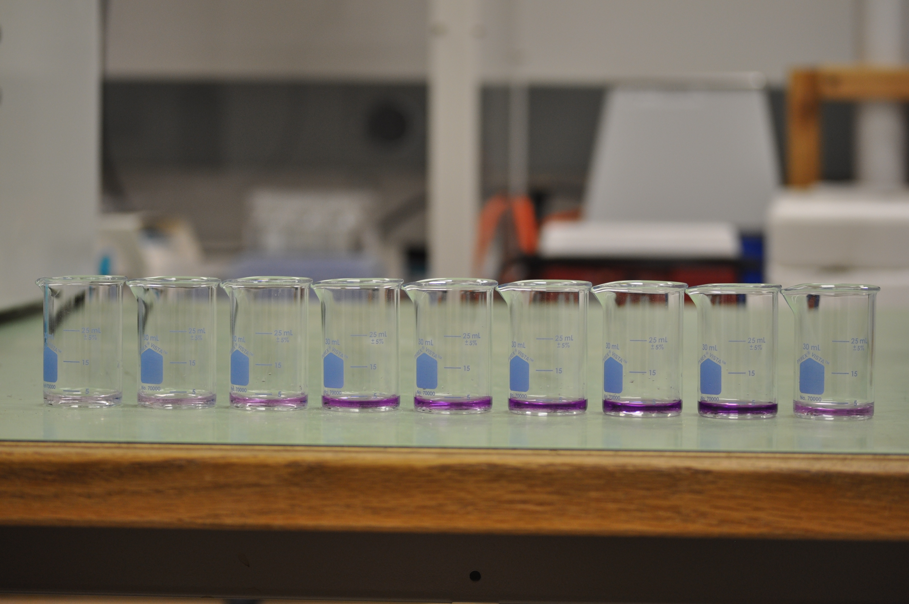

Figure 1. Copper Standard for Determination of Copper Concentration in Solution, Cu = 0.5, 1.0, 2.0, 4.0, 5.0, 6.0, 8.0, and 10.0 mg/L, respectively. The last beaker on the right is the saturated copper ion solution.

Copper chips were manufactured by manual milling; the metal shavings were approximately rectangular in shape and were produced as uniformly as possible. The copper chips were placed in distilled water for a two week period. The resulting copper-ladened water was used during experimentation and exhibited a copper concentration of 4.04 mg/L.

The rate of coliform deactivation was measured at varied copper concentrations. Water collected from the Ocmulgee River was spiked with copper-ladened water. Experiments were conducted in glass beakers; each beaker initially contained a combined volume of 200 mL of river plus copper-ladened water. Copper concentrations ranged from 0.028 to 1.65 mg/L. For coliform quantification, samples ranging from 5 to 25 mL of the mixed solution were regularly taken between t=0 and 120 minutes. Coliform concentration was evaluated using membrane filtration and Hach m-ColiBlue24 broth according to Standard Methods, 9222D [23]. The control for each experiment diluted the river water samples with deionized water instead of the copper-ladened water.

Results and Analysis

Coliform Concentration over Time

River water was diluted with copper-ladened water; six experiments were conducted where the initial copper concentration ranged from 0.028 – 1.65 mg/L Cu. The coliform concentration for the experimental controls showed no statistically significant decrease of initial values during the 120 minute test periods (independent one sample t test, p < 0.1). The coliform concentration in the copper-ladened river water mixture did, however, decrease over time for each of the six experiments. As the concentration of copper in solution increased, the time to deactivate coliforms decreased. For example, when the experimental Cu concentration equaled 1.645 mg Cu/L and 0.028 mg Cu/L, the inactivation half-life was t1/2 = 2.2 min and t1/2 = 27.7 min, respectively (t1/2 =ln(0.5)/k).

First-Order Kinetics Analysis

The decrease in coliform concentration over time in every experiment verifies that copper in solution does have biocidal effects. The relationship between copper concentration and the deactivation rate of coliforms in river water was modeled using first-order kinetics.

Rate constants were found based on first-order kinetics as shown in Equation 1.

$$r=\frac{∂C}{∂t}= -kC$$

(1)

$$\ln\left(\frac{C_{t}}{C_{0}}\right)= -kt$$

$$C_{t}≡coliform concentration at some time, t, in \frac{mg}{L}$$

$$C_{0}≡initial coliform concentration, in \frac{mg}{L}$$

A plot of ln(Ct/C0) versus time for each of the six experiments shows that as time increases, ln(Ct/C0) decreases. The rate constant, k, is the slope of the trendline of each normalized coliform concentration data set (Figure 2**)**.

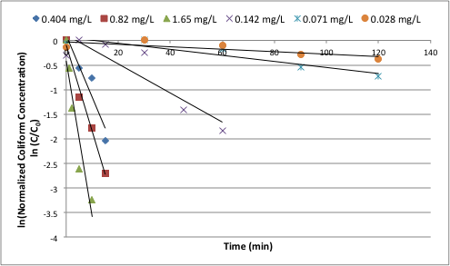 

Figure 5. First-Order Kinetics Batch

System Derivation

Figure 5. First-Order Kinetics Batch

System Derivation

Figure 5. First-Order Kinetics Batch

System Derivation

Figure 5. First-Order Kinetics Batch

System Derivation

Figure 2. Deactivation Trends at Six Different Copper Concentrations. Copper concentrations ranged from 0.028 mg Cu/L to 1.645 mg Cu/L.

The copper concentrations and corresponding rate constants and associated R2 values derived from Figure 2 are presented in Table 1. As the copper concentration increases the rate constant also increases. With an increase in copper concentration from 0.028 to 1.645 mg/L, the first order rate constant increased by two orders of magnitude from 0.0025 to 0.3169 min-1, respectively. All of the R2 values range from 0.81 to 0.99 except for at Cu = 0.028 mg/L, which has a value of 0.62. When Cu = 0.823 mg/L an exceptional R2 value of 0.99 was observed. These R2 values indicate a strong linear relationship between ln(Ct/C0) and time showing that the copper-induced microbial deactivation process is well characterized with a first-order model.

|  |  |  |
| --- | --- | --- |
| **Copper**  **Concentration (mg/L)** | **k(min-1)** | **R2** |
| 1.645 | 0.3169 | 0.89 |
| 0.823 | 0.1754 | 0.99 |
| 0.404 | 0.1261 | 0.90 |
| 0.142 | 0.0296 | 0.81 |
| 0.071 | 0.0062 | 0.86 |
| 0.028 | 0.0025 | 0.62 |

Table 1. First-Order Rate Constants

The linear relationship between Cu concentration and first-order rate constants is shown in Figure 3. Regression analysis of the data provides Equation 2.



$$k\left(\min^{-1}\right)=0.1939×Cu\left(\frac{mg}{L}\right)+0.0088 R^{2}=0.9715 \left(2\right)$$

Figure 3. First-Order Deactivation Rate Constants are Linearly Related to Copper Concentration.

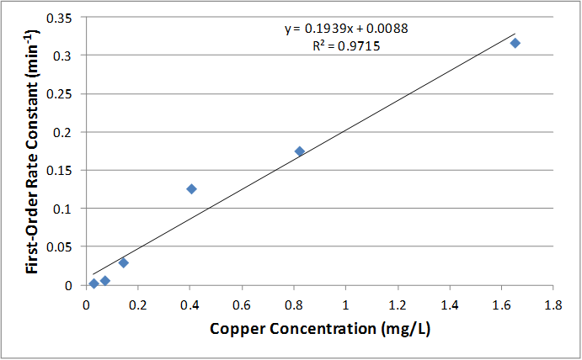

Conclusion

Bench-scale, batch experiments were performed to determine the rate of coliform deactivation in river water spiked with copper. The deactivation of coliforms was well modeled using first-order kinetic theory. Rate constants ranged from 0.0025 to 0.3169 min-1 as copper concentration increased from 0.028 to 1.65 mg/L, respectively. A linear relationship between copper concentration and the deactivation rate constant was observed. With a known copper concentration the first-order deactivation rate of coliforms can be determined using Equation 2. This knowledge can be used to estimate how long a copper solution can stay in contact with the biofilm layer in a BSF without causing damage; this provides insight to improve BSF design.

Acknowledgements

This work would not have been possible without the financial and administrative support of the Engineering Honors Program at Mercer University.

References

[1] Borkow, G. and Gabbay, J., “Using Copper Oxide in Medical Devices and Textiles to Fight Disease-Effective, Inexpensive, and Feasible,” 2006, pg 137.

[2] Konieczny, J. and Rdzawski Z., “Antibacterial properties of copper and its alloys”, Archives of Materials Science and Engineering, Vol 56, Issue 2, 2012, pg 53-60.

[3] Chang, S.M., and Tien, M., “Effects of Heavy Metal Ions on the Growth of Microorganisms”, Bull. Inst. Chem., Adad. Sinica, Vol. 16, 1969, pg 29-39.

[4] Domek, J.J., Lechevallier, M.W., Cameron, S.C., and McFeters, G.A., “Evidence for the role of copper in the injury process of coliform bacteria in drinking water”, Applied and environmental microbiology, 1984, pg 48(2): 289-93.

[5] Johnson, F.H., Carber, C.M., and Harryman, W.K., “Luminous bacterial auxanograms in relation to heavy metals and narcotics, self-photographed in color”, Journal of bacteriology, 1942, pg 44(6): 703-715.

[6] Colobert, L., “Sensitivity of poliomyelitis virus to catalytic systems generating free hydroxyl radicals”, Revue de Pathologie Gnerale et de Physiologie Clinique Vol. 62, 1962, pg 551-555.

[7] Michels, H.T., “Anti-microbial characteristics of copper”, ASTM Standardization News, October, 2006, pg 28-31.

[8] **Noyce, J. O., Michels, H., and Keevil, C. W., “**Use of copper cast alloys to control Escherichia coli O157 cross-contamination during food processing”, Appl. Environ. Microbiol, 2006a, pg 72**:**4239-4244.

[9] Wilks, S. A., **Michels, H., and Keevil, C. W.,** “The survival of *Escherichia coli* O157 on a range of metal surfaces”, Int. J. Food Microbiol, 2005, pg 105**:**445-454.

[10] **Noyce, J. O., Michels, H., and Keevil, C. W., “**Potential use of copper surfaces to reduce survival of epidemic methicillin-resistant Staphylococcus aureus in the healthcare environment”, J. Hosp. Infect, 2006b, pg 63**:**289-297.

[11] **Mehtar, S., Wiid, I., and Todorov, S.D.,** “The antimicrobial activity of copper and copper alloys against nosocomial pathogens and Mycobacterium tuberculosis isolated from healthcare studies in the Western Cape: an in vitro study”, J. Hosp. Infect., 2008, pg 68**:**45-51.

[12] Samuni, A., Aronovitch, J., Godinger, D., Chevion, M., and Czapski, G., “On the cytotoxicity of vitamin C and metal ions, A site-specific Fenton mechanism”, European journal of biochemistry/FEBS, 1983, pg 137 (1-2): 119-24.

[13] Samuni, A., Chevion, M., and Czapski, G., "Roles of Copper and Superoxide Anion Radicals in the Radiation-Induced Inactivation of T7 Bacteriophage", *Radiat. Res.*, 1984, pg 99 (3): 562–572.

[14] Thurman, R.B. and Gerba, C.P., "The Molecular Mechanisms of Copper and Silver Ion Disinfection of Bacteria and Viruses", *CRC Critical Reviews in Environmental Control,* 1989, pg 18 (4): 295–315.

[15] Sterritt, RM; Lester, JN, "Interactions of heavy metals with bacteria", *The Science of the total environment,* 1980, pg 14 (1): 5–17.

[16] Manzl, C., Enrich, J., Ebner, H., Dallinger, R., and Krumschnabel, G., "Copper-induced formation of reactive oxygen species causes cell death and disruption of calcium homeostasis in trout hepatocytes", *Toxicology*, 2004, pg 196 (1–2): 57–64.

[17] Buzunis, B.J., “Intermittently Operated Slow Sand Filtration: A New Water Treatment Process”, The University of Calgary, Calgary, Alberta, 1995, pg 34, 54.

[18] **Palmateer, G., Manz, D., Jurkovic, A., McInnis, R., Unger, S., Kwan, K.K., and Dutka, B.J.,** “Toxicant and Parasite Challenge of Manz Intermittent Slow Sand Filter”, John Wiley & Sons, Inc., 1999, pg 220-221.

[19] Stauber, C.E., Elliott, M.A., Koksal, F., Ortiz, G.M., DiGiano, F.A., and Sobsey, M.D., “Characterization of the biosand filter for *E.coli* reductions from household drinking water under controlled laboratory and field use conditions”, Water Science & Technology, 2006, pg 54(3): 4.

[20] Earwaker, Paul and James Webster, “Evaluation of Household BioSand Filters in Ethiopia”, Cranfield University, 2006, pg 7.

[21] Hyde, E.M. and Lackey, L.W., “The impact of loading frequency and copper as a biocide on biosand filter performance”, Journal of Water, Sanitation and Hygiene for Development, 2013, pg 1-11.

[22] Tellen, V., Nkeng, G., and Dentel, S., "Improved Filtration Technology for Pathogen Reduction in Rural Water Supplies", *Water,* 2010, pg 287.

[23] Greenberg, A. E., Clesceri, L. S. and Eaton, A. D. (eds), Standard Methods for the Examination of Water and Waste Water, 18th edn. American Public Health Association, American Water Works Association, Water Environment Federation, Washington, DC, 1992.

M. Erin Brett

Erin is a senior at Mercer University working towards her B.S.E. with a specialization in Environmental Engineering. She has conducted research each year of her college career. Her research focus has been on improving biosand filters by focusing on the biocidal and disinfectant properties of copper and copper alloys and their implementation in biosand filtration systems.

Laura Lackey

Dr. Laura W. Lackey is a Professor of Environmental Engineering and Associate Dean at the Mercer University School of Engineering. She earned B.S., M.S., and Ph.D. degrees in Chemical Engineering from the University of Tennessee. The terminal degree was awarded in 1992. She has six years of industrial experience at the Tennessee Valley Authority as an Environmental/Chemical Engineer where she conducted both basic and applied research with emphasis on the mitigation of organic wastes through bioremediation. In the 16 years since Dr. Lackey began her career at Mercer, she has taught 20 different courses, ranging from a freshman-level Introduction to Problem Solving course to a senior-level Process Chemistry course, which she developed. She is a registered professional engineer.

Philip McCreanor

Dr. McCreanor holds a B.S. in Mechanical Engineering M.S. in Environmental Science, and a Ph.D. in Environmental Engineering.  He currently holds the rank of Associate Professor in the Environmental Engineering Department and is Director of the Engineering Honors Program at Mercer University.  He has been inducted into the Phi Kappa Phi, Sigma Xi, and Tau Beta Pi honor societies.  His professional awards include Frontiers in Education New Faculty Fellow; Outstanding Referee by the Waste Management: Journal of Integrated Waste Management, Science, and Technology; the Mercer University / Vulcan Materials Company Innovations in Teaching Award; Georgia Governor’s Teaching Fellow; and the ASEE-SE’s 2012 Outstanding Mid-Career Teacher.  His research interests include flow and transport in variably saturated media, bioreactor landfills, and gray water reuse.

1. Mercer University, MU Box 71061, Macon, GA, USA 31207, mitzi.e.brett@live.mercer.edu
2. Mercer University, Mercer University School of Engineering, 1400 Coleman Avenue, Macon, GA, USA 31207, lackey_l@mercer.edu

   3 Mercer University, Mercer University School of Engineering, 1400 Coleman Avenue, Macon, GA, USA 31207, mccreanor_pt@mercer.edu