Providing Sub-Saharan Africans with Drinking Water through Service Learning

*Elizabeth Hyde[1], Laura Lackey2, Richard O. Mines3, Loren Sumner4, Kristen Wyckoff5*

**Abstract** – In June 2010, Mercer University sent a group of students and professors to the community of Sisit in Kenya’s Northwest Rift Valley through an undergraduate service-learning program, Mercer on Mission. The Mercer on Mission course and associated trip focused on the availability and quality of water in Sub-Saharan Africa with an emphasis on marginalized communities.

Two notable outcomes from this service-learning experience are shared here. First, the experience is an example of a simple project having an immediate and sustainable impact with little resources. Secondly, technical questions arising from the project resulted in research appropriate for student thesis work.

Through collaboration with Africa Exchange—a non-profit, Nairobi-based organization run by Sam Harrell—the students from Mercer served the community of Sisit through the installation of 25 home water filters as well as a pump that relays water from the Wei-Wei River to a 10,000-liter tank near Sisit’s Nursery School, located 400 ft up a hill half a mile away. The water filtration units are modified biological sand filters, constructed from a local sand source, milled brass, and a plastic 70-liter container and PVC. The water pump runs without electricity, as it harnesses the kinetic energy in the source water to provide the force to pump the water up the hill. These solutions seek to serve as appropriate technology for the community—thus, they are not only “sustainable” and affordable, but they also address the available skills and resources of the people living in Sisit.

The focus of the thesis work outlined in this document is to investigate guidelines for appropriate filter construction, use and maintenance. Preliminary testing implies that biological sand filters are an effective form of water treatment, and that a copper or brass biocide may not be influential. An assessment of undergraduate student learning and reaction to the service-learning experience will be presented in a subsequent manuscript.

*Keywords:* service-learning, water filters, water quality, NDUME, Sisit, Kenya, Mercer on Mission

Introduction

*Water is fundamental for life and health. The human right to water is indispensable for leading a healthy life in human dignity. It is a pre-requisite to the realization of all other human rights.*

- The United Nations Committee on Economic, Cultural and Social Rights, Environment News Service, 27 Nov 02

According to the United States Geological Survey, American citizens use over 408 billion gallons of water a year, including approximately 123 million gallons of water a day for personal use and 380 million gallons a day for agriculture and farming [USGS, 8]. However, in many parts of the world, potable water is a precious commodity. Much like gold, diamonds and oil, wars have been fought and people killed over the pursuit of clean water. Vital to human health, growth and development, water composes two-thirds of the human body, is useful for cleaning, cooking and drinking, and is integral to the agricultural industry. Proper provision of potable water and effective sanitation serves to reduce and correct illnesses due to ingestion or contact with contaminated water, from cholera and dysentery to guinea worms and other parasites. At bare minimum, the World Health Organization (WHO) estimates the average human needs at least 7.5 liters of water a day for drinking, cooking, and hygiene [WHO, 10]. This requirement is easily met in the United States, where the population is provided with a seemingly inexhaustible supply of potable water—it is cheap, abundant, and readily accessible from any number of faucets in a home, business, or public building.

While developed countries, including the United States, have a seemingly unlimited supply of potable water, other countries do not have the same opportunities. Water that is readily accessible for a community is often polluted—if not with human or animal waste, sometimes with industrial or toxic waste—especially as people who lived in rural communities gravitate towards jobs and homes in suburban slums. It is estimated that 2.5 billion people—or half of the developing world’s population—lack proper sanitation facilities, and over 884 million people use water from unsafe sources [UNICEF, 6]. As a result, retrieving potable water can be a rather involved task. Heavy machinery is often necessary to dig deep enough to access an aquifer needed to create a well supplied with groundwater. If a well is not readily available, it is common for an individual to walk anywhere between 1-5 kilometers to access a potable water source. Eighteen percent of Sub-Saharan Africans must travel to a water source at least half an hour away from their home, which often reduces the amount of water collected, since it must then be returned that same distance [WHO, 12]. According to the WHO, water scarcity also encourages people to store water in their homes for long periods of time, which increases the risk of providing a breeding ground to mosquitoes, carriers of malaria and dengue fever [WHO, 11]. The lack of readily available potable water is also connected to feminine illiteracy and subsequently poverty, since women and girls are often expected to collect water, deal with refuse, and attend to those in the home who are sick and ailing. As a result, girls may stay home from school in order to complete chores on behalf of the family, spending long hours in line at the water source and then making the lengthy journey home, often sacrificing the ability to escape the chain of poverty through education. Unsafe water also contributes to illnesses—and even death—that may prevent the poor from working or attending school.

Unfortunately, the need for potable water is not the only issue that directly impacts world poverty. It is estimated that more than one-sixth of the world's population still lives in extreme poverty, which beyond clean water, implies the need for proper nutrition, health care and social requirements necessary for life, like education [United Nations, 7]. In 2000, determined to help halve the number of people living in extreme poverty by the year 2015, the United Nations resolved to pursue eight goals, known as Millennium Development Goals (MDG).

The eight goals seek to:

* Eradicate extreme poverty and hunger
* Achieve Universal Primary Education
* Promote Gender Equality and Empower Women
* Reduce Child Mortality
* Improve Maternal Health
* Combat HIV/AIDS, Malaria and other diseases
* Ensure Environmental Stability
* Develop a Global Partnership for Development

As a companion to the MDG, the United Nations has also provided a list of “Quick Wins”—projects that could efficiently bring aid to thousands of people while contributing to the MDG. A few of the Quick Wins are outlined, below:

* Training large numbers of village workers in health, farming, and infrastructure (in one-year programmes) to ensure basic expertise and services in rural communities.
* Eliminating user fees for basic health services in all developing countries, financed by increased domestic and donor resources for health.
* Eliminating school uniform fees to ensure that all children, especially girls, are not out of school because of their families’ poverty
* Empowering women to play a central role in formulating and monitoring MDG-based poverty reduction strategies and other critical policy reform processes, particularly at the level of local governments.

A comprehensive account of Quick Wins may be found at the United Nations Millennium Project website [United Nations, 6]. As evidenced by this short list of goals, it is a tall order to provide for a poverty-free world. Therefore, it is necessary to enlist aid in all its forms: public and private, including businesses, churches, and universities.

Africa Exchange, founded by Sam and Melody Harrell, is an organization whose mission is to “exchang[e] information, ideas and resources across cultures to promote mutual understanding and respect, resulting in works of Christian compassion among the poor and marginalized in sub-Saharan Africa” [Africa Exchange, 1]. Focused on serving marginalized communities in each of Kenya’s eight provinces, many of the programs and ideas developed by Africa Exchange are founded heavily in the United Nations’ MDG and Quick Wins, with particular effort towards MDG #4, which pertains to infant mortality. According to their website, Africa Exchange wishes to focus on Quick Win targets including:

* Providing micro-nutrient (especially zinc and vitamin A) supplementation for pregnant and lactating women and children under five;
* Providing regular annual de-worming to all school children in affected areas to improve health and educational outcomes;
* Distributing free, long-lasting, insecticide-treated bed nets to all children in malaria-endemic zones to cut decisively the burden of malaria;
* Providing free school meals for all children using locally produced foods with take-home rations; and,
* Providing access to electricity, water, sanitation for schools and other social service institutions using off-grid diesel generators, solar panels, or other appropriate technologies.

To reach these Quick Win targets, Africa Exchange seeks to help the communities they serve obtain proper sources of potable water, income generation projects, and Nursery Schools. Since January 2003, the Kenyan government has provided free primary-age education to any student. However, there often seems to be a number of caveats, as students must afford their own uniform and school supplies, and sometimes even a writing desk. Another issue that often confronts school-aged Kenyan children is the language barrier. While the official languages of Kenya—and therefore, education—are English and Swahili, many Kenyans are most familiar with their mother tongue, which can be any number of languages associated with the 40+ tribes that find their roots in the country. The conflict of language can often set a child from a remote village at a disadvantage if they are unfamiliar with English or Swahili by the time they attend primary school. In this light, the purpose of nursery schools are to provide the children in remote communities the opportunity to learn the basics of math, reading, and writing in both English and Swahili before they come of age to attend primary school-thus bolstering their opportunity to excel under primary school tutelage. Nursery schools, however, are not provided for financially through the government subvention, and communities that desire to provide this preparatory education for their children must cooperatively finance the teachers’ salary and other associated costs, like meals for students. According to Sam Harrell, it is fairly common for parents to neglect sending their children to nursery school unless there is a meal served during the school day. Thus, in order to encourage attendance, the school board will often provide nursery-aged children with at least one hot meal every day.

In order to initiate the Nursery school programs in the communities they serve, Africa Exchange provided funding to buy food for the first term, with plans to encourage the community to progressively learn how to shoulder the financial responsibility without the use of endless private donations. The income-generation projects mentioned above serve to help assuage this need, and Africa Exchange has worked with each community to determine the best projects for their respective regions—from honey harvesting to fish farming. Also due to the relationship between water quality and poverty, Africa Exchange has also sought to encourage the overall health and well-being of a community through providing clean water to the people in the areas they aid.

Continuing in its strong tradition of academic excellence and social involvement, Mercer University has recently begun hosting service projects for students called Mercer on Mission (MOM), which works with non-government organizations (NGO), like Africa Exchange. MOM is a course option for undergraduate students that “blends service learning and study abroad,” providing class credit for students while they engage in “serving peoples and cultures around the world” [Mercer University, 3]. Student participants spend two to three weeks on campus to study under the professors leading the trip to their given country of service, and then participate in a three week trip abroad. Through MOM, students have provided prosthetics to amputees in Vietnam, served orphans in Guatemala, and will install a wind turbine to generate sustainable energy for a school in Liberia. Trips have also been taken to South Africa, Kenya, Moldova, Brazil, Greece, Thailand, Malawi and Mozambique.

Recently, the MOM program has begun to focus more intently on partnering with communities from across the world that can benefit from the service and knowledge of Mercer students and professors. Evolving from the social service style of teaching children or passing out mosquito nets, the MOM of recent years puts a high value on providing appropriate technology that was not only installed, but was also planned, designed and optimized by Mercer students and professors. One of the teams MOM sent abroad in June 2010 traveled to Kenya, where they worked with Africa Exchange by helping install a water-powered pump and twenty-five home water-filtration units for the community of Sisit. Sisit is a small community of no more than 100 persons, neighboring the town of Sigor, in the Northwest Rift Valley Province of Kenya. A map depicting the location of Sisit is below, in Figure 1.



**Figure 1. MOM Kenya Project Location**

The community of Sisit, with help from Africa Exchange, hosts a nursery school where young children are taught according to the preferred curriculum for early childhood education. Without this early education, the children in the community would be at a disadvantage if and when they begin attending the local primary school. The nursery school—referred to as a CONSEP, or Community Operated Nursery School Enhancement—is currently supported through church and community donations. The teacher’s salary, lunches for the students, and school supplies, are funded through these donations. A picture of the Sisit Nursery school, called the Sigor CONSEP due to its proximity to the larger town of Sigor, may be seen in Figure 2.

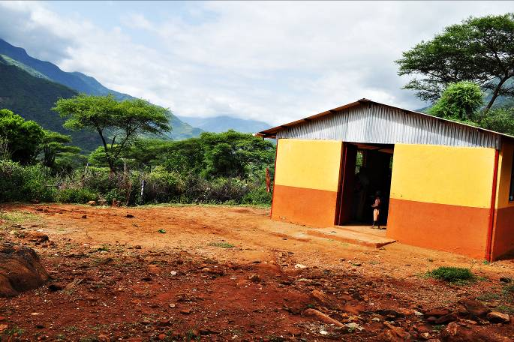

**Figure 2. Sigor CONSEP**

In line with the Quick Wins listed previously, Africa Exchange desires to provide a pathway for the Sigor CONSEP to operate in a self-sustaining manner, while encouraging the growth and health of the surrounding community. One way this goal is being reached is through the water project, which will generate revenue for the school while ensuring the village of Sisit has potable water for its inhabitants.

Kenya, like many other countries in Africa, is often subjected to a scarce potable water supply, due to recurring drought as well as flooding during rainy seasons. Many areas are impacted by water pollution from urban and industrial wastes and degradation of water quality from increased use of pesticides and fertilizers [The World Factbook, 9]. The people in Sisit are fortunate, as they have a source of water within a reasonable distance from their village: the Wei-Wei River, which originates in the Cherangani Hills and flows northeast from their foothills.

Prior to June 2010, the girls and young women in Sisit would walk, at a minimum, a half mile to the Wei-Wei River, along a precarious rocky path which includes a drop in elevation around 400 feet, collect 20-40 liters of water, and then make the return trip home. According to surveys conducted by Africa Exchange before the initiation of the MOM water project, families in Sisit spent an average of three and up to seven hours a day collecting water from the Wei-Wei River. Thus, water collection takes up a significant portion of daily chores, and the community eagerly looked forward to the water pump in hopes to decrease the amount of time required to collect water. Pumping water to the nursery school provided water to the children and community, reducing the burden of fetching water from the female population and encouraging them to pursue education. Due to the fact that electricity is not readily available in Sisit, Africa Exchange, in conjunction with the MOM group, installed a water-powered pump that was designed and manufactured by a Nairobi-based business that specializes in agricultural tools. The pump harnesses the kinetic energy in the water flowing through an irrigation channel fed by the Wei-Wei River, and pumps the water up to a 10,000-liter tank located at the Sisit CONSEP, which serves as a centralized location for the community. A connection point will also be provided so as to distribute water to the nearby Sangat community.

While expediting the collection of water is a boon for the community, it is important to remember that the water they are drinking is still not considered potable. Water consumed without treatment straight from any surface water can cause a variety of illnesses, from stomachaches and parasites to Typhoid fever and dysentery. Thus, the installation of point of use (POU) water filtration units was a key instrument in creating a foundation for a healthy community. The filtration systems were simple to construct and based on advice and training provided by Aqua Clara International, a NGO that focuses on providing POU water filters known as modified Biological Sand Filters (BSFs) to marginalized communities around the world. The BSFs were constructed of local materials—a plastic 70-Liter container, PVC piping, chipped brass and locally supplied sand. Mercer students provided the majority of the labor—digging up the sand, transporting it, sifting it twice, and washing it. Students also assembled each filter in every home and taught the family at each site how to use the filters appropriately, providing the mothers of the home with a few simple rules:

* Every day for the first 20 days, pour 20 Liters (1 jerry can) of river water into the filter. This cannot be rainwater. And do not drink this water. Use it for irrigation or pets.
* After 20 days, you may use the effluent for drinking. You may also pour in 40 liters a day.
* After 6 months-1year, the filter will begin to flow too slowly. The filter may be cleaned by mixing the top 2-3 inches of sand and removing the dirty water.

Biological Sand Filters are an adaptation of the traditional slow sand filter, which has been used for over two hundred years. The widely-accepted contemporary BSF design is accredited to Dr. David Manz, the co-founder of the Center for Affordable Water and Sanitation Technology (CAWST). According to their website, CAWST is a Canadian charity that seeks to provide “education, training and technical consulting in water and sanitation to organizations working with the poor in developing countries,” and as of June 2009, they estimate to have installed over 200,000 BSFs in more than 70 countries worldwide. As visualized in Figure 3, a basic BSF consists of seven key parts: Filter body, outlet tube, diffuser, lid, sand, a separating layer, and a drainage layer. CAWST identifies the use of a concrete body, whereas many NGOs have begun encouraging plastic bodies, which eases construction and transport of the filters.



**Figure 3. Parts of a BSF**

*Source: Center for Affordable Water and Sanitation Technology (CAWST)*

Another alteration of CAWST’s original design includes the addition of a biocide, like copper or brass, to the sand layer. A schematic of AquaClara’s suggested BSF construction with the inclusion of a biocidal brass/copper mixture (notated as ACX) is illustrated below in Figure 4.

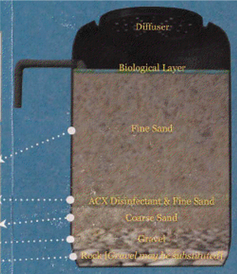

**Figure 4. Modified BSF Schematic**

*Source: AquaClara International*

One of the major project goals—aside from ensuring the community had a source of potable water—was to provide solutions for Sisit that were appropriate and sustainable, which in this case, meant they were cheap, easy to produce with materials that are readily available, and easy to use. Eventually, Africa Exchange hopes to encourage the community of Sisit to use the water and household filtration systems as a source of income for the CONSEP; filters are simple to construct and may be sold for a nominal fee to the families in Sisit, treated water could be sold for a few shillings. The proceeds could then be used to cover nursery school operational expenses. As a result of the trip and the installation of the BSFs, several technical questions arose, including:

1. Are BSFs an appropriate and effective technology for the people of Sisit?
2. Did students assemble the BSFs appropriately and communicate effectively with the new owners of the filter? Often, the students gave instructions to a translator who relayed the information about proper use and maintenance.
3. How effective will the BSFs be if the users do not follow the directions prescribed by Aqua Clara—whether through ignorance or negligence?
4. Do the filters benefit significantly from the use of copper? In encouraging the development of sustainable filtration units for people in remote areas, the cost and labor associated with acquiring a suitable biocide may not be reasonable.

While BSFs are well-documented in many journals and experiments, these concerns were seemingly unanswered. Thus, experimentation was initiated to determine the effect of user compliance on the removal efficiency of BSFs and the net benefit of brass in the filtration units.

Sand Filter Testing

Four biological sand filters were created for the duration of this experiment. In order to evaluate the impact of a biocide on the effectiveness of the biological sand filters, two filters were constructed according to the CAWST BSF (CBSF) construction—a 70-liter plastic container was filled to have 2.5 inches of gravel, 2.5 inches of coarse sand, and 15 inches of fine sand. The remaining two filters, following a modified BSF (mBSF) method, contained a layer of 150g chipped copper mixed in with the bottom inch of the fine sand layer—providing a final layer depths of 2.5 inches of gravel, 2.5 inches of coarse sand, 1 inches of fine sand mixed with copper, and 14 inches of fine sand. A schematic of the two filters is found in the Figure 5, below. Filters 1 and 3 are the mBSFs and 2 and 4 are the CBSFs.

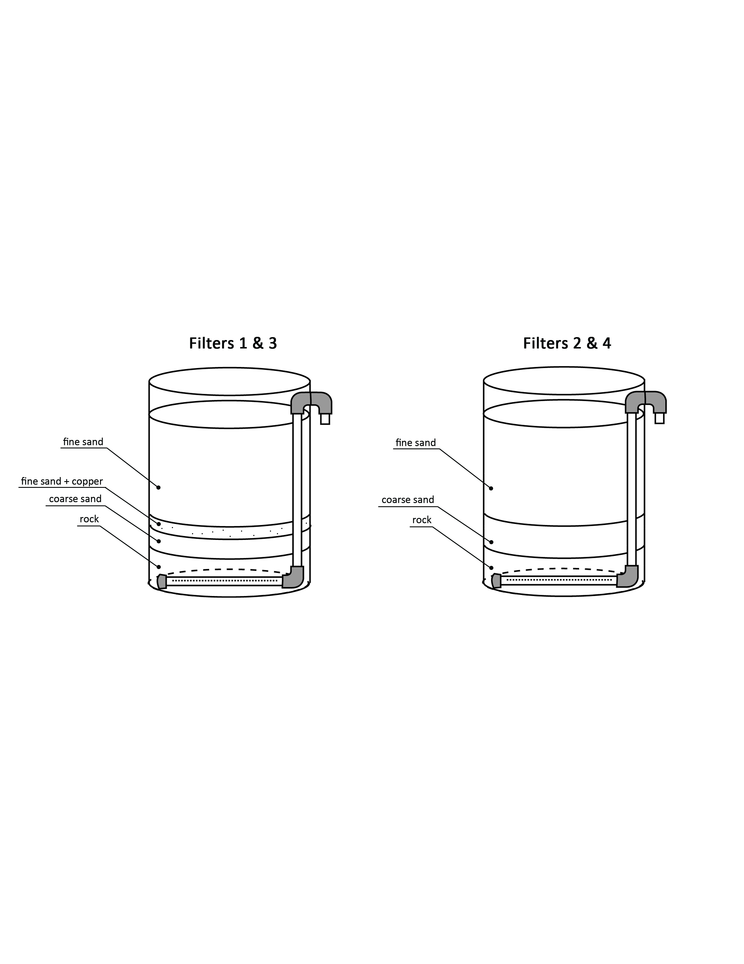

**Figure 5. mBSF (on left) and CBSF (on right)­­**

Construction-grade sand was sifted twice to identify two gradations of sand—the fine sand, and the coarse sand. 1-inch PVC piping was used for the outlet pipe. The water, as it was forced through the filter due to the pressure head created by application of water on the top layer of the sand, reaches the perforated pipe at the bottom of the filter and exits at the spigot towards the top of the filter. The effluent pipe was located 1 inch above the top of the sand layer and flow through the system averaged 1 liter/min.

To evaluate the importance of user compliance on filter performance, one set of filters (one CBSF, one mBSF) was watered 18L daily, and the remaining set was watered with 18L every three days, thus evaluating the effect of pause-period length on water quality. Filters 1 and 2 were watered daily, while filters 3 and 4 were watered every three days. Influent water was collected daily from the Ocmulgee River’s Spring Street boat ramp in Macon, Georgia.

Water quality was based on five parameters: turbidity, pH, coliforms (total and E. coli), COD and solids (fixed and volatile). Turbidity was monitored by Hach Turbidometer Model 2100P, and pH was evaluated through use of a Hach EC10 pH meter. Coliforms were evaluated using membrane filtration and Hach m-ColiBlue24 broth according to Standard Methods, 9222D [Eaton, 2]. Filtered samples were acquired at approximately 10L of effluent volume. Solids anaylsis was conducted using Standard Method 2540D [Eaton, 2]. COD was evaluated through the use of Hach COD Digestion Vials and the DR 2800 Portable Spectrophotometer.

Sand-Filter Test Results

During the course of this project, all of the filters performed well, providing significant removal of coliforms in comparison to influent concentrations. Figure 6 shows the data corresponding to the first 30 days of testing. The peaking and valleying of the influent coliform count correlates with rainy weather around the Ocmulgee River.



**Figure 6. Total Coliforms vs. Time**

While all filters yielded coliform counts lower than the influent, Filters 3 and 4 consistently had a lower effluent concentration of total coliforms than Filters 1 and 2. Filters 1 and 3 also tended to have a slightly higher coliform count than Filters 2 and 4, signifying that perhaps at this point in the filters’ lifetime, copper does not have a significant impact on pathogen reduction. Literature suggests that ripening time for the biological layer in the filters occurs after 30 days of operation [Tellen, 4].

Turbidity was also used to monitor BSF effectiveness. Considered the cloudiness of a liquid, turbidity is often an indicator of the presence of pathogens in water, and is measured in Nephlometric Turbity Units, or NTUs. As seen in Figure 7, the turbidity of the influent water fluctuates in the same manner as influent coliform levels, due to the weather. Effluent turbidity mimicked the influent’s declining trend, and then continued to remain low – around 1 NTU – through the duration of the testing. This implies the filters are effectively removing solids and potentially pathogens.



**Figure 7. Turbidity vs. Time**

Conclusion

With close to six years remaining before the United Nations’ deadline of 2015, the Millennium Development Goals are still far from being reached. It is of vital importance that those with the time, knowledge and resources join in the vision and push to engage the most marginalized in hopes that world poverty can be solved and subsequently eradicated. Mercer University desires to provide sustainable solutions to communities in need, through programs like Mercer on Mission and the service-learning opportunities offered through the Mercer University School of Engineering.

Through research inspired by NGOs like CAWST and Africa Exchange, practical and appropriate sources of potable water for marginalized communities is becoming more readily accessible. The Biological Sand Filter, a type of slow sand filtration, is a common method of water treatment in marginalized communities world-wide. Current testing at Mercer University implies that while a copper or brass biocide is not—at least at the early stage of a filter’s lifetime—effective in pathogen removal, overall, BSFs are an effective and affordable form of water treatment for communities with a limited supply of potable water. Further testing will yield more efficient filters and operation guidelines, thus providing communities with the highest form of filtration requiring the least amount of resources.

References

[1] Africa Exchange. About Africa Exchange. In Africa Exchange. Retrieved on October 31, 2009 from<http://www.africaexchange.org/about.htm>.

[2] Eaton A.D., Clesceri L.S. & Greenberg A.E., (Eds.) (1995) Standard Methods for the Examination of Water and Wastewater, 19th edn. American Public Health Association, Washington, DC, 15 pp.

[3] Mercer University. Mercer on Mission. Retrieved October 29, 2009 from http://www.mercer.edu/mom/.

[4] Tellen, V., G. Nkeng and S. Dentel. Water. Improved Filtration Technology for Pathogen Reduction in Rural Water Supplies. 18 June 2010.

[5] United Nations. Acheiving the Millennium Development Goals. In UN Millennium Project. Retrieved October 27, 2009, from http://www.unmillenniumproject.org/who/index.htm.

[6] United Nations. UN Millennium Project "Quick Wins". In UN Millennium Project. Retrieved October 27, 2009, from www.unmillenniumproject.org/resources/quickwins.htm

[7] United Nations Children’s Fund (UNICEF) "Water, Sanitation, and Hygiene." UNICEF Water and Sanitation. 18 August 2009. Retrieved November 1, 2009. <http://www.unicef.org/wash/index_3951.html>

[8] United States Geological Services (USGS). Estimated Water Use in the United States. March 2004. Accessed on December 1, 2010 from http://www.usgs.gov/features/us_water_use_news_briefing.pdf

[9] The World Factbook 2009. Washington, DC: Central Intelligence Agency, 2009. https://www.cia.gov/library/publications/the-world-factbook/index.html

[10] World Health Organization. Guidelines for Drinking-water Quality. Third Edition. Geneva, 2008. p 90.

[11] World Health Organization. Water Scarcity Fact File. http://www.who.int/features/factfiles/water/water_facts/en/index5.html, accessed October 27, 2009

[12] World Health Organization and United Nations Children’s Fund Joint Monitoring Programme for Water Supply and Sanitation (JMP). Progress on Drinking Water and Sanitation: Special Focus on Sanitation. UNICEF, New York and WHO, Geneva, 2008. page 37.

Elizabeth M. Hyde

Elizabeth Hyde holds a Bachelor of Science in Engineering with a Specialization in Environmental Engineering from Mercer University and is currently a second year Environmental Engineering graduate student at Mercer.

Laura W. Lackey

Dr. Laura W. Lackey is the Chair of the Department of Environmental Engineering and a Professor at the Mercer University School of Engineering.  She earned B.S., M.S., and Ph.D. degrees in Chemical Engineering from the University of Tennessee. The terminal degree was awarded in 1992.  She has six years of industrial experience at the Tennessee Valley Authority as an Environmental/Chemical Engineer where she conducted both basic and applied research with emphasis on the mitigation of organic wastes through bioremediation.  In the 12 years since Dr. Lackey began her career at Mercer, she has taught 14 different courses, ranging from a freshman-level Introduction to Problem Solving course to a senior-level Process Chemistry course, which she developed.  She is a registered professional engineer.

Richard Mines

Dr. Mines is the Director of MSE and Associated MS Engineering Programs and Professor of Environmental Engineering at Mercer University in Macon, Georgia. Dr. Mines graduated from the Virginia Military Institute with a Bachelor of Science degree in Civil Engineering in 1975. He received a Master of Engineering degree in Civil Engineering from the University of Virginia in 1977 and a Doctor of Philosophy degree in Civil Engineering from Virginia Tech in 1983. Dr. Mines has over six years of consulting experience with CH2M Hill and BLACK & VEATCH consulting engineers. He has over twenty years of teaching experience at the undergraduate and graduate level. Dr. Mines taught at the Virginia Military Institute and the University of South Florida prior to his coming to Mercer University. He is a registered Professional Engineer in New Mexico. Dr. Mines has authored or co-authored over 100 technical and educational papers on civil and environmental engineering. His research interests lie in water and wastewater treatment, modeling of bionutrient removal systems, and enhancing learning in the classroom. Dr. Mines is an active member of ASEE and ASCE.

Loren Sumner

Loren Sumner is an associate professor of mechanical engineering at the Mercer University School of Engineering. He received his Ph.D. from the Georgia Institute of Technology in 1998 in the area of hydrodynamic stability. At Mercer, he teaches fluid mechanics, thermodynamics, heat transfer and other thermal science courses. His research interests include alternative energy technologies, fluid-interface phenomena, boundary-driven Stokes flows, and thesis committees.

Kristen Wyckoff

## Kristen Wyckoff is a third year undergraduate Engineering student attaining a Specialization in Environmental Engineering at Mercer University.

1. 1 Mercer University School of Engineering 1400 Coleman Avenue, Macon, GA 31207 [elizabeth.marie.hyde@live.mercer.edu](mailto:elizabeth.marie.hyde@live.mercer.edu)

   2 Mercer University School of Engineering 1400 Coleman Avenue, Macon, GA 31207 [Lackey_L@Mercer.edu](mailto:Lackey_L@Mercer.edu)

   3 Mercer University School of Engineering 1400 Coleman Avenue, Macon, GA 31207 [Mines_RO@Mercer.edu](mailto:Mines_RO@Mercer.edu)

   4 Mercer University School of Engineering 1400 Coleman Avenue, Macon, GA 31207 [Sumner_LB@mercer.edu](mailto:Sumner_LB@mercer.edu)

   5 Mercer University School of Engineering 1400 Coleman Avenue, Macon, GA 31207 [kristen.n.wyckoff@live.mercer.edu](mailto:kristen.n.wyckoff@live.mercer.edu)