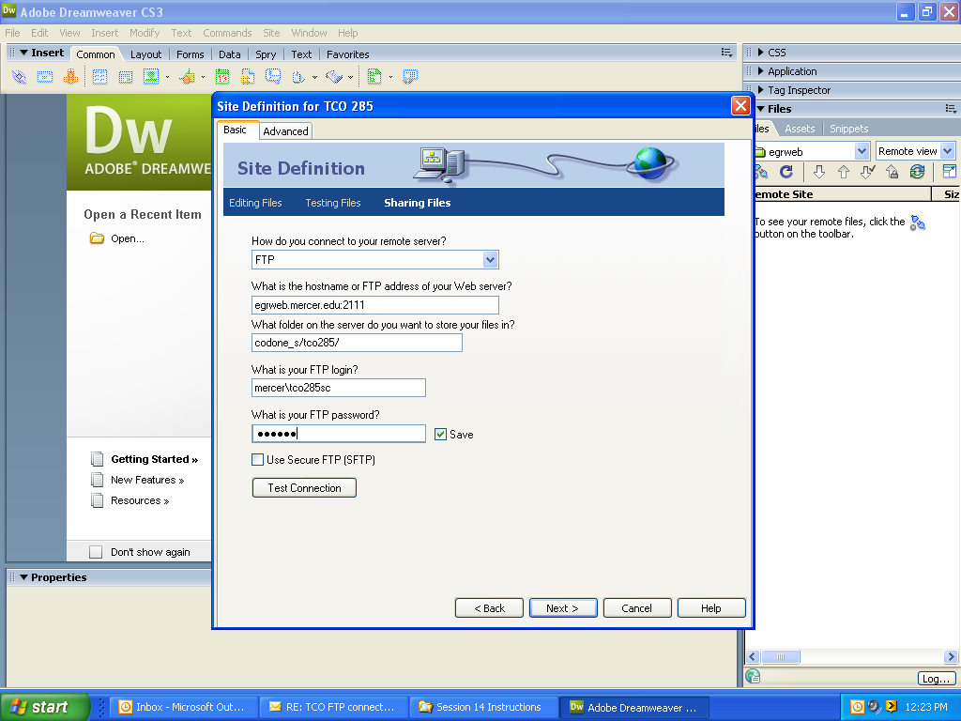
TCO285

Once you are logged into the remote site, click on Fall 2007 and then the folder for your last name. This is the folder in which you will store your files.

