Generating Interaction Graphs in Minitab 17

If you have entered the data correctly for a balanced two-way ANOVA, you can use Minitab to generate an interaction plot.

Go to Pull Down Menu

Stat/

ANOVA/

Interaction Plot/

Enter Responses and Factors

See the Dialog box below. The order in which you enter the Factors determines which Factor will be on the x-axis.

(Note that you do not need to conduct a two-way ANOVA in order to generate the plot.)

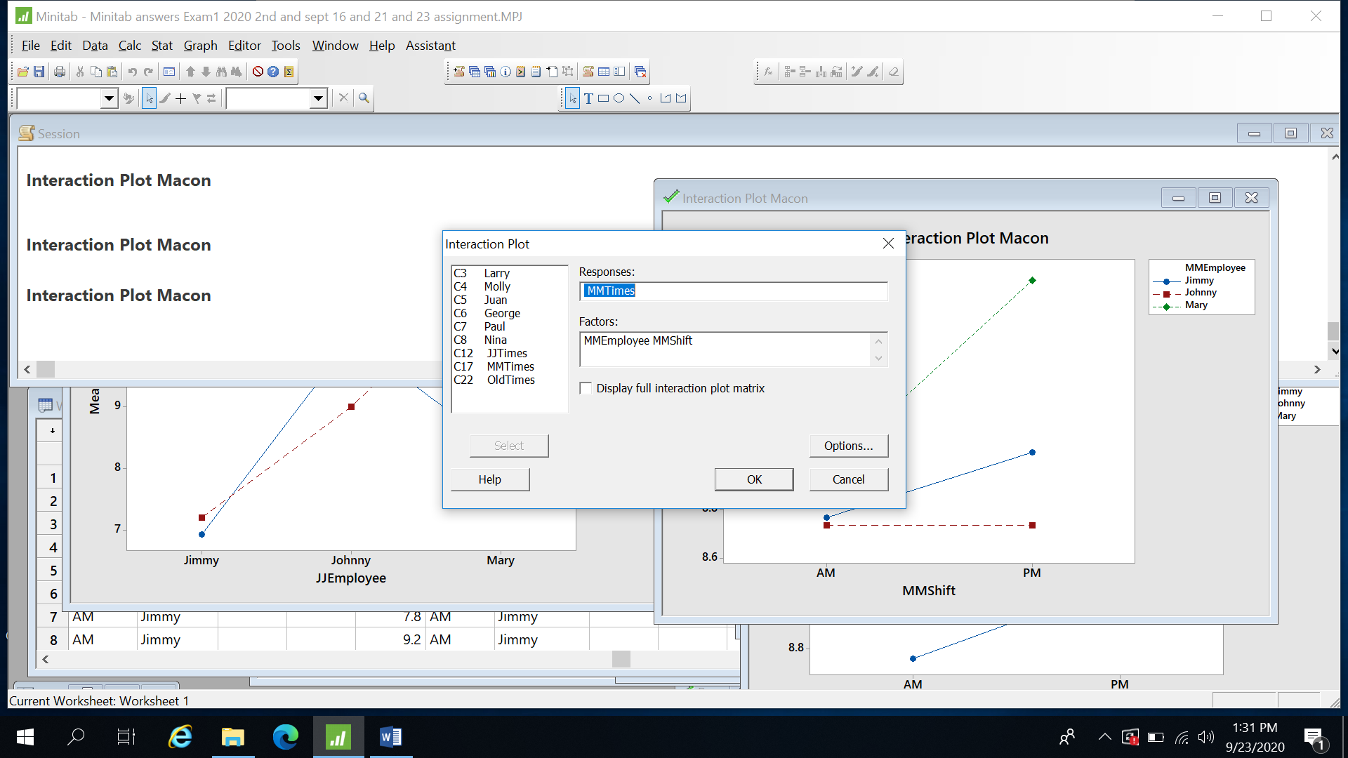



Interaction Plot Macon version 1



Interaction Plot Macon version 2

Note that I have generated two graphs with the title Interaction Plot Macon. They both represent the same data. One graph has MMEmployee on the x-axis. The other graph has MMShift on the x-axis. Although the graphs look very different, the information is the same and your management recommendations should be the same, regardless of which version of the interaction plot you are using.



