October 5 Lecture Note

Are MonthlySales related to TestScores?
You can use either variable as the “X” value. The other variable will be the “Y” variable.
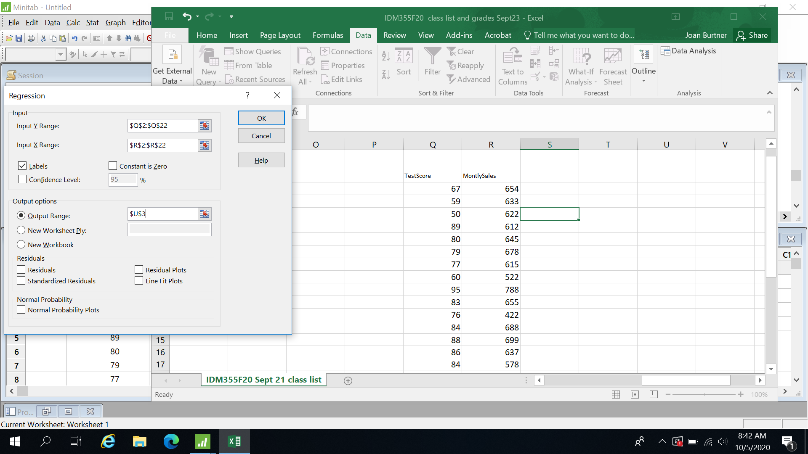
The result will give us an estimate of the linear relationship between X and Y and is expressed in the format of Y = coefficient X + intercept. (Y = mx+b).

SUMMARY OUTPUT
Regression Statistics
Multiple R | 0.430459244
R Square | 0.185295161
Adjusted R Square | 0.140033781
Standard Error | 11.46182439
Observations | 20
ANOVA
 | df | SS | MS | F | Significance F
Regression | 1 | 537.8284691 | 537.8285 | 4.093891 | 0.058146749
Residual | 18 | 2364.721531 | 131.3734
Total | 19 | 2902.55
 | Coefficients | Standard Error | t Stat | P-value | Lower 95% | Upper 95% | Lower 95.0% | Upper 95.0%
Intercept | 44.19516459 | 15.85340912 | 2.787739 | 0.012152 | 10.88838796 | 77.50194121 | 10.88838796 | 77.50194121
MontlySales | 0.053286483 | 0.026335946 | 2.023337 | 0.058147 | -0.002043285 | 0.108616252 | -0.00204329 | 0.108616252
DISCUSSION
Significance F
0.058146749 | *******This p-value is greater than 0.05. Therefore the regression is not significant.
R Square | 0.185295161 | ******This is a very low R Square value.
 |  | R Square 0.80 suggests a strong relationship between the two variables.
How do you calculate F? MS Regression / MS Residual
What are the degrees of freedom for a single linear regression? 1
The total degrees of freedom is the number of observations minus 1.

