Review of Hypothesis Testing Using ANOVA for ISE 491 Fall 2009

Review of Excel
Statistical Functions
Data Analysis
Graphing

Orientation to Minitab
Worksheet
Session Window

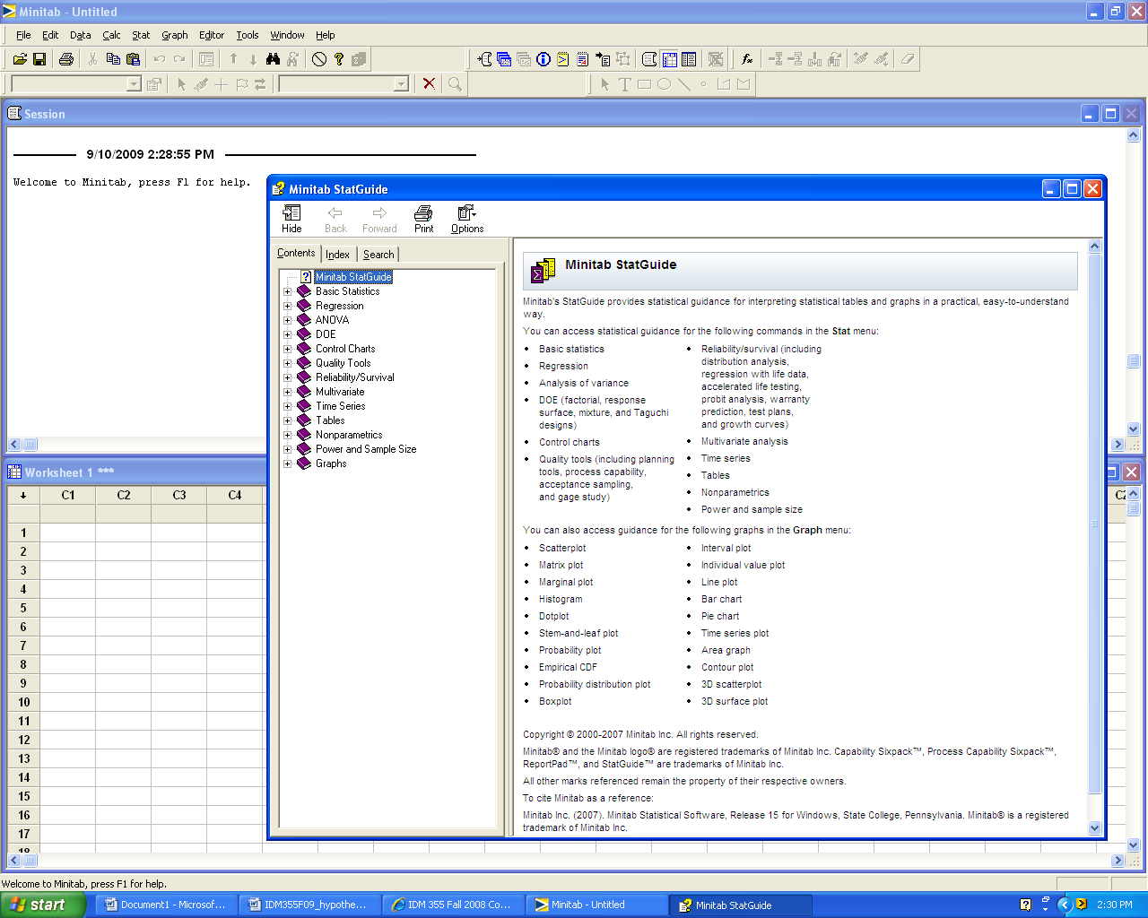

Experimental Designs

Single sample hypothesis test

Two sample hypothesis test

Paired sample hypothesis test

Multiple sample hypothesis test (One-way ANOVA)

Advanced multiple sample hypothesis tests Two-way ANOVA, Three factor ANOVA, Factorial Designs, etc
Typical Hypothesis Test Template

Hypotheses:
H₀:
H₁:

Critical values for determining correct of test statistic:

Calculation of test statistic and p-value: (Computer Output)

Graphics: (Choose applicable graphic drawn by hand or computer)

0 0.05 1 (p-value)

Decision: _________H₀

Conclusion: Use complete sentences. (Refer to problem statement and make an engineering/managerial decision based on p-values)

Multiple sample hypothesis test (One-way ANOVA) A quality researcher is interested in comparing the sodium content of three brands of corn flakes. He collects the following data. Does this data suggest that brands differ in terms of average sodium content? Assume the distribution of sodium contents to be normal.

CFlakes PFlakes WFlakes
244 254 251
245 256 251
246 245 254
248 244 251
241 242 256
241 243 243
245 243 243
244 245 250
241 252 252

Hypotheses:
H₀: μ _{Crowger} = μ _{Publicks} = μ _{Wallyworld}
H₁: At least one population mean is different.

Critical values: The test statistic for an ANOVA is F. The critical value of F will vary based on several criteria (significance level, number of factor levels, etc) .

Calculation of test statistic and p-value:

Method 1: We can use the Minitab pull-down menu: Stat / ANOVA/ One-way (Unstacked)

One-way ANOVA: CFlakes, PFlakes, WFlakes

Source DF SS MS F P
Factor 2 174.3 87.1 4.81 0.017
Error 24 434.7 18.1
Total 26 609.0

S = 4.256 R-Sq = 28.62% R-Sq(adj) = 22.67%

Individual 95% CIs For Mean Based on
Pooled StDev
Level N Mean StDev --+---------+---------+---------+-------
CFlakes 9 243.89 2.47 (--------*-------)
PFlakes 9 247.11 5.35 (-------*-------)
WFlakes 9 250.11 4.43 (--------*-------)
--+---------+---------+---------+-------
241.5 245.0 248.5 252.0

Graphics:

F = + 4.81

0 0.05 0.10 1

Decision: Reject H₀

Conclusion: With a p-value = 0.017, the data suggest that there is a statistically significant difference in the mean sodium content. At least one of the brands yields mean sodium content that differs from the other brands. We should conduct post-hoc analyses to determine which brands differ.

Model Checking

Residual Plots for CFlakes, PFlakes, WFlakes

A check of residual plots indicates no major deviations from assumptions.

Post-Hoc Analyses

The p-value indicates that we should conduct post-hoc analyses to determine which mean sodium contents differ.

Tukey Comparisons

CFlakes subtracted from:

Lower Center Upper ------+---------+---------+---------+---
PFlakes -1.785 3.222 8.230 (---------*---------)
WFlakes 1.215 6.222 11.230 (---------*---------)
------+---------+---------+---------+---
-5.0 0.0 5.0 10.0

PFlakes subtracted from:

Lower Center Upper ------+---------+---------+---------+---
WFlakes -2.008 3.000 8.008 (---------*---------)
------+---------+---------+---------+---
-5.0 0.0 5.0 10.0

Tukey Comparisons show that the mean sodium content of CFlakes differs significantly from the mean sodium content of WFlakes. We draw this conclusion because the 95% confidence interval for the difference between the means does not contain zero.

However, the mean sodium content of CFlakes is not significantly different from the mean sodium content of PFlakes.

Note that the confidence interval for CFlakes minus PFlakes is ( -1.785 , 8.230 ). This confidence interval ‘contains zero’.

One-way ANOVA in Excel (using same data as Minitab example) A quality researcher is interested in comparing the sodium content of three brands of corn flakes. He collects the following data. Does this data suggest that brands differ in terms of average sodium content? Assume the distribution of sodium contents to be normal.

CFlakes PFlakes WFlakes
244 254 251
245 256 251
246 245 254
248 244 251
241 242 256
241 243 243
245 243 243
244 245 250
241 252 252

Hypotheses:
H₀: μ _{Crowger} = μ _{Publicks} = μ _{Wallyworld}
H₁: At least one population mean is different.

Method 2: We can use the Excel Pull-Down Menu: Tools / Data Analysis / ANOVA Single Factor

Anova: Single Factor
SUMMARY
Groups | Count | Sum | Average | Variance
CFlakes | 9 | 2195 | 243.8889 | 6.111111
PFlakes | 9 | 2224 | 247.1111 | 28.61111
WFlakes | 9 | 2251 | 250.1111 | 19.61111
ANOVA
Source of Variation | SS | df | MS | F | P-value | F crit
Between Groups | 174.296 | 2 | 87.14815 | 4.811861 | 0.01749 | 3.402826
Within Groups | 434.666 | 24 | 18.11111
Total | 608.963 | 26
Compare the ways in which the Minitab output differs from the Excel output. (Note the column order.) Is the F statistic the same? Is the P-value the same? Are the decisions and conclusions the same for both methods?

Note that there is no automatic Model Checking or Post-Hoc Analysis in Excel.

Excel assumes a significance level of 0.05. You can change that value when you execute the function.

