Chi-Square Test for Association in Minitab 17

Null Hypothesis: There is no association between row factor and column factor.
Alternate Hypothesis: There is an association between row factor and column factor.

Enter the data in a “table format”. Include descriptive labels for the columns and rows.
Pull down menu:
Stat / Tables / Chi-Square Test for Association
Select summarized data in a two-way table.
Enter data from EGR 252 text as shown below.

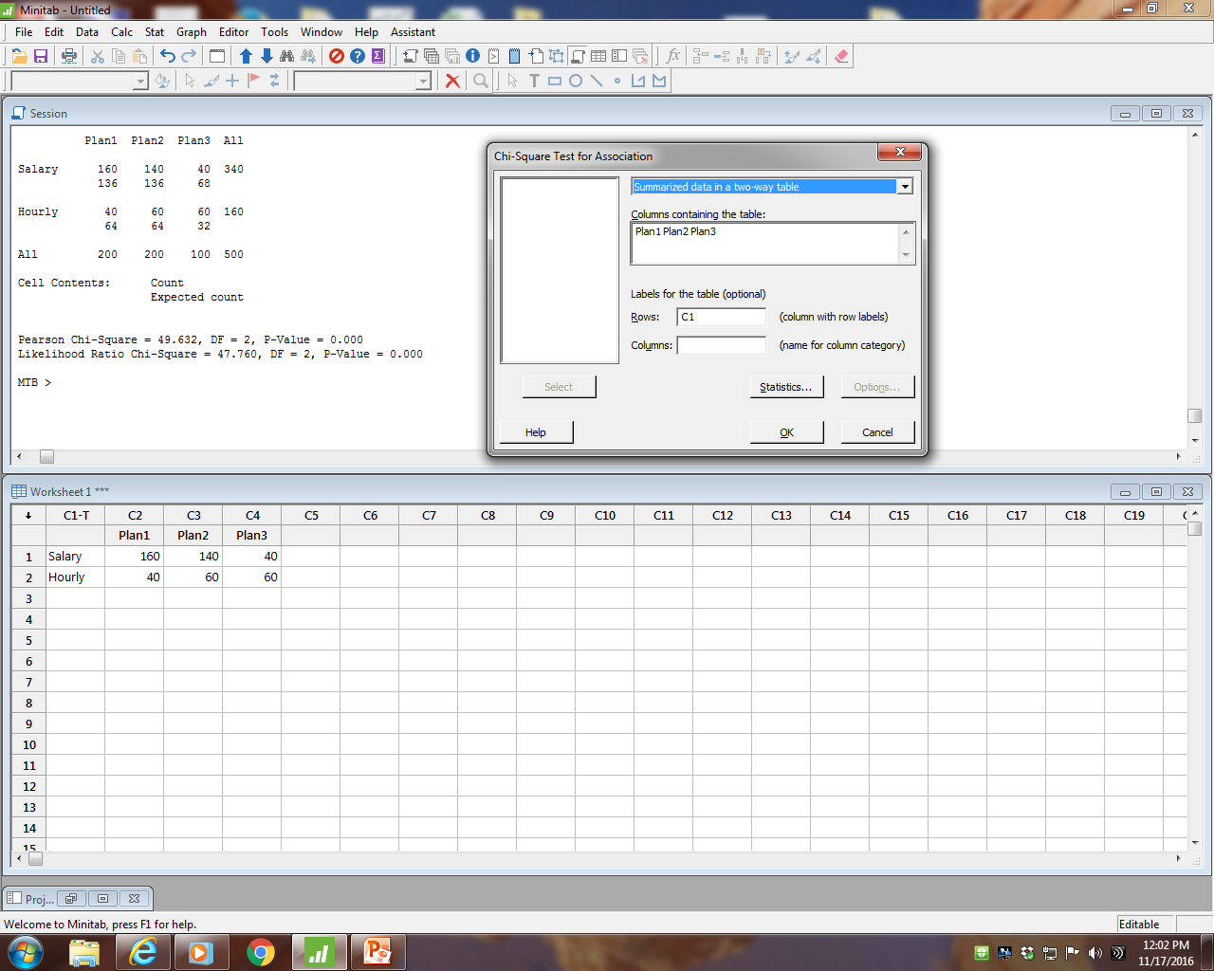

Row Worker
Column Plan Number
p-value less than alpha
Decision: Reject Ho.
Therefore, we conclude Worker and Plan Number are associated.
Therefore, we conclude Worker and Plan Number are not independent.

Minitab Input 1
Plan1 Plan2 Plan3
Salary 160 140 40
Hourly 40 60 60

Chi-Square Test for Association: C1, Worksheet columns

Rows: C1 Columns: Worksheet columns

Plan1 Plan2 Plan3 All

Salary 160 140 40 340
136 136 68

Hourly 40 60 60 160
64 64 32

All 200 200 100 500

Cell Contents: Count
Expected count

Pearson Chi-Square = 49.632, DF = 2, P-Value = 0.000
Likelihood Ratio Chi-Square = 47.760, DF = 2, P-Value = 0.000

We use the Pearson Chi-Square for Chi-Square calculated.
Our decision, based on a p-value less than alpha, is: Reject HO.
Our conclusion is that there is an association between Plan and Worker Type.

Minitab Input 2
Salaried worker hourly worker plan
160 40 p#1
140 60 p#2
40 60 p#3

Chi-Square Test for Association: plan, Worksheet columns

Rows: plan Columns: Worksheet columns

Salaried worker hourly worker All

p#1 160 40 200
136 64

p#2 140 60 200
136 64

p#3 40 60 100
68 32

All 340 160 500

Cell Contents: Count
Expected count

Pearson Chi-Square = 49.632, DF = 2, P-Value = 0.000
Likelihood Ratio Chi-Square = 47.760, DF = 2, P-Value = 0.000

We use the Pearson Chi-Square for Chi-Square calculated.
Our decision, based on a p-value less than alpha, is: Reject HO.
Our conclusion is that Plan and Worker Type are associated.

Another Example:

Let's look at 500 customer complaints from three hospital chains in two different cities.

Input:

City Northside Eastside Downtown
Macon 90 102 40
Atlanta 110 98 60

Output:

Chi-Square Test for Association: City, Worksheet columns

Rows: City Columns: Worksheet columns

Northside Eastside Downtown All

Macon 90 102 40 232
92.80 92.80 46.40
0.0845 0.9121 0.8828

Atlanta 110 98 60 268
107.20 107.20 53.60
0.0731 0.7896 0.7642

All 200 200 100 500

Cell Contents: Count
Expected count
Contribution to Chi-square

Pearson Chi-Square = 3.506, DF = 2, P-Value = 0.173
Likelihood Ratio Chi-Square = 3.516, DF = 2, P-Value = 0.172

Based on a p-value of 0.172, we conclude that there is no association between hospital and city with respect to customer complaints.

Using terminology from the EGR 252 text, we conclude that hospital and city are independent.

