Chi-Square Test for Association in Minitab 17

Null Hypothesis: There is no association between row factor and column factor.
Alternate Hypothesis: There is an association between row factor and column factor.

Enter the data in a “table format”. Include descriptive labels for the columns and rows.
Pull down menu:
Stat / Tables / Chi-Square Test for Association
Select summarized data in a two-way table.
Enter data as shown below.

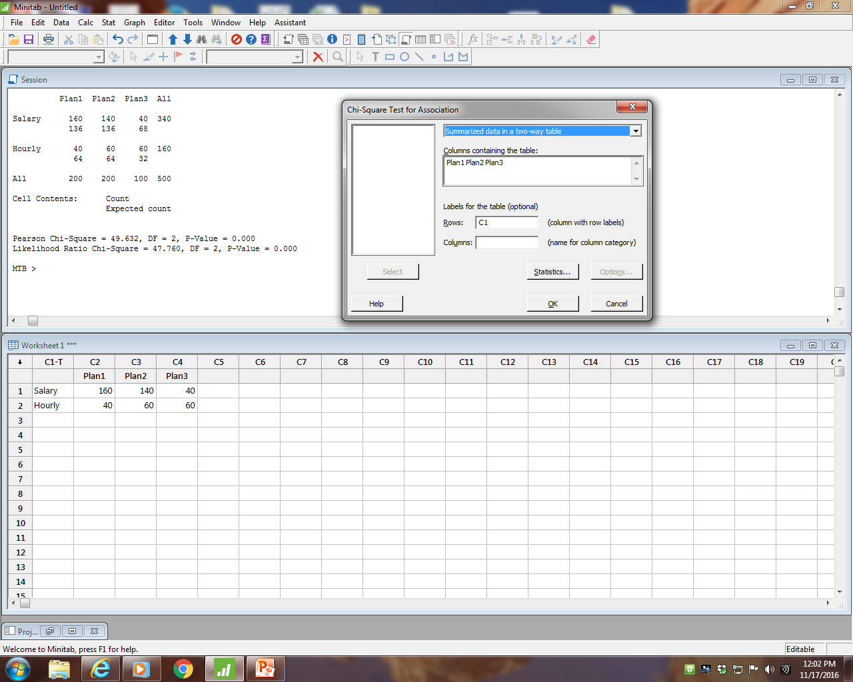
Row Worker
Column Plan Number
p-value less than alpha
Decision: Reject Ho.
Therefore, we conclude Worker and Plan Number are associated.

(We can also conclude Worker and Plan Number are not independent.)

Minitab Input 1
Plan1 Plan2 Plan3
Salary 160 140 40
Hourly 40 60 60

Chi-Square Test for Association: C1, Worksheet columns

Rows: C1 Columns: Worksheet columns

Plan1 Plan2 Plan3 All

Salary 160 140 40 340
136 136 68

Hourly 40 60 60 160
64 64 32

All 200 200 100 500

Cell Contents: Count
Expected count

Pearson Chi-Square = 49.632, DF = 2, P-Value = 0.000
Likelihood Ratio Chi-Square = 47.760, DF = 2, P-Value = 0.000

We use the Pearson Chi-Square for Chi-Square calculated.
Our decision, based on a p-value less than alpha, is: Reject HO.
Our conclusion is that there is an association between Plan and Worker Type.

Minitab Input 2
Salaried worker hourly worker plan
160 40 p#1
140 60 p#2
40 60 p#3

Chi-Square Test for Association: plan, Worksheet columns

Rows: plan Columns: Worksheet columns

Salaried worker hourly worker All

p#1 160 40 200
136 64

p#2 140 60 200
136 64

p#3 40 60 100
68 32

All 340 160 500

Cell Contents: Count
Expected count

Pearson Chi-Square = 49.632, DF = 2, P-Value = 0.000
Likelihood Ratio Chi-Square = 47.760, DF = 2, P-Value = 0.000

We use the Pearson Chi-Square for Chi-Square calculated.
Our decision, based on a p-value less than alpha, is: Reject HO.
Our conclusion is that Plan and Worker Type are associated.

Quality Engineering ISE 428 ETM 528

In the Certified Quality Engineer Handbook (3rd edition), this topic is discussed in the section on Contingency Tables (pp. 469-472). However, the CQE Handbook describes this hypothesis test as a Test for Independence.

The statistical assumptions are the same. The calculations are the same. The difference is in the phrasing of the hypotheses.

Chi-Square Test for Independence

Null Hypothesis: The row factor and column factor are independent.

Alternate Hypothesis: The row factor and column factor are not independent.

Chi-Square Test for Association

Null Hypothesis: There is no association between row factor and column factor.

Alternate Hypothesis: There is an association between row factor and column factor.

