**Chi-Square Goodness of Fit Test in Minitab 17**

Let's look at a sample of 200 M&M’s. Do the data support the hypothesis that the distribution is uniform?

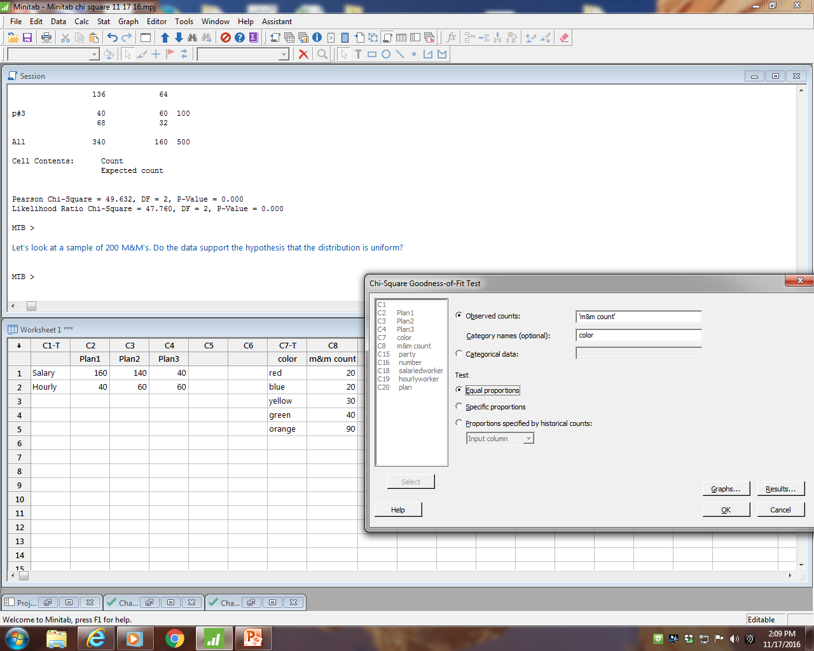

**Chi-Square Goodness-of-Fit Test for Observed Counts in Variable: m&m count**

Using category names in color

Test Contribution

Category Observed Proportion Expected to Chi-Sq

red 20 0.2 40 10.0

blue 20 0.2 40 10.0

yellow 30 0.2 40 2.5

green 40 0.2 40 0.0

orange 90 0.2 40 62.5

N DF Chi-Sq P-Value

200 4 85 0.000

H0: The distribution of M&M’s is uniform.

H1: The distribution of M&M’s is not uniform.

The p-value is very small.

We reject the null hypothesis.

We conclude the distribution of M&M’s is not uniform.

Minitab 17 graphs help us visualize the results.





Quality Engineering ISE 428 ETM 528

In the Certified Quality Engineer Handbook (3rd edition), this topic is discussed in the section on Goodness of Fit Tests (pp. 456-459).

The null hypothesis is that the observed proportions for each category match the historical (expected) proportions for each category.

The alternate hypothesis is that the observed proportion for at least one category is different from the historical (expected) proportion for that category.

The Chi-Square calculated test statistic is:



If Chi-Square calculated is greater than Chi-Square critical, we reject the null hypothesis.

For the CQE exam, you will be expected to calculate the test statistic value with a calculator. You will also be expected to look up the critical value in the table in the back of the book. The df is the number of categories minus 1.