How to Generate a Two-Way ANOVA Table in Minitab 15
Including a Check of Model Assumptions

PROBLEM: You have been called in as a consultant to help the Pratt and Whitney plant in Columbus determine the best method of applying the reflective stripe that is used to guide the Automated Guided Vehicles (AGVs) along their path. There are two ways of applying the stripe (paint and coated adhesive tape) and three types of flooring (linoleum and two types of concrete) in the facilities using the AGVs. You have set up two identical “test tracks” on each type of flooring and applied the stripe using the two methods under study. You run 3 replications in random order and count the number of tracking errors per 1000 ft of track. The results are as follows:

Enter the data into Minitab and conduct a two-way ANOVA at the 5% significance level. Select the four-in-one residual plot option. You will need one column for the observations, one column for Factor A (Stripe) and one column for Factor B (Flooring).
(See Figure 1.)

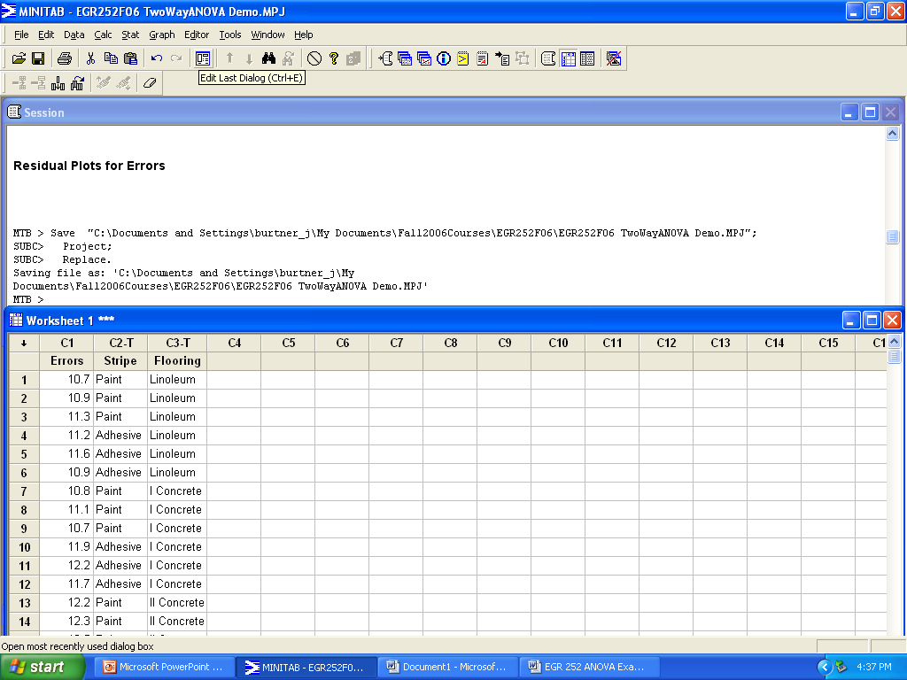
Figure 1. Worksheet Setup for Two-Way ANOVA
How to Generate a Two-Way ANOVA Table in Minitab 15 (cont.)

Your ANOVA Table results should look like the output shown in Figure 2.

Two-way ANOVA: Errors versus Stripe, Flooring

Source DF SS MS F P
Stripe 1 0.10889 0.10889 1.07 0.321
Flooring 2 1.96000 0.98000 9.64 0.003
Interaction 2 2.83111 1.41556 13.92 0.001
Error 12 1.22000 0.10167
Total 17 6.12000

S = 0.3189 R-Sq = 80.07% R-Sq(adj) = 71.76%

Figure 2. Minitab ANOVA Table Format

Your residual plots should look like the graphs shown in Figure 3a or 3b.
Figure 3a. Residual Plots for a Two-Factor Experimental Design Minitab 14

Figure 3b. Residual Plots for a Two-Factor Experimental Design Minitab 15

Since the interaction is significant, you should generate an interaction graph by plotting the means for each factor at each level.

