Development of Trial Control Charts for Variables using Xbarcharts and Rcharts. 10/27/20
This analysis will use Minitab Stat Control Charts Xbar-R chart to analyze variables data that consist of subgroups of size n=3 or n=4 or n=5. These are the settings for the xbar chart.
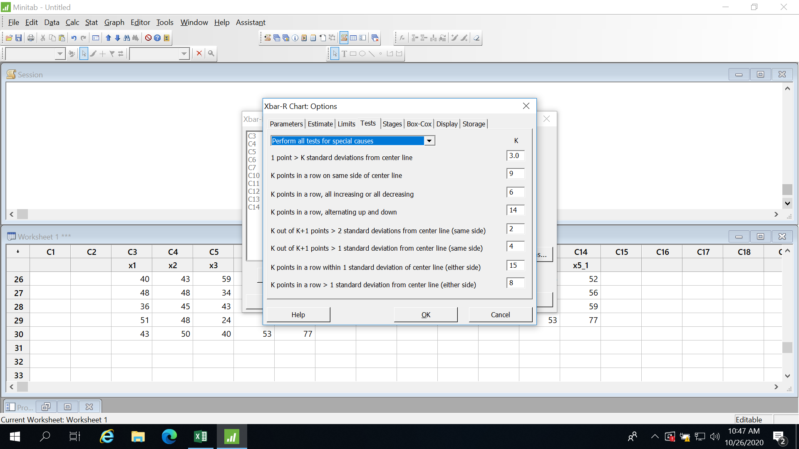

Problem 1 Example

*Xbar-R Chart of x1, ..., x5

Test Results for Xbar Chart of x1, ..., x5

TEST 1. One point more than 3.00 standard deviations from center line.
Test Failed at points: 10

Test Results for R Chart of x1, ..., x5

TEST 1. One point more than 3.00 standard deviations from center line.
Test Failed at points: 29

* WARNING * If graph is updated with new data, the results above may no
* longer be correct.

METHOD FOR DEVELOPING TRIAL CONTROL CHARTS

Output states that there is one point OOC in Rchart and one point OOC in Xbar chart.
Analyze Rchart FIRST.
Investigate process and fix special cause associated with sample 29.
COPY data to new columns.
Eliminate all of the items in sample 29.
Recalculate control limits.
Repeat the process until there are no special causes in the Rchart.

Problem 2 Example
Suppose there are no special causes in the Rchart.
Then analyze the Xbar chart.
Suppose Samples 4 and 17 are OOC.
Copy and paste data to new columns.
Investigate process and fix special causes.
Either highlight samples 4 and 17 and remove OR remove samples in reverse order.
That is, remove sample 17 BEFORE sample 4.
Recalculate control limits and repeat the process until there are no special causes in the Xbarchart/Rchart.

