EGR 252 Spring 2008 Dr. Burtner

How to Generate a Two-Way ANOVA Table in Minitab 14
Including a Check of Model Assumptions and Recommendations for Analysis

PROBLEM: You have been called in as a consultant to help a middle Georgia manufacturing facility determine the best method of applying the reflective stripe that is used to guide the Automated Guided Vehicles (AGVs) along their path. The two application methods under consideration are 1) paint and 2) coated adhesive tape. Using the current facility layout, the AGVs will need to operate on three different floors: 1) linoleum 2) Concrete A and 3) Concrete B. Concrete A has a lower water-to-cement ratio than Concrete B. You have set up two identical oval “test tracks” on each type of flooring and applied the stripe using the two methods under study. You run 3 replications in random order and record the time (in minutes) the AGV travels before deviating from the path. The results are:

Enter the data into Minitab and conduct a two-way ANOVA at the 5% significance level. Select the four-in-one residual plot option. You will need one column for the observations, one column for Factor 1 (Striping) and one column for Factor 2 (Flooring).
(See Figure 1.)

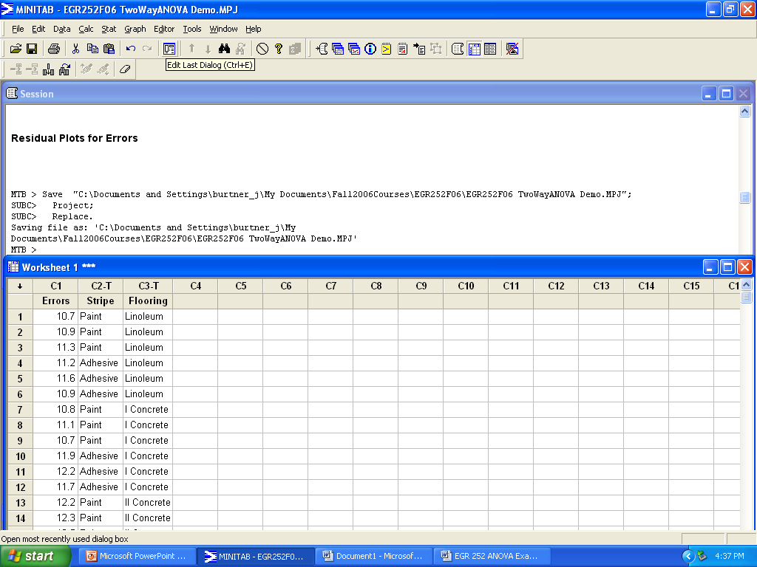
Figure 1. Worksheet Setup for Two-Way ANOVA
How to Generate a Two-Way ANOVA Table in Minitab 14 (cont.)

Your ANOVA Table results should look like the output shown in Figure 2.

Two-way ANOVA: Errors versus Striping, Flooring

Source DF SS MS F P
Striping 1 0.10889 0.10889 1.07 0.321
Flooring 2 1.96000 0.98000 9.64 0.003
Interaction 2 2.83111 1.41556 13.92 0.001
Error 12 1.22000 0.10167
Total 17 6.12000

S = 0.3189 R-Sq = 80.07% R-Sq(adj) = 71.76%

Figure 2. Minitab ANOVA Table Format

Your residual plots should look like the graphs shown in Figure 3.

Figure 3. Residual Plots for a Two-Factor Experimental Design

ANALYSIS:
Are there any serious violations of model assumptions?
Is there a significant effect for Factor 1 (striping)?
Is there a significant effect for Factor 2 (flooring)?
Is there a significant interaction effect? If so, you should generate an interaction graph by plotting the means for each factor at each level.
What recommendation would you make based on these experimental results?

