EGR252 Fall 2019 Exercise 1 v2 Page 1 EXAMPLE Enter your full name here:
A) Go to the course web site. Use the correct data set (based on your last name) to build a histogram in Excel using the default bin settings. Put your full name in the title of the histogram. Be sure to use the Excel built-in Histogram function. Do not use bar graph.

B) Using the same data set, follow the guidelines from the Chapter 1 lecture to develop your own bin intervals. Build a second histogram in Excel. Put your full name in the title of the histogram. Reduce the gap to 0. Label the uppermost (More) column correctly.

C) Use Minitab to build a third histogram. Put your full name in the title of the histogram. Copy the Minitab. Use Paste Special/ Bitmap to paste graph in the Word file.

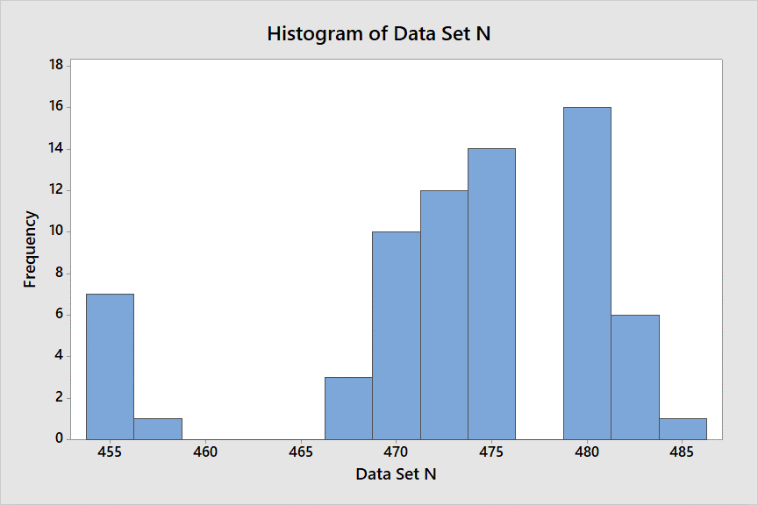

EGR252 Fall 2019 Exercise 1 v2 Page 2 EXAMPLE Enter your full name here:

D) Use either Excel or Minitab to determine the following values for your data set.
_____74_____ Number of items in the data set
___476.18____ Mean
____476_____ Median
_____7______ Interquartile Range (IQR)
_____19_____ Range
____480_____ Mode
___35237____ Sum
____4.34_____ Standard deviation

E) Consider the histogram you built in Part B.
______9_____ How many intervals did you use for your customized Excel histogram?
_____2.5____ What was the bin width?
____462.5___ What was the LOWER bound of your bins?

F) Save your Word file as EGR252Exercise1_yourfirstandlastname Example: EGR252Exercise1_JoanBurtner. Print both pages of the Word file and bring them to class on October 8. I will collect the assignment in class on October 8.

