Chi-Square Test for Association in Minitab 17

Null Hypothesis: There is no association between row factor and column factor.
Alternate Hypothesis: There is an association between row factor and column factor.

Enter the data in a “table format”. Include descriptive labels for the columns and rows.
Pull down menu:
Stat / Tables / Chi-Square Test for Association
Select summarized data in a two-way table.
Enter data as shown below.

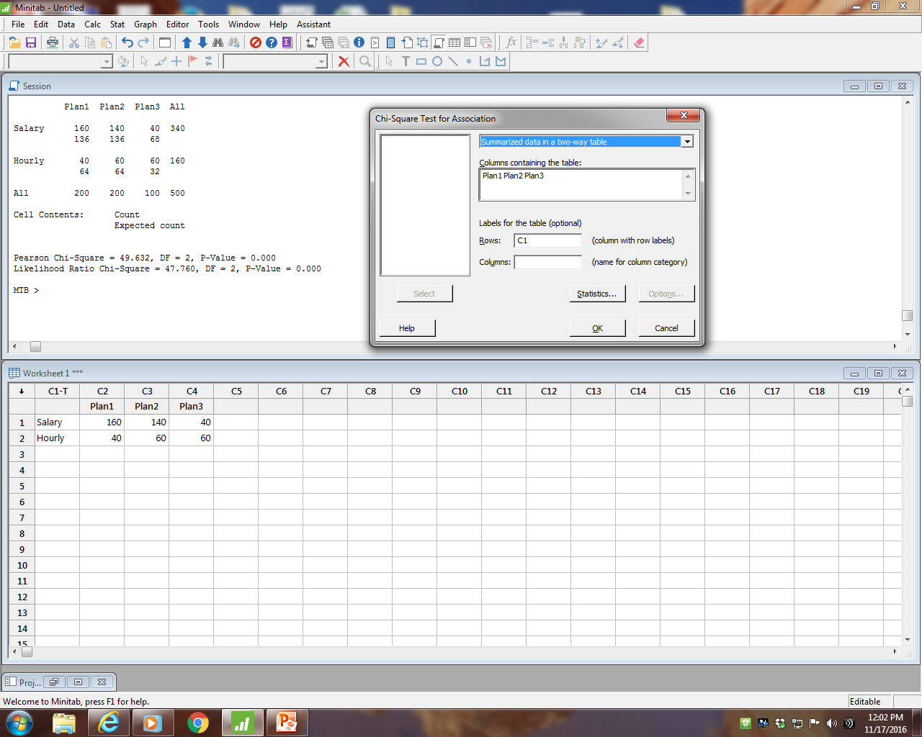

Row Worker
Column Plan Number
p-value less than alpha
Decision: Reject Ho.
Therefore, we conclude Worker and Plan Number are associated.
Therefore, we conclude Worker and Plan Number are not independent.

Minitab Input 1
Plan1 Plan2 Plan3
Salary 160 140 40
Hourly 40 60 60

Chi-Square Test for Association: C1, Worksheet columns

Rows: C1 Columns: Worksheet columns

Plan1 Plan2 Plan3 All

Salary 160 140 40 340
136 136 68

Hourly 40 60 60 160
64 64 32

All 200 200 100 500

Cell Contents: Count
Expected count

Pearson Chi-Square = 49.632, DF = 2, P-Value = 0.000
Likelihood Ratio Chi-Square = 47.760, DF = 2, P-Value = 0.000

We use the Pearson Chi-Square for Chi-Square calculated.
Our decision, based on a p-value less than alpha, is: Reject HO.
Our conclusion is that there is an association between Plan and Worker Type.

Minitab Input 2
Salaried worker hourly worker plan
160 40 p#1
140 60 p#2
40 60 p#3

Chi-Square Test for Association: plan, Worksheet columns

Rows: plan Columns: Worksheet columns

Salaried worker hourly worker All

p#1 160 40 200
136 64

p#2 140 60 200
136 64

p#3 40 60 100
68 32

All 340 160 500

Cell Contents: Count
Expected count

Pearson Chi-Square = 49.632, DF = 2, P-Value = 0.000
Likelihood Ratio Chi-Square = 47.760, DF = 2, P-Value = 0.000

We use the Pearson Chi-Square for Chi-Square calculated.
Our decision, based on a p-value less than alpha, is: Reject HO.
Our conclusion is that Plan and Worker Type are associated.

