**Chi-Square Goodness of Fit Test in Minitab 17**

Let's look at a sample of 200 M&M’s. Do the data support the hypothesis that the distribution is uniform?

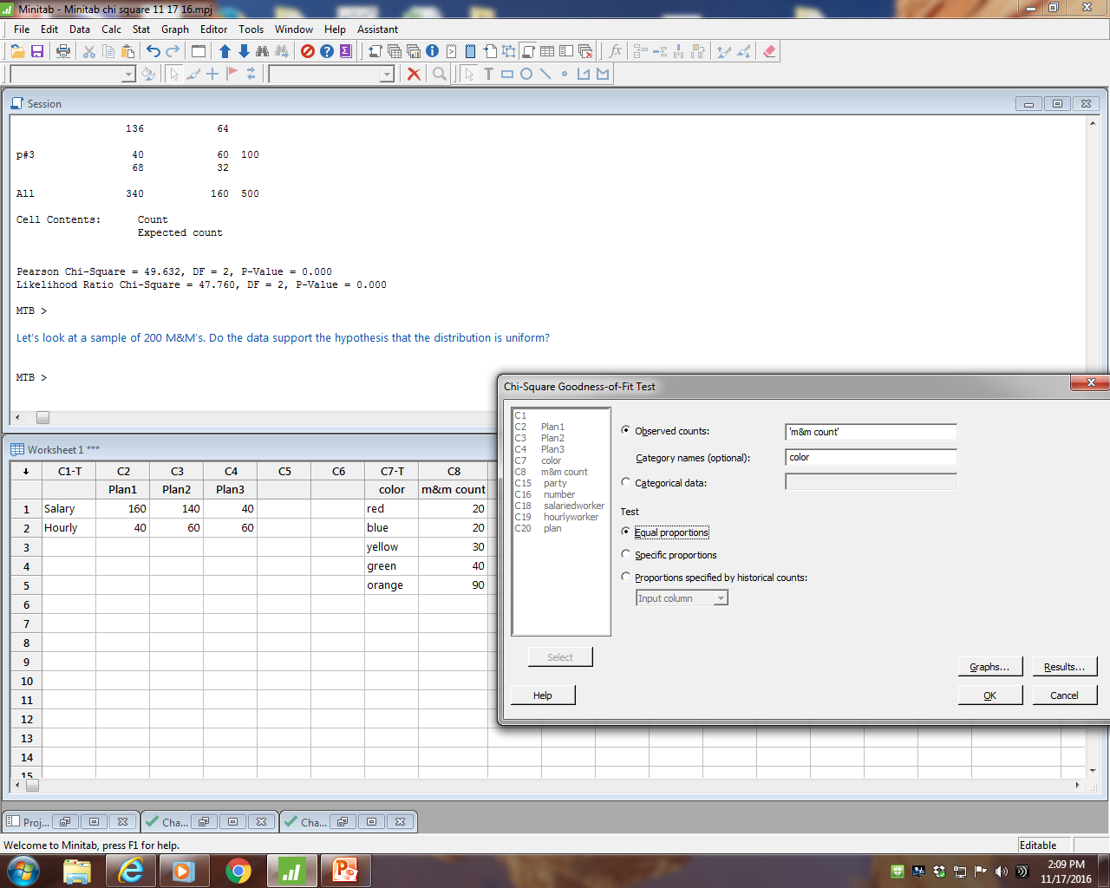

**Chi-Square Goodness-of-Fit Test for Observed Counts in Variable: m&m count**

Using category names in color

Test Contribution

Category Observed Proportion Expected to Chi-Sq

red 20 0.2 40 10.0

blue 20 0.2 40 10.0

yellow 30 0.2 40 2.5

green 40 0.2 40 0.0

orange 90 0.2 40 62.5

N DF Chi-Sq P-Value

200 4 85 0.000

H0: The distribution of M&M’s is uniform.

H1: The distribution of M&M’s is not uniform.

The p-value is very small.

We reject the null hypothesis.

We conclude the distribution of M&M’s is not uniform.

Minitab 17 graphs help us visualize the results.



