Nonparametric EXAMPLE 5 ONEWAY ANOVA -TUKEY SIMULTANEOUS CONFIDENCE INTERVALS

SOURCE: Joan Burtner
A recently hired management engineer at a tertiary care hospital was asked to analyze a set of data collected by a former employee as part of a Six Sigma Green Belt project. The executive summary of the Six Sigma report showed that the twenty-seven data points comparing case loads were as follows:

January | May | July
70 | 53 | 36
30 | 39 | 23
26 | 27 | 29
60 | 29 | 34
34 | 23 | 16
26 | 28 | 21
57 | 25 | 23
39 | 23 | 25
44 | 22 | 20

Based on this data, should the management engineer conclude that case load varies by month?

Measured Response: Case Load

Analytical Method Selected: One way ANOVA

Assumptions: Case load is interval level data. We assume the variable is normally distributed in the population. We will use graphical analyses to check our assumptions.

General Format of Hypotheses:
H0: μ ₁ = μ ₂ = … = μ _{r}
H1: At least one mean is not equal to the others

For our data set, the hypotheses are:
H0: Mean case load does not vary by month.
H1: Mean case load varies by month.

Alternatively:
H0: Mean case load JAN = Mean case load MAY = Mean case load JULY
H1: Mean case load differs for at least one of the three months.

Calculations / Computer Output

One-way ANOVA: January, May, July

Source DF SS MS F P
Factor 2 1509 754 5.63 0.010
Error 24 3217 134
Total 26 4726

S = 11.58 R-Sq = 31.92% R-Sq(adj) = 26.25%

Individual 95% CIs For Mean Based on
Pooled StDev
Level N Mean StDev ---+---------+---------+---------+------
January 9 42.89 16.04 (-------*-------)
May 9 29.89 10.07 (-------*-------)
July 9 25.22 6.59 (-------*-------)
---+---------+---------+---------+------
20 30 40 50

Pooled StDev = 11.58

Tukey 95% Simultaneous Confidence Intervals
All Pairwise Comparisons

Individual confidence level = 98.02%

January subtracted from:

Lower Center Upper -+---------+---------+---------+--------
May -26.62 -13.00 0.62 (--------*--------)
July -31.29 -17.67 -4.04 (--------*--------)
-+---------+---------+---------+--------
-30 -15 0 15

May subtracted from:

Lower Center Upper -+---------+---------+---------+--------
July -18.29 -4.67 8.96 (--------*--------)
-+---------+---------+---------+--------
-30 -15 0 15

Decision: Reject the null hypothesis.

Conclusion: With a p-value of 0.01, we conclude that the mean case load differs for at least one month. Based on an analysis of the Tukey 95% simultaneous confidence intervals, we conclude that the mean case load for January is significantly different from July, but not from May. Mean case loads for May and July do not differ significantly in the population.

Analysis of the residuals indicates some deviation from normality. The box plots suggest that the variances may not be equal in the population. Many authors state that the one way ANOVA procedure is robust to slight violations of the assumptions of normality and homogeneity of variances, especially when the design is balanced (equal sample sizes for each of the factor levels).

Nonparametric EXAMPLE 6 KRUSKAL-WALLIS TEST

SOURCE: Joan Burtner
A recently hired management engineer at a tertiary care hospital was asked to analyze a set of data collected by a former employee as part of a Six Sigma Green Belt project. The executive summary of the Six Sigma report showed that the twenty-seven data points comparing case loads were as follows:

January | May | July
70 | 53 | 36
30 | 39 | 23
26 | 27 | 29
60 | 29 | 34
34 | 23 | 16
26 | 28 | 21
57 | 25 | 23
39 | 23 | 25
44 | 22 | 20

The management engineer is not familiar with the history of case load data at this hospital and is reluctant to assume case loads are normally distributed in the population. Based on this data, should the management engineer conclude that case load varies by month?

Measured Response: Case Load

Analytical Method Selected: Kruskal-Wallis

Assumptions: Case load is interval level data. We are unwilling to assume the variable is normally distributed in the population.

General Format of Hypotheses:
H0: The medians are equal for all levels of the factor.
H1: At least one median is not equal to the others.

For our data set, the hypotheses are:
H0: Median case load does not vary by month.
H1: Median case load varies by month.

Alternatively:
H0: Median case load JAN = Median case load MAY = Median case load JULY
H1: Median case load differs for at least one of the three months.

Calculations / Computer Output

Kruskal-Wallis Test on CaseLoad

Month31 N Median Ave Rank Z
January 9 39.00 20.1 2.83
July 9 23.00 9.2 -2.24
May 9 27.00 12.7 -0.59
Overall 27 14.0

H = 8.91 DF = 2 P = 0.012
H = 8.95 DF = 2 P = 0.011 (adjusted for ties)

Decision: Reject the null hypothesis.

Conclusion: After adjusting for ties, the p-value was 0.011. Thus, we conclude that the mean case load differs for at least one month.

Since we were reluctant to assume the data were normally distributed in the population, we did not attempt to develop Tukey 95% simultaneous confidence intervals. However, we can conduct the Mann-Whitney Test for all possible pairs.

Nonparametric EXAMPLE 7 MANN-WHITNEY TEST and MULTIPLE NONPARAMETRIC TESTS

SOURCE: Joan Burtner
Consider the following data on case loads:
January |  | July
70 |  | 36
30 |  | 23
26 |  | 29
60 |  | 34
34 |  | 16
26 |  | 21
57 |  | 23
39 |  | 25
44 |  | 20
Assume that you are not familiar with the history of case load data at this location. You are reluctant to assume case loads are normally distributed in the population. Based on this data and these assumptions, determine if case loads for January and July differ significantly.

Measured Response: Case Load

Analytical Method Selected: Mann-Whitney Test for two samples

Assumptions: Case load is interval level data. We are unwilling to assume the variable is normally distributed in the population.

General Format of Hypotheses:
H0: The medians are equal.
H1: The medians are not equal.

For our data set, the hypotheses are:
H0: Median case load JAN = Median case load JULY
H1: Median case load JAN does not equal median case load JULY

Mann-Whitney Test and CI: January, July
N Median
January 9 39.00
July 9 23.00

Point estimate for ETA1-ETA2 is 14.00
95.8 Percent CI for ETA1-ETA2 is (3.01,34.00)
W = 116.5

Test of ETA1 = ETA2 vs ETA1 not = ETA2 is significant at 0.0071
The test is significant at 0.0070 (adjusted for ties)

Decision: Reject the null hypothesis.

Conclusion: With a p-value of 0.0071, we conclude that the median case load for January is significantly different from July.

******ADDENDUM to Example 7********

Suppose we want to conduct post-hoc tests on the data from a significant Kruskal-Wallis Test. We can use the Mann-Whitney Test to compare samples two at a time. Refer back to the analysis of the data from Example 6. After adjusting for ties, the p-value for the Kruskal-Wallis Test was 0.011. Thus, we concluded that the median case load differs for at least one month. Which months are different?

Mann-Whitney Test and CI: January, July
N Median
January 9 39.00
July 9 23.00

Point estimate for ETA1-ETA2 is 14.00
95.8 Percent CI for ETA1-ETA2 is (3.01,34.00)
W = 116.5

Test of ETA1 = ETA2 vs ETA1 not = ETA2 is significant at 0.0071
The test is significant at 0.0070 (adjusted for ties)

Mann-Whitney Test and CI: January, May

N Median
January 9 39.00
May 9 27.00

Point estimate for ETA1-ETA2 is 11.00
95.8 Percent CI for ETA1-ETA2 is (1.00,31.00)
W = 109.5
Test of ETA1 = ETA2 vs ETA1 not = ETA2 is significant at 0.0380
The test is significant at 0.0377 (adjusted for ties)

Mann-Whitney Test and CI: July, May

N Median
July 9 23.00
May 9 27.00

Point estimate for ETA1-ETA2 is -3.00
95.8 Percent CI for ETA1-ETA2 is (-11.00,4.00)
W = 73.0
Test of ETA1 = ETA2 vs ETA1 not = ETA2 is significant at 0.2893
The test is significant at 0.2863 (adjusted for ties)

Because of the multiple comparisons, we need to adjust our significance level. Using a Bonferroni correction, which is a very conservative approach, our adjusted significance level is 0.05/3 or 0.017.
With a p-value of 0.0071, we conclude that the median case load for January is significantly different from July. As we continue with the Bonferroni adjusted significance level, we conclude that January’s case load is not significantly different from May’s case load. It is clear that there is no significant difference in case load between the May and July data.

Nonparametric EXAMPLE 8 THE SIGN TEST FOR PAIRED SAMPLES EXTENED TO THREE GROUPS (FRIEDMAN TEST)

SOURCE: Joan Burtner
A recently hired management engineer at a tertiary care hospital was asked to analyze a set of data collected by a former employee as part of a Six Sigma project. As the engineer reviewed the raw data collected by the former employee, she noted that the three samples were not, in fact, randomly selected for each month. Instead, data were collected on case loads of nine specific physicians for three different 31-day months during the previous year. The twenty-seven data points comparing case loads are as follows:

CaseLoad | Month31 | Physician
70 | January | Allen
30 | January | Brown
26 | January | Cook
60 | January | Dodd
34 | January | Ellis
26 | January | Frank
57 | January | Grey
39 | January | Howard
44 | January | Ingle
53 | May | Allen
39 | May | Brown
27 | May | Cook
29 | May | Dodd
23 | May | Ellis
28 | May | Frank
25 | May | Grey
23 | May | Howard
22 | May | Ingle
36 | July | Allen
23 | July | Brown
29 | July | Cook
34 | July | Dodd
16 | July | Ellis
21 | July | Frank
23 | July | Grey
25 | July | Howard
20 | July | Ingle

Based on this data, should the management engineer conclude that case load varies by month?

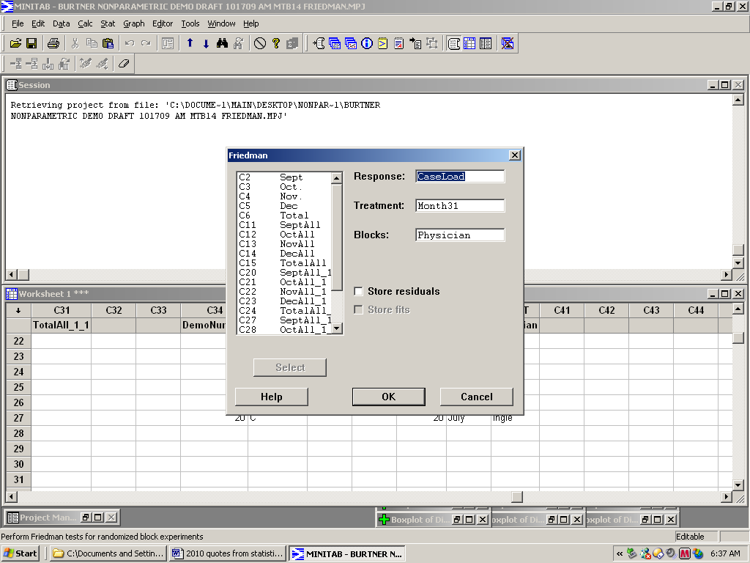

Measured Response: Case Load

Analytical Method Selected: Friedman Test

Assumptions: Case load is interval level data. We do not assume the variable is normally distributed in the population.

General Format of Hypotheses:
H0: all treatment effects are zero versus
H1: not all treatment effects are zero

For our data set, the hypotheses are:
H0: Case load does not vary by month when blocked by physician.
H1: Case load varies by month when blocked by physician.

Calculations / Computer Output

Friedman Test: CaseLoad versus Month31 blocked by Physician
S = 5.56 DF = 2 P = 0.062
Month31 N Est Median Sum of Ranks
January 9 41.00 23.0
July 9 23.00 13.0
May 9 25.00 18.0
Grand median = 29.67

Decision: Fail to reject the null hypothesis.

Conclusion: With a p-value of 0.062, we do not have sufficient evidence to conclude that the case load differs for the months of January, July, and May when blocked by physician.

EXCERPTS FROM MINITAB 14 HELP GUIDE:
Stat > Nonparametrics > Friedman
Friedman test is a nonparametric analysis of a randomized block experiment, and thus provides an alternative to the Two-way analysis of variance. The hypotheses are:
H0: all treatment effects are zero versus H1: not all treatment effects are zero
Randomized block experiments are a generalization of paired experiments, and the Friedman test is a generalization of the paired sign test. Additivity (fit is sum of treatment and block effect) is not required for the test, but is required for the estimate of the treatment effects.

Output
Minitab prints the test statistic, which has an approximately chi-square distribution, and the associated degrees of freedom (number of treatments minus one). If there are ties within one or more blocks, the average rank is used, and a test statistic corrected for ties is also printed. If there are many ties, the uncorrected test statistic is conservative; the corrected version is usually closer, but may be either conservative or liberal. Minitab displays an estimated median for each treatment level. The estimated median is the grand median plus the treatment effect.

