JMB ACCEPTANCE SAMPLING NOTES
ISE 428 ETM 528 Spring 2016
Nomogram Examples

Acceptance Sampling is a term that describes a process for inspection performed on an incoming shipment, in which samples are taken from the lot and inspected with regard to certain quality characteristics.

The purpose of Acceptance Sampling is to determine a course of action (accept or reject the lot).

NOTE: The purpose of Acceptance Sampling is not to estimate or control the quality of incoming materials.

Definitions for Single Sampling Plans

The acceptance quality level (AQL) is a level of lot quality which, if the vendor produces lots which are at least as good as this or better, the manufacturer would like to accept a high percentage of the time.

The lot tolerance percent defective (LTPD) is a level of quality such that if the vendor produces lots that are this bad or worse, the manufacturer wishes to reject them a high percentage of the time.

Steps for Using a Nomogram to Develop a Single Sampling Plan
Nomogram Examples
Step 1. Specify α, ß, p₁ (the fraction nonconforming value for which the probability of acceptance is high), and p₂ (the fraction nonconforming value for which the probability of acceptance is low).
Step 2. Draw one line connecting p₁ and (1-α).
Step 3. Draw another line connecting p₂ and ß.
Step 4. Identify n and c. (The intersection of these two lines determines approximate values for n and c.)
When choosing, use smaller value for c.

Plan A
AQL (p1) = 2%. LTPD (p2) = 8%. Alpha is 5% and beta is 40%.

Draw the p1 / 1-alpha line. Draw the p2 / beta line.
The intersection is close to n = 40 and c = 2.
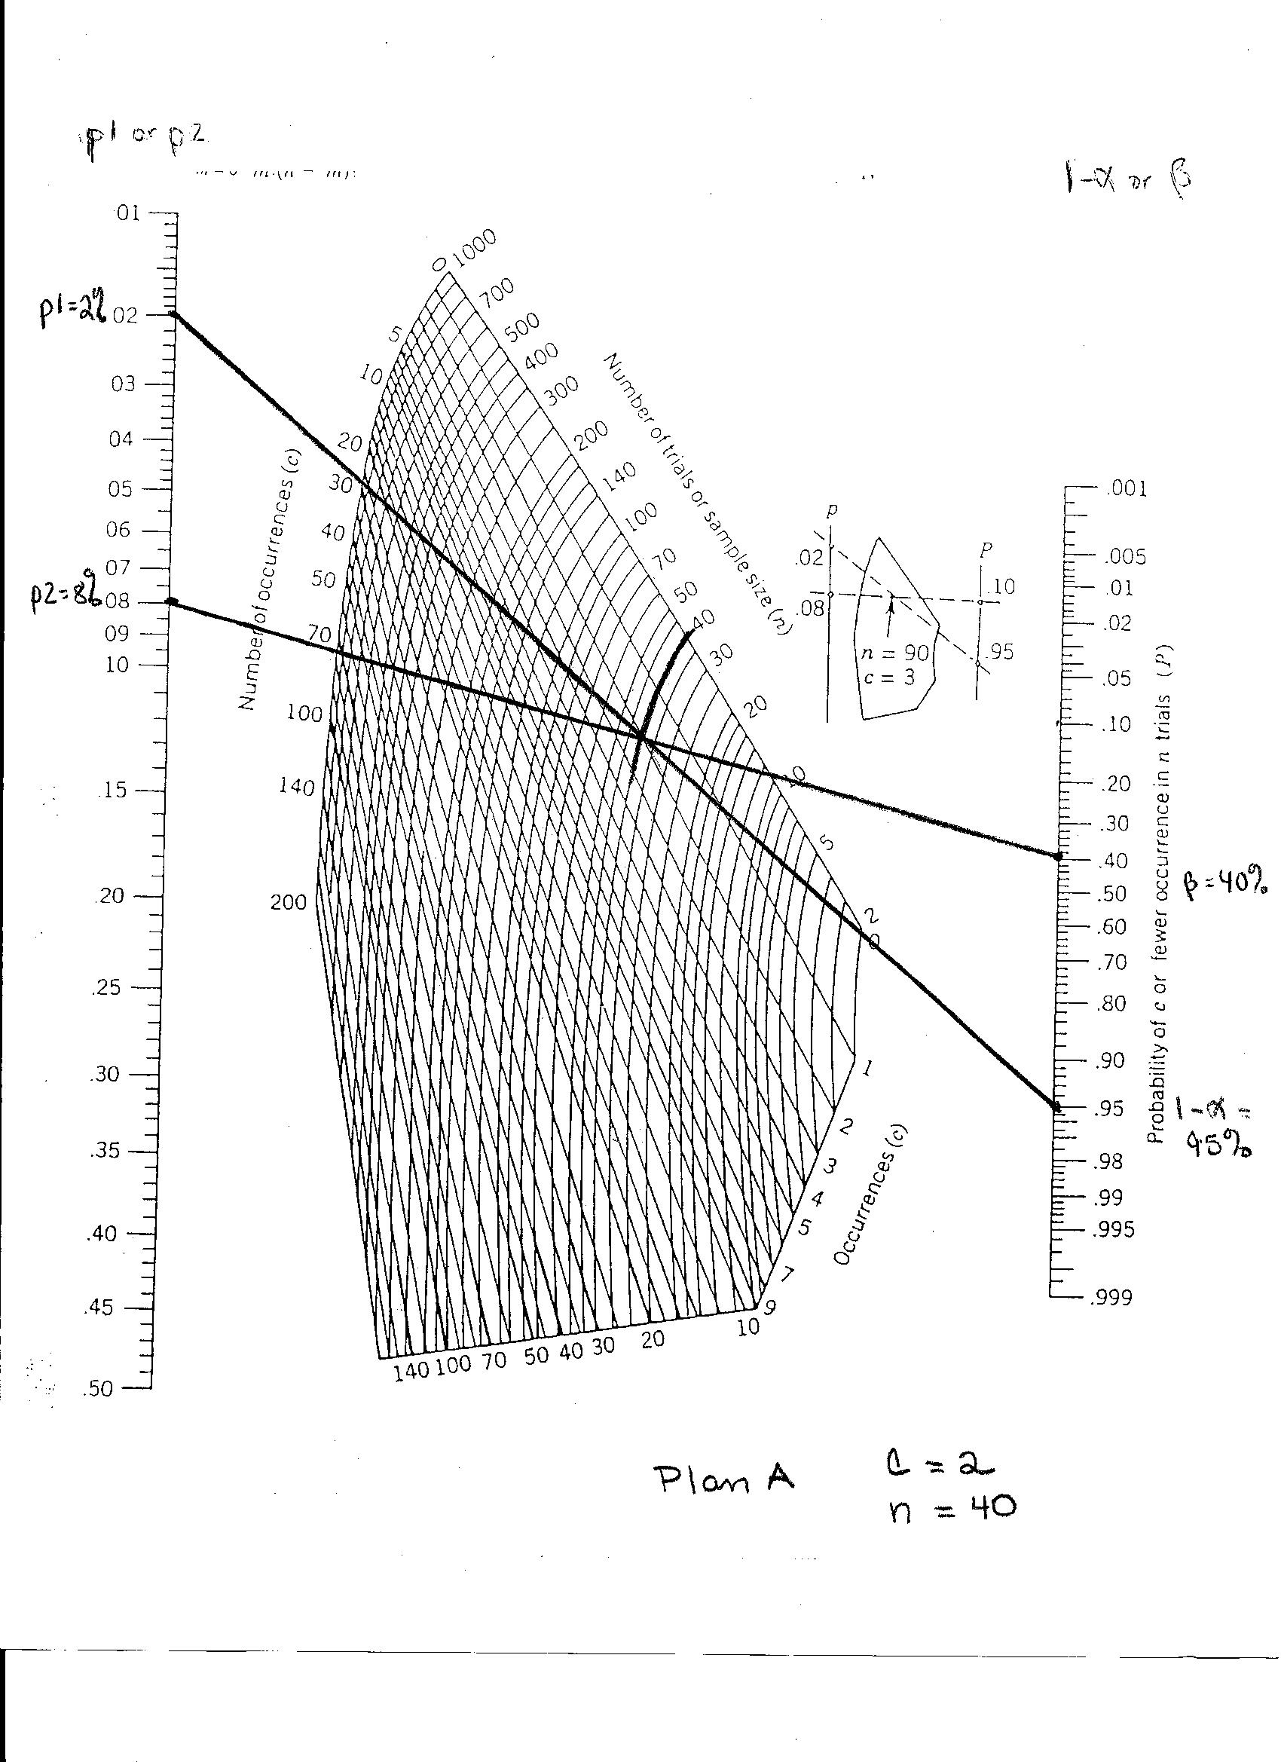
Figure 1. Nomogram for Plan A.

Plan B
Suppose you don’t have 40 items in each lot.
One solution is to keep the p1 / 1-alpha line the same (0.02 to 0.95).
We can change the p2 / beta line as follows.
Decide the LTPD (p2) is .10. Try beta = .60 The resulting p2 / beta line is shown on Figure 2. The intersection is close to n=10 and c is between 0 and 1. Choose the smaller c value. So decide c = 0.
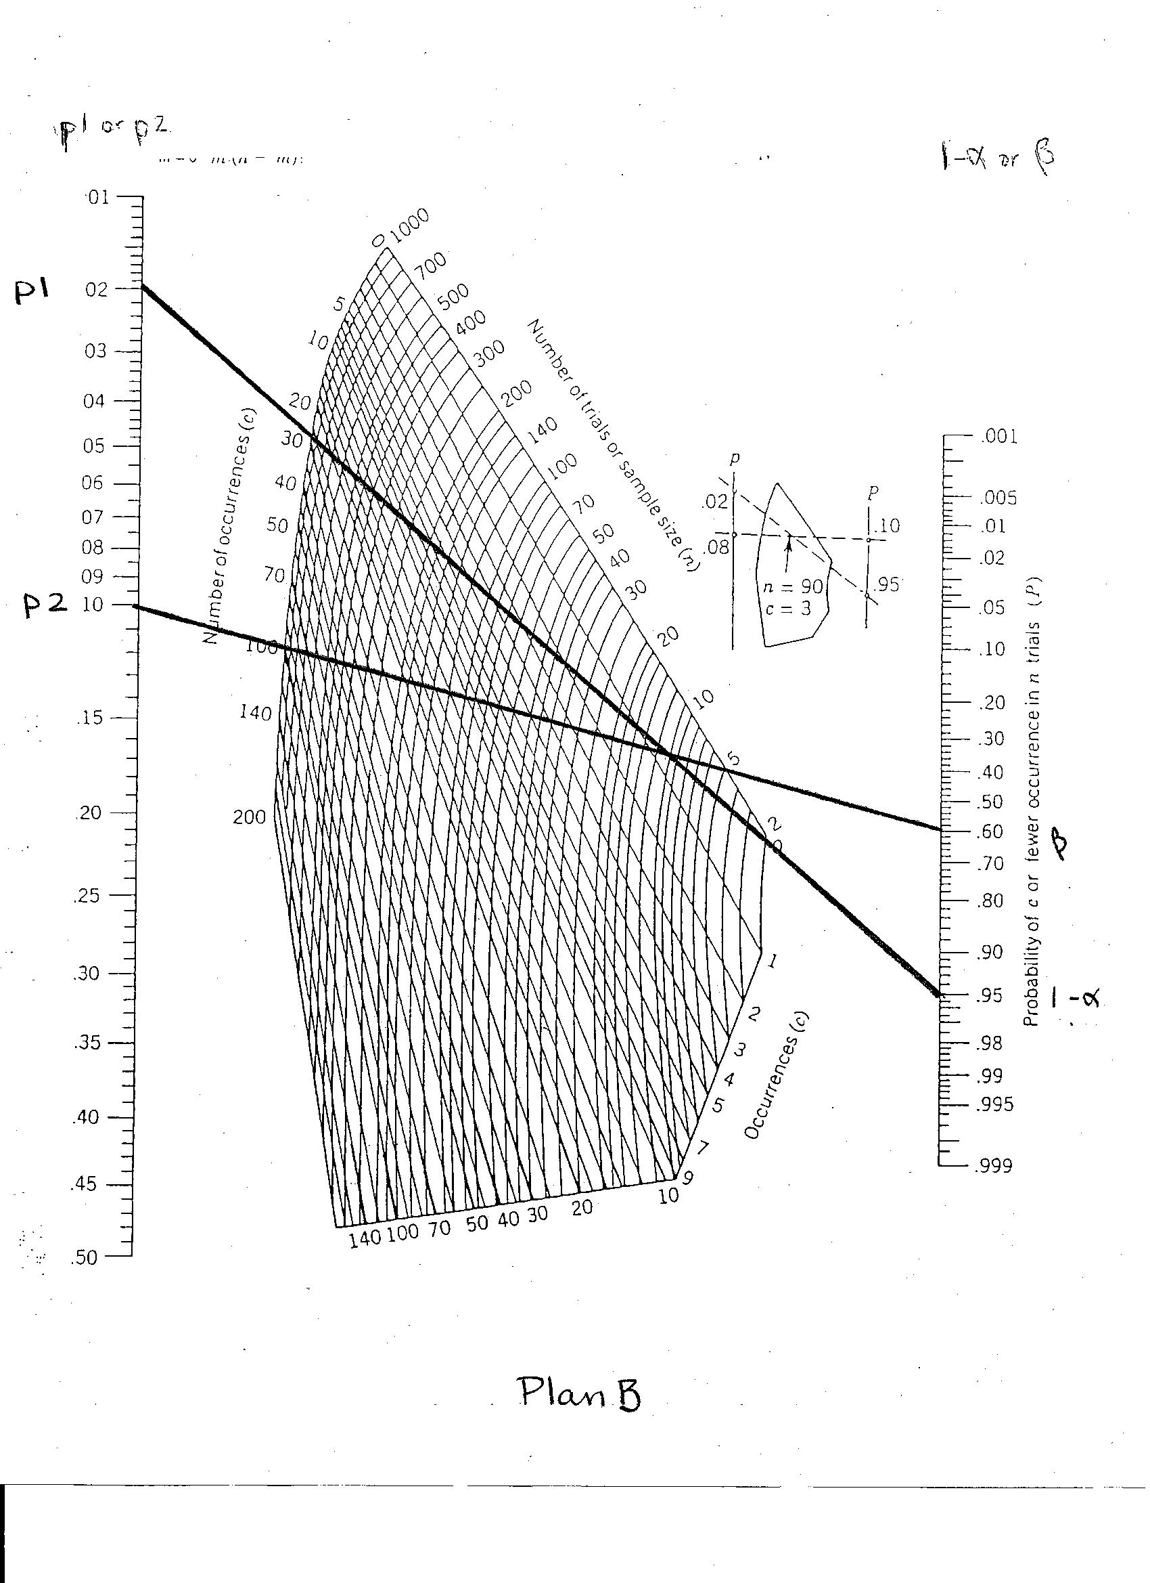
Figure 2. Nomogram for Plan B.

With this new plan, there will be fewer samples to inspect. However, we will be accepting “bad” product a higher percentage of the time. Is this good?

