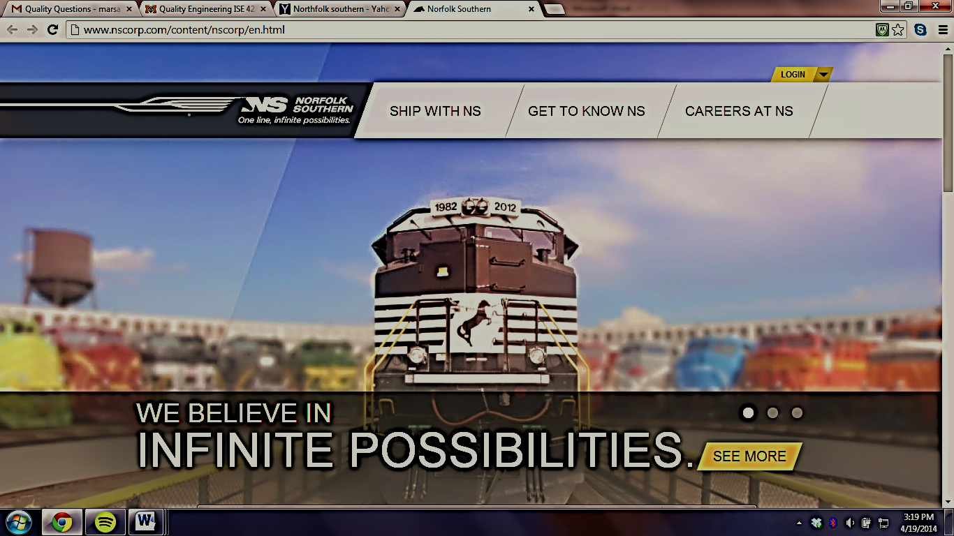
Norfolk Southern Corporation
Interview on Quality
By: Marsalis Charles
Client: Antonio S. Ward
Professor: Dr. Burtner
ISE 428.000
4/21/2014

Introduction:
Norfolk Southern (NS) history spans nearly two centuries to the earliest days of American railroading. Since the early 1800’s, hundreds of railroad companies were built, merged, reorganized, and consolidated into what eventually become NS. NS was created from the consolidation of Southern Railway and Norfolk and Western Railway in 1982. NS is one of the leading transportation providers. Norfolk operates around 20,000 route miles in 22 states including D.C. Some of the routes supports international trade service to every major Eastern seaport, 10 river ports, and nine lake ports. Norfolk also operates the most extensive intermodal network in the East. When it comes to being a leader NS’ board of directors and executive management team lead one of the nation’s top transportation companies. NS vision is to “be the safest, most customer-focused, and successful transportation company in the world.” NS is also committed on providing an injury-free work environment, delivering customers’ products efficiently and reliably, and being a good corporate citizen.
The person I’m interviewing name is Antonio S. Ward. Mr. Ward. His position title is Industrial Engineering in Strategic Planning. The interview process was done by cell phone, In-person, and by email. The dates included March 10, March 28, April 2, and April 19.

CORPORATE PHILOSOPHY
The format of the interview listed below goes by the question first then the response given by Mr. Ward.
What does your mission statement state?
Norfolk Southern Mission Statement: To enhance the value of our stockholders’ investment over time by providing quality freight transportation services and undertaking any other related businesses in which our resources, particularly our people, give the company an advantage.
- Does your company's mission statement mention quality? Yes
- Does your company's mission statement mention customer service? Yes
- Does the company have a separate quality mission statement? Yes
We are responsible to our stockholders, customers, employees and the communities we serve. For all constituencies, we will provide quality service, always trying to reduce our costs in order to offer competitive prices. For our stockholders, we will strive to earn a return on their equity investment which will increase the value of their ownership. By generating a reasonable return on invested capital, we will provide the security of a financially strong company to our customers, employees, stockholders and communities. For our employees, our greatest asset, we will provide fair and dignified treatment with equal opportunity at every level. We will seek a talented, diverse work force and management with the highest standards of honesty and fairness. For the communities we serve, we will be good corporate citizens, seeking to enhance their quality of life through service, jobs, investment and the energies and good will of our employees.
- Does the company have a written quality plan? If so, where is it located? Corporate Annual Report
- In your organization, who is responsible for quality? Every employee here at Norfolk Southern is responsible for Quality. More specifically we have a dedicated Quality Management department based in Roanoke, VA. Their primary focus is Kaizen and Process Improvement initiatives.
- What are some job titles that relate to quality in your company? What is the educational background for these positions? (All positions hold a bachelor of science in Engineering or Mathematics **All managers have Master Degrees)
- Manager of Quality Improvement
- Manager of Business and Process Improvement
- Manager of Industrial Engineering
- Lean Engineer
- Industrial Engineer
- Director of Quality Management
- Director of Industrial Engineering and Operations Research
- Director of Strategic Planning

- How does your organization define quality? Refer to Quality Mission statement
- How do you train/educate your employees concerning quality issues?
NGauge
Norfolk Southern has several initiatives/programs that are geared toward quality and process improvement. One of the most recent programs, NGauge, is initiative to improve our network performance at the ground level. In order to improve communication we are installing tools that will allow front line supervisors to manage their day to day operations more efficiently. Another primary function of the program is the implementation of daily and weekly planning meetings. These meeting help all departments to work and plan as a team to handle the variations in daily field operations.
NSight
Norfolk Southern focuses a lot of resources on our ability to keep the railroad running. In order to maintain a high standard of quality we must continue to get better. Our NSight initiative focuses on the Mechanical operations. Our locomotives and car shops function much like a manufacturing plant. There is a systematic flow to how we handle repairs in which, a standard approach to these numerous processes are vital to our success. NSight teaches middle managers “The 8 Steps to Problem Solving” which in the end provides a standard approach to solutions.
- How do your customers influence your quality program? In our business time is money. We have to focus daily on how we deliver freight or else our customers go shopping with another company. It’s not just about delivering freight as fast as we possibly can. Delivering a product to a customer before they can handle the product can be just as costly as not having the products there on time. Therefore how we operate and the quality in which we operate is huge in our business.
- Has your company ever applied for or earned a national quality award or certification? (Baldrige Award, ISO 9000, CMMI, Other?) ISO 9000
- Do government regulations have a large impact on your quality procedures?
Yes, we governed by the Federal Railroad Administration and we have to move freight in compliance with their rules and regulations at all times.

QUALITY METHODOLOGY
- Do you routinely collect data on the quality of your product or process? Do you use statistics to analyze the data collected? Yes, we software modeling products to predict future traffic patterns as well as monitor capacity issues. We primarily use run time data when researching & analyzing projects. Our company has a huge database of information which we have at our finger tips. Developing macros to pull this information from data warehouses and using Minitab to analyze the data are some of our typical functions.
- Do you use control charts? If so, what processes are charted? We use control charts to grapy Upper and Lower limits for our run time data. We could also use control charts to analyze employee overtime.
- What kind of quality reporting techniques do you use? Who generates the reports? Who sees the reports?
We have several metrics in our organization. Our field operations use a metric titled “Local Operation Plan Adherence (LOPA)”. This metric gives us an idea how well we stuck to the operation plan and did we meet our performance metrics. Our entire company is metric driven. To list all of our quality metrics would take numerous amounts of hours in which I’m not getting paid to provide with this survey
- What kind of quality/process control software do you use? (Excel, generic SPC, proprietary, etc.) Excel, Minitab Access
- How do you monitor incoming materials and/or your suppliers? We have a certain positions in our Engineering department who manage the flow of our material. We are currently building a material/procurement system that will track the ordering and delivering of railroad material (crossties, rail, spikes, ballast, etc.)
- Do you use acceptance sampling methods? If so, what standards are they based on? Who designs the plan? N/A
- What percentage of your product is scrapped or reworked? Hard to say but I know we refurbish our used rail and crossties to go on territories with less flow of traffic. The wear and tear on most of our material last 30 – 50 years. We do not build or make any of our products in house. We only repair and maintain our equipment.
- Has your organization ever issued a product recall? If so, please identify the product and the date of the recall. N/A
- Does your organization follow Six Sigma or Lean Sigma quality methodologies for process improvement? N/A
- Are employees encouraged to obtain quality credentials such as Certified Quality Engineer or Six Sigma Black Belt? Yes

AUTHORIZATION
Do you give Dr. Burtner permission to publish your interview responses on her course website?
I give your permission to publish the responses onto your course website.

