Chi-Square Goodness of Fit Test in Minitab 17

Let's look at a sample of 200 M&M’s. Do the data support the hypothesis that the distribution is uniform?

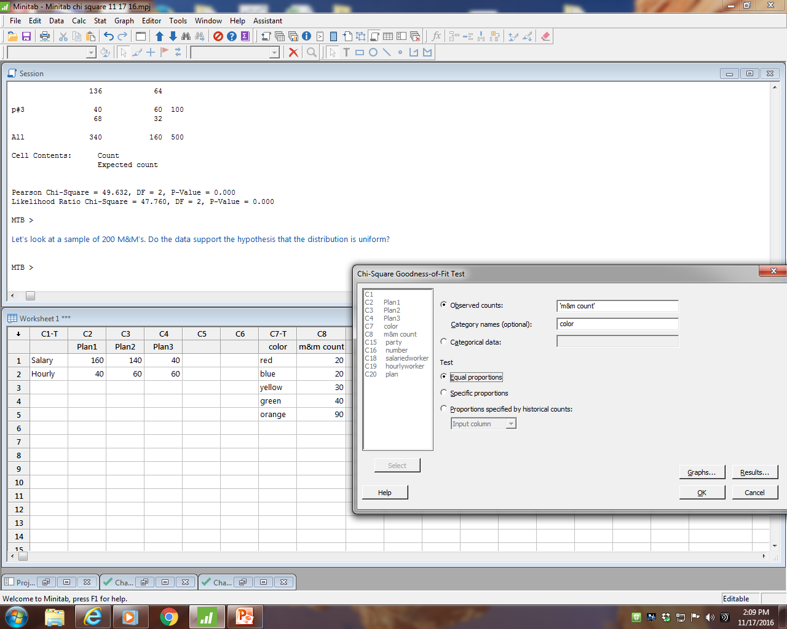

Chi-Square Goodness-of-Fit Test for Observed Counts in Variable: m&m count

Using category names in color

Test Contribution
Category Observed Proportion Expected to Chi-Sq
red 20 0.2 40 10.0
blue 20 0.2 40 10.0
yellow 30 0.2 40 2.5
green 40 0.2 40 0.0
orange 90 0.2 40 62.5

N DF Chi-Sq P-Value
200 4 85 0.000

H0: The distribution of M&M’s is uniform.
H1: The distribution of M&M’s is not uniform.

The p-value is very small.
We reject the null hypothesis.
We conclude the distribution of M&M’s is not uniform.

Minitab 17 graphs help us visualize the results.

