P chart Example Fall 2010
Thirteen samples of size n=100 each were collected. The number of defective items for each sample are shown below.
Sample Number of
# Defectives
1 5
2 4
3 3
4 3
5 2
6 4
7 4
8 4
9 2
10 5
11 2
12 6
13 3

Use Minitab to build a p chart and evaluate the process control.

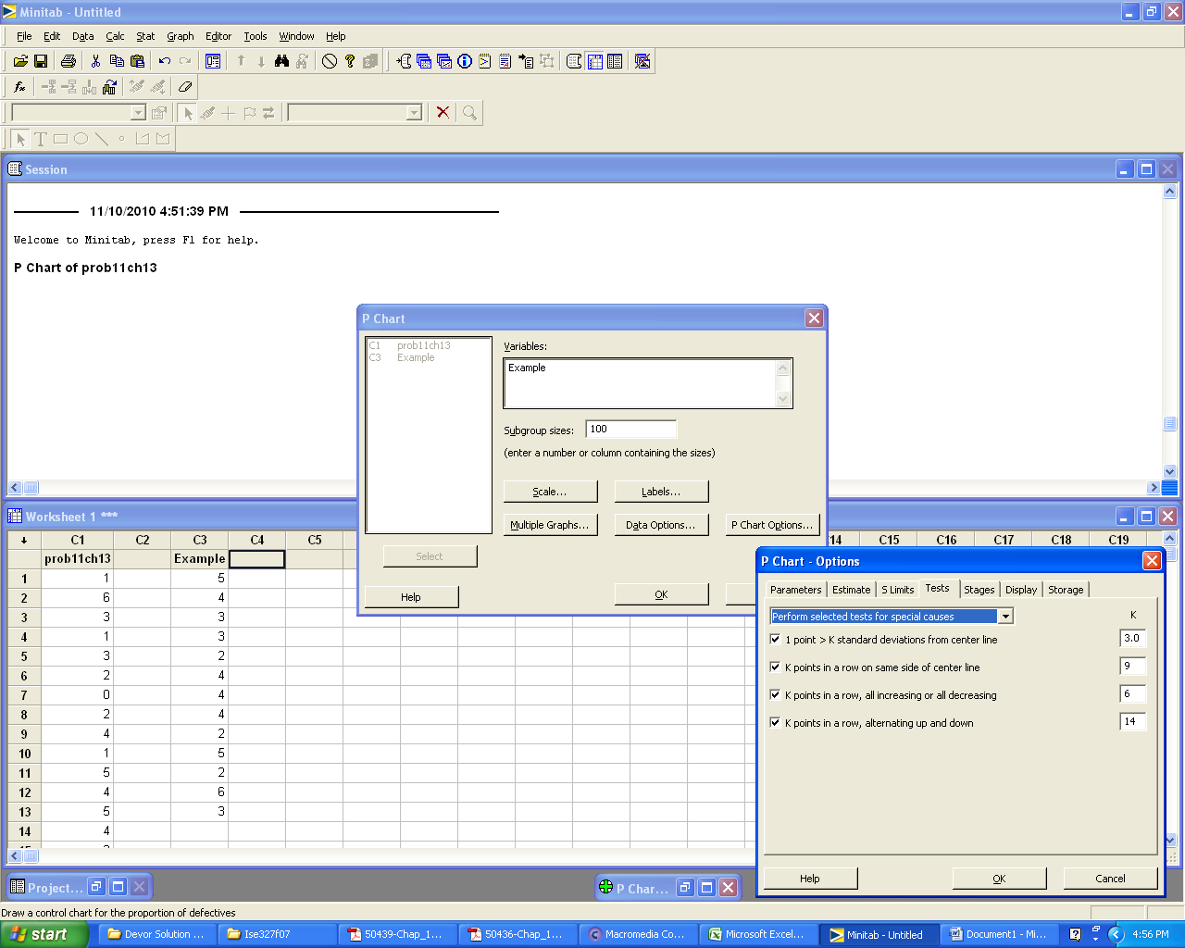
Results:
The process does not exhibit any out-of-control characteristics.

