Fall 2018 Hypothesis Testing Template: One Factor Design - Excel Example

Problem Statement The data represent the running times of films produced by three different motion picture companies. Do the data suggest the mean running times are significantly different? Use the 0.05 significance level. USE EXCEL.

Experimental Design One factor ANOVA– 3 levels (independent samples)

DATA

Factor 1 Level 1 Factor 1 Level 2 Factor 1 Level 3

Company A | Company B | Company C
91  102  86  98  119  92  155  105 | 92  96  98  99  92  97 | 109  102  165  105  145  135

Factor : Company Levels A B C

Response: running times

Hypotheses H0 : The mean running times for the three companies are equal.
H1 : The mean running times for the three companies are not all equal.

METHOD FOR CONDUCTING A ONE-WAY ANOVA IN EXCEL

Data/ Data Analysis/ ANOVA: Single Factor
Input Range -- Select Data (Include Labels)
Designate columns or rows.
Check appropriate boxes.
Designate area for Output

Excel Output
(Copy and Paste from Spreadsheet or Worksheet using Courier New 10 point font)

Anova: Single Factor
SUMMARY
Groups | Count | Sum | Average | Variance
Company A | 8 | 848 | 106.00000 | 496.000000
Company B | 6 | 574 | 95.66667 | 9.066667
Company C | 6 | 761 | 126.8333 | 652.9667
ANOVA
Source of Variation | SS | df | MS | F | P-value | F crit
Between Groups | 3046.383 | 2 | 1523.192 | 3.817992 | 0.042704 | 3.591531
Within Groups | 6782.167 | 17 | 398.951
Total | 9828.55 | 19

Interpretation of Results

p-value 0.042704

Decision: Reject H0

Conclusion: The mean running times for the three companies are not all equal.

In order to determine which means differ from each other, we can conduct a Tukey Comparison in Minitab.

See Minitab example on next page.

Minitab Method: Open Minitab. Enter data into a Minitab worksheet.
Pull down menu: Stat/ ANOVA/ One Way

Choose how the response data are organized (single column or multiple columns).

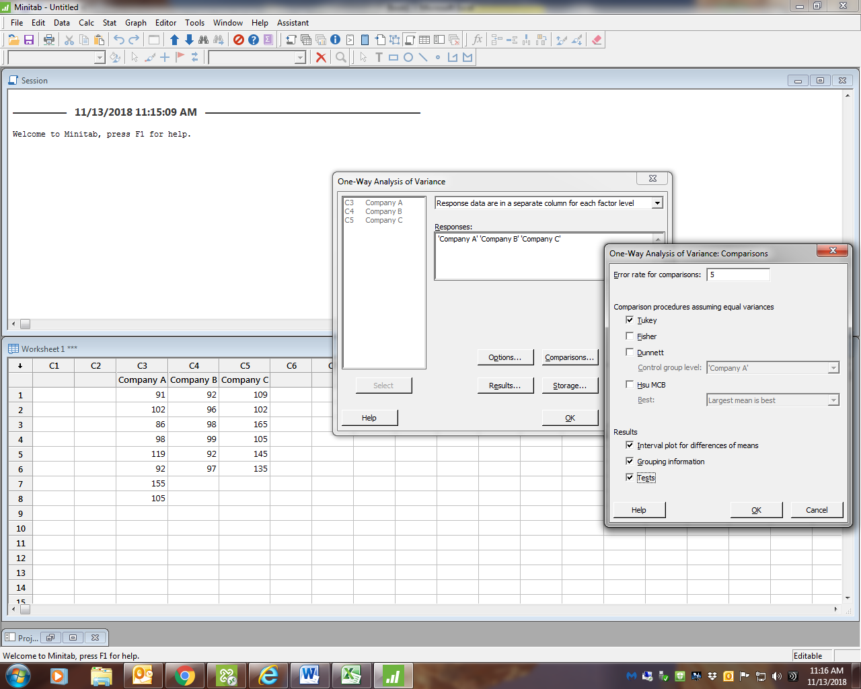

Factor Information

Factor Levels Values
Factor 3 Company A, Company B, Company C

Analysis of Variance

Source DF Adj SS Adj MS F-Value P-Value
Factor 2 3046 1523.2 3.82 0.043
Error 17 6782 399.0
Total 19 9829

How does the Minitab ANOVA compare to the EXCEL ANOVA?

Tukey Simultaneous Tests for Differences of Means

Difference SE of Adjusted
Difference of Levels of Means Difference 95% CI T-Value P-Value
Company B - Company A -10.3 10.8 (-38.0, 17.4) -0.96 0.612
Company C - Company A 20.8 10.8 ( -6.9, 48.5) 1.93 0.160
Company C - Company B 31.2 11.5 ( 1.6, 60.8) 2.70 0.038

Individual confidence level = 98.00%

Note that there is not a significant difference between the two means if the confidence interval contains 0. In this example, Company A’s mean time is significantly longer than Complany B’s mean time.There is no signiificant difference in the mean time between Company B and Company C. There is no signiificant difference in the mean time between Company A and Company C.

Look at the graph below. Which confidence intervals cross zero?

