Fall 2018 Hypothesis Testing Template: One Factor Design – Two Samples

Problem Statement The data represent the running times of films produced by two different motion picture companies. Do the data suggest the mean running times are significantly different? Use the 0.05 significance level. USE EXCEL.

Experimental Design One factor two levels (independent samples)

DATA

Factor 1 Level 1 Factor 1 Level 2

Company A | Company C
91  102  86  98  119  92  155  105 | 109  102  165  105  145  135

Factor : Company Levels A C

Response: running times

Hypotheses H0 : The mean running times for the two companies are equal.
H1 : The mean running times for the two companies are not equal.

METHOD FOR CONDUCTING A two sample t-test IN EXCEL

Data / Data Analysis / t-Test: Two Sample Assuming Unequal Variances

Enter data.
Check appropriate boxes.
Designate area for Output.

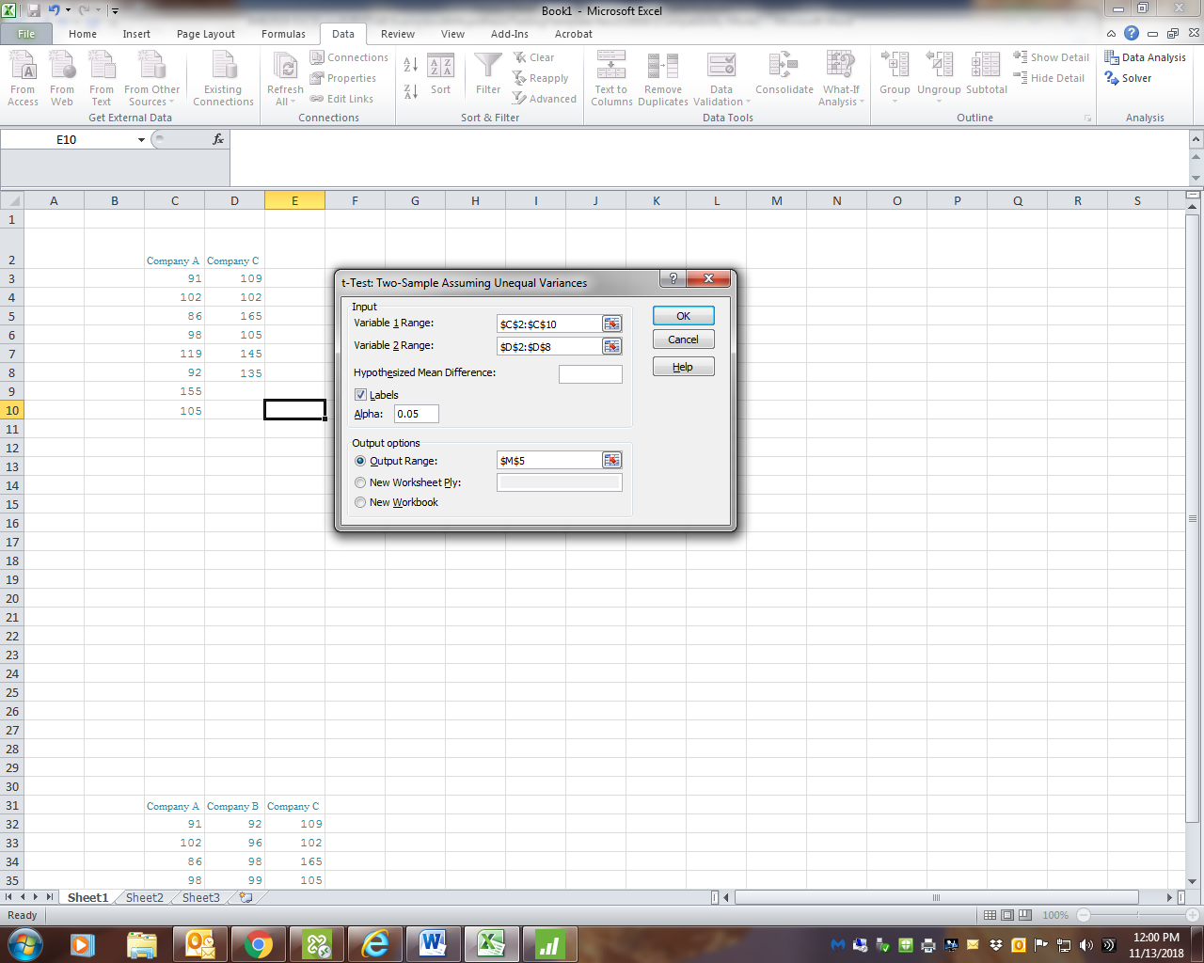

t-Test: Two-Sample Assuming Unequal Variances
 | Company A | Company C
Mean | 106 | 126.8333333
Variance | 496 | 652.9666667
Observations | 8 | 6
Hypothesized Mean Difference | 0
df | 10
t Stat | -1.593967701
P(T<=t) one-tail | 0.071013771
t Critical one-tail | 1.812461123
P(T<=t) two-tail | 0.142027543
t Critical two-tail | 2.228138852

Interpretation of Results

p-value 0.142027

Decision: Fail to Reject H0

Conclusion: The mean running times for the two companies are not significantly different.

