ISE428 Fall 2007: How to Generate a Two-Way ANOVA Table in Minitab 14
Including a Check of Model Assumptions

PROBLEM: You have been called in as a consultant to help the Pratt and Whitney plant determine the best method of applying the reflective stripe that is used to guide the Automated Guided Vehicles (AGVs) along their path. There are two ways of applying the stripe (paint or coated adhesive tape) and three types of flooring (linoleum, I concrete or II concrete) in the facilities that use the AGVs. You have set up two identical “test tracks” on each type of flooring and applied the stripe using the two methods under study. You run 3 replications in random order and count the number of tracking errors per 1000 ft of track. The results are as follows:

Enter the data into Minitab and conduct a two-way ANOVA at the 5% significance level. Select the four-in-one residual plot option. You will need one column for the observations, one column for Factor A (Stripe) and one column for Factor B (Flooring). (See Figure 1.)

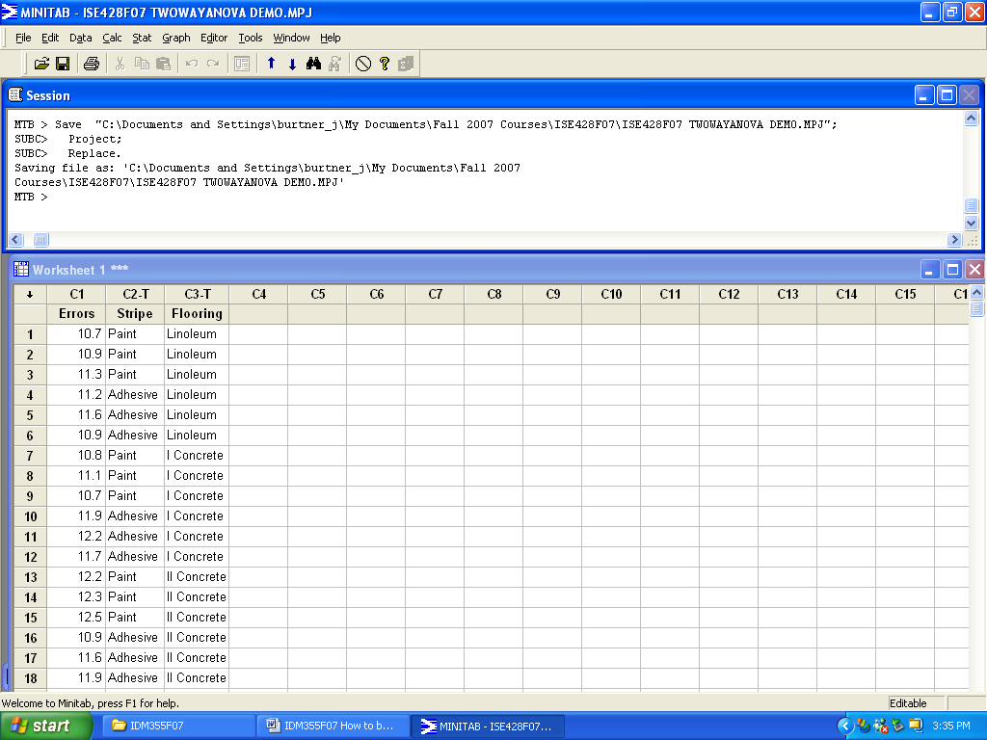
Figure 1. Worksheet Setup for Two-Way ANOVA in Minitab
How to Generate a Two-Way ANOVA Table in Minitab 14 (cont.)

Your ANOVA Table results should look like the output shown in Figure 2.

Two-way ANOVA: Errors versus Stripe, Flooring

Source DF SS MS F P
Stripe 1 0.10889 0.10889 1.07 0.321
Flooring 2 1.96000 0.98000 9.64 0.003
Interaction 2 2.83111 1.41556 13.92 0.001
Error 12 1.22000 0.10167
Total 17 6.12000

S = 0.3189 R-Sq = 80.07% R-Sq(adj) = 71.76%

Figure 2. Minitab ANOVA Table Format

Your residual plots should look like the graphs shown in Figure 3.

Figure 3. Residual Plots for a Two-Factor Experimental Design

The residuals appear to be somewhat normally distributed. There does not seem to be a pattern based on the order in which the data was collected. We can conclude that there are no strong violations of model assumptions.

Since the interaction is significant (p-value less than significance level), we should generate an interaction graph by plotting the means for each factor at each level.

