Review of Hypothesis Testing for Fall 2013
One-Way ANOVA
Minitab 15

Review of Excel
Statistical Functions
Data Analysis
Graphing

Orientation to Minitab
Worksheet
Session Window

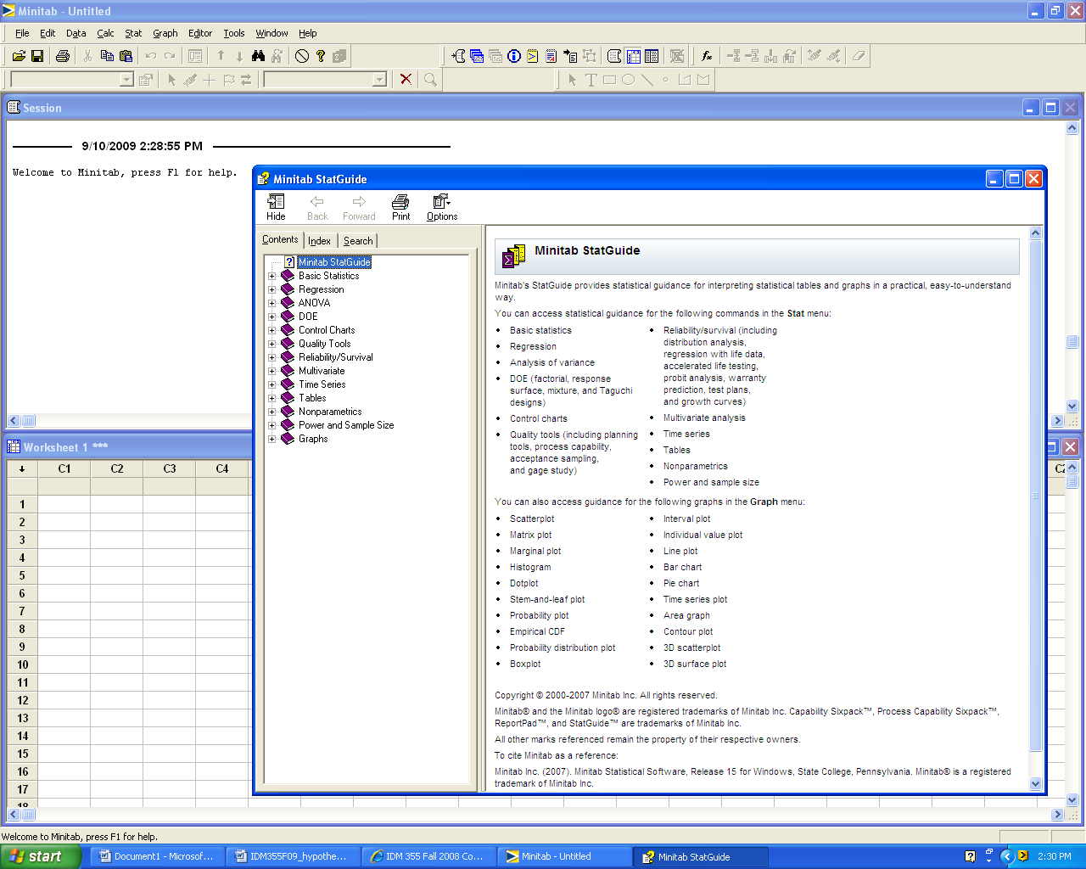

Experimental Designs

Single sample hypothesis test

Two sample hypothesis test

One-factor ANOVA
ISE 327 Hypothesis Test Template (Manual Calculation)

Problem Statement

Hypotheses:
H₀:
H₁:

Determination of correct test statistic (sigma known or unknown, sample size):

Governing equation (tcalc or zcalc)

Calculation of test statistic:

Determination of p-value:

Graphics: (Choose applicable graphic drawn by hand or computer)

0 0.05 1 (p-value)

Decision: _________H₀

Conclusion: Use complete sentences. (Refer to problem statement and managerial decision based on p-values)
Two sample hypothesis test (raw data) A quality researcher is interested in comparing the sodium content of two brands of corn flakes. She collects the following data. Does this data suggest that two brands differ in terms of average sodium content? Assume the distribution of sodium contents to be normal.

CFlakes PFlakes
244 254
245 256
246 245
248 244
241 242
241 243
245 243
244 245
241 252

Hypotheses:
H₀: μ _{Crowger} = μ _{Publicks}
H₁: μ _{Crowger} ≠ μ _{Publicks}

Critical values: *small sample *sigma unknown *two-sided alternate hypothesis
*p-value approach ~Therefore, there is no value for t critical.

Calculation of test statistic and p-value:

Method 1: We can use the Minitab pull-down menu: Stat/Basic Statistics/2-Sample t
Two-Sample T-Test and CI: CFlakes, PFlakes

Two-sample T for CFlakes vs PFlakes

N Mean StDev SE Mean
CFlakes 9 243.89 2.47 0.82
PFlakes 9 247.11 5.35 1.8

Difference = mu (CFlakes) - mu (PFlakes)
Estimate for difference: -3.22222
95% CI for difference: (-7.54537, 1.10092)
T-Test of difference = 0 (vs not =): T-Value = -1.64 P-Value = 0.129 DF = 11

Graphics:

0 0.05 0.10 1 (p-value)

Decision: Fail to reject H₀

Conclusion: With a p-value = 0.129, the data suggest that there is not a statistically significant difference in the mean sodium content of the two brands.
Typical Hypothesis Test Template (Computer Calculation)

Problem Statement:
A law enforcement organization conducted a study on the accuracy radar guns. They tests were conducted using a projectile moving at 60 mph. Results are as follows:
 |  |  | GunX | GunY | GunZ
 |  |  |  | 63.7 | 61.5 | 63.0
 |  |  |  | 65.5 | 64.2 | 61.5
 |  |  |  | 59.0 | 63.5 | 59.0
 |  |  |  | 63.5 | 64.8 | 63.5
 |  |  |  | 60.2 | 61.5 | 57.8
 |  |  |  | 61.5 | 60.9 | 61.5
 |  |  |  | 60.0 | 62.5 | 60.0
 |  |  |  | 60.5 | 64.0 | 60.5
 |  |  |  | 60.7 | 60.5 | 64.0
 |  |  |  | 62.2 | 64.0 | 62.2
Do the data suggest the mean measured mph of the guns differs significantly?

Hypotheses:
H₀: µGunX = µGunY = µGunZ
H₁: At least two of the means are different.

Critical values for determining correct test statistic:
More than two groups, assume normal distribution in the population, decision based on p-value of F statistic

Calculation of test statistic and p-value:
Method 1: We can use the Minitab pull-down menu: Stat/ANOVA/One-way (Unstacked)

(Minitab 15 Computer Output)

One-way ANOVA: GunX, GunY, GunZ

Source DF SS MS F P
Factor 2 11.14 5.57 1.59 0.221
Error 27 94.28 3.49
Total 29 105.42

S = 1.869 R-Sq = 10.57% R-Sq(adj) = 3.94%

Individual 95% CIs For Mean Based on
Pooled StDev
Level N Mean StDev ---------+---------+---------+---------+
GunX 10 61.680 2.023 (-----------*-----------)
GunY 10 62.740 1.551 (-----------*------------)
GunZ 10 61.300 1.994 (-----------*-----------)
---------+---------+---------+---------+
61.0 62.0 63.0 64.0

Pooled StDev = 1.869
Graphics:

P = 0.221

0 0.05 1 (p-value)

Decision: Fail to reject_H₀

Conclusion: Use complete sentences. (Refer to problem statement and the decision based on p-values.)

Based on a p-value = 0.221, the data suggests that there is no statistically significant difference between µGunX, µGunY, and µGunZ.

******Additional output from Minitab

The graphs do not indicate any violations of the normality and homogeneous variance assumptions.

Note: If the p-value was less than the significance level (alpha), we would use output from Mintab’s Tukey comparisons to determine which means were significantly different from each other. (See below)

Tukey 95% Simultaneous Confidence Intervals
All Pairwise Comparisons

Individual confidence level = 98.04%

GunX subtracted from:

Lower Center Upper --------+---------+---------+---------+-
GunY -1.014 1.060 3.134 (---------*----------)
GunZ -2.454 -0.380 1.694 (---------*---------)
--------+---------+---------+---------+-
-2.0 0.0 2.0 4.0

GunY subtracted from:

Lower Center Upper --------+---------+---------+---------+-
GunZ -3.514 -1.440 0.634 (----------*---------)
--------+---------+---------+---------+-
-2.0 0.0 2.0 4.0

The Tukey intervals support our conclusion that there is no significant difference between the means.

One-factor ANOVA(unstacked or stacked formatting) A quality researcher is interested in comparing the sodium content of three types of cereal. She collects the following data. Does this data suggest that three types of cereal differ in terms of average sodium content? Assume the distribution of sodium contents to be normal.

Corn | Oat | Bran
244 | 222 | 254
245 | 225 | 256
246 | 234 | 245
248 | 245 | 244
241 | 246 | 242
241 | 248 | 243
245 |  | 243
244 |  | 245
241 |  | 252

Hypotheses:
H₀: μ _{CornFlakes} = μ _{OatFlakes} = μ _{BranFlakes}
H₁: The μ’s are not all equal.

Let’s format the data so that we can conduct a one-way ANOVA (stacked) in Minitab.

sodium type
244 Corn
245 Corn
246 Corn
248 Corn
241 Corn
241 Corn
245 Corn
244 Corn
241 Corn
222 Oat
225 Oat
234 Oat
245 Oat
246 Oat
248 Oat
254 Bran
256 Bran
245 Bran
244 Bran
242 Bran
243 Bran
243 Bran
245 Bran
252 Bran
Let’s also do a Tukey test as part of our analysis. (Comparisons in Minitab)

MINITAB 15 OUTPUT

One-way ANOVA: sodium versus type

Source DF SS MS F P
type 2 397.8 198.9 4.54 0.023
Error 21 921.1 43.9
Total 23 1319.0

S = 6.623 R-Sq = 30.16% R-Sq(adj) = 23.51%

Individual 95% CIs For Mean Based on
Pooled StDev
Level N Mean StDev -----+---------+---------+---------+----
Bran 9 247.11 5.35 (-------*-------)
Corn 9 243.89 2.47 (------*-------)
Oat 6 236.67 11.34 (--------*---------)
-----+---------+---------+---------+----
234.0 240.0 246.0 252.0

Pooled StDev = 6.62

Tukey 95% Simultaneous Confidence Intervals
All Pairwise Comparisons among Levels of type

Individual confidence level = 98.00%

type = Bran subtracted from:

type Lower Center Upper ---------+---------+---------+---------+
Corn -11.081 -3.222 4.637 (-------*-------)
Oat -19.231 -10.444 -1.658 (--------*-------)
---------+---------+---------+---------+
-10 0 10 20

type = Corn subtracted from:

type Lower Center Upper ---------+---------+---------+---------+
Oat -16.009 -7.222 1.565 (--------*--------)
---------+---------+---------+---------+
-10 0 10 20

What is our decision? What should we conclude?

Revised August 28, 2013

