Turnover Case Study Part 2

For this part of the Turnover case study, you will write a one-page 12 point Times Roman double-spaced essay that shows your ability to apply principles of organizational psychology to a fictional case study. The article below describes issues in the work environment at the Days Inn hotel chain in 1990. You may make assumptions about the work environment for younger and older workers at Motel9 by analyzing the data collected by the industrial manager in Part 1 of the Turnover case study.

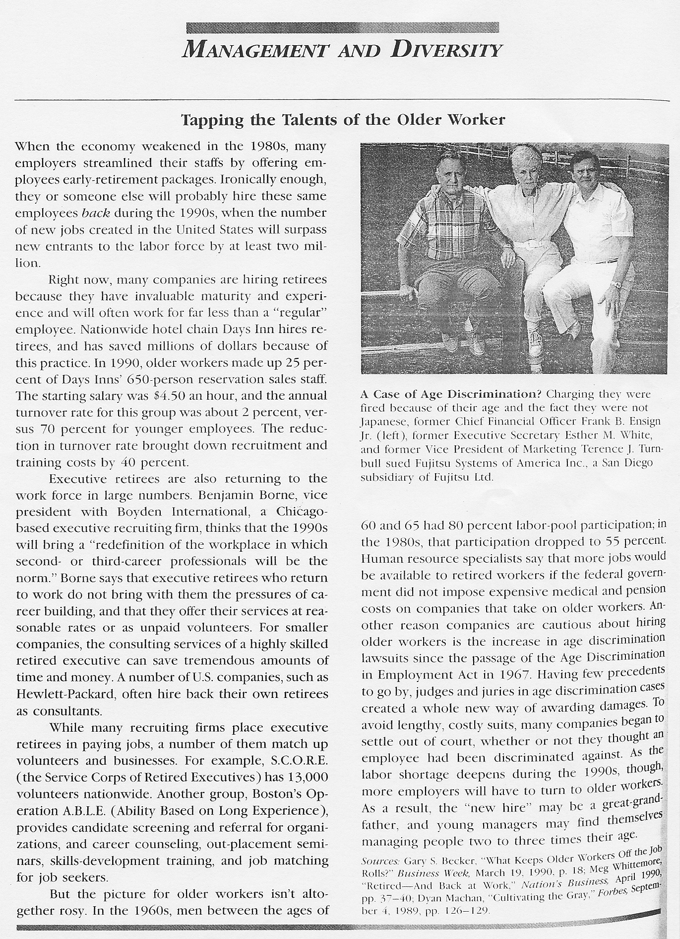

Some questions to consider: (I do not expect your essay to address all of these issues.)
1) How might recent unemployment trends affect management’s desire/need to hire older workers?
2) The article suggests that companies may be cautious about hiring older workers because of the passage of the 1967 Age Discrimination in Employment Act. In what ways can an organization provide a workplace environment that minimizes age discrimination lawsuits?
3) The article describes the likelihood that new hires may find themselves managing people two to three times their age. Should the organization provide special training in how to supervise older workers?
4) Do you think the Patient Protection and Affordable Care Act might have changed hiring practices at Days Inn?
5) Compare the 1990 turnover rates at Motel9 and Days Inn. Were they significantly different in 1990?
6) Consider the difference in turnover rates at Days Inn in 1990. Do you have suggestions with respect to what the company could do to close the gap between the turnover rates for the different age groups?

