How to Generate a Two-Way ANOVA Table in Minitab 15
Including a Check of Model Assumptions and Considerations for Management Decision-Making

PROBLEM: You have been called in as a consultant to help the Pratt and Whitney plant in Columbus determine the best method of applying the reflective stripe that is used to guide the Automated Guided Vehicles (AGVs) along their path. There are two ways of applying the stripe (paint and coated adhesive tape) and three types of flooring (linoleum and two types of concrete) in the buildings that use the AGVs. You have set up two identical “test tracks” on each type of flooring and applied the stripe using the two methods under study. You run 3 replications in random order and count the number of tracking errors per 1000 ft of track. The results are as follows:

This is a 2x3 design. The response is Errors. There are three replicates per cell.
The first factor is Stripe (2 Levels: Paint, Adhesive).
The second factor is Flooring (3 Levels: Linoleum, Concrete I, Concrete II).

Enter the data into Minitab. You will need one column for the observations, one column for Factor A (Stripe) and one column for Factor B (Flooring).Conduct a two-way ANOVA at the 5% significance level. Select the four-in-one residual plot option.

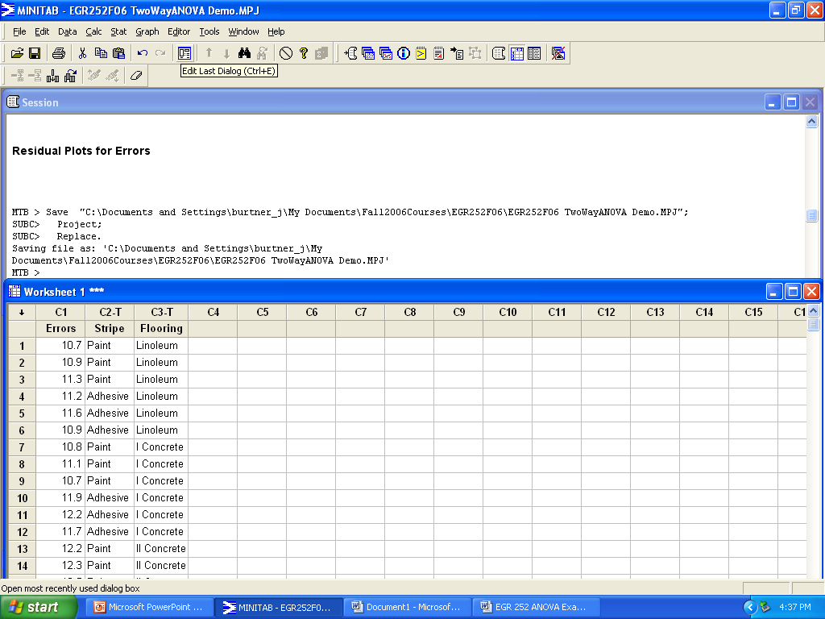
Figure 1. Worksheet Setup for Two-Way ANOVA
How to Generate a Two-Way ANOVA Table in Minitab 15 (cont.)

Your ANOVA Table results should look like the output shown in Figure 2.

Two-way ANOVA: Errors versus Stripe, Flooring

Source DF SS MS F P
Stripe 1 0.10889 0.10889 1.07 0.321
Flooring 2 1.96000 0.98000 9.64 0.003
Interaction 2 2.83111 1.41556 13.92 0.001
Error 12 1.22000 0.10167
Total 17 6.12000

S = 0.3189 R-Sq = 80.07% R-Sq(adj) = 71.76%

Figure 2. Minitab ANOVA Table Format

Your residual plots should look like the graphs shown in Figure 3.

Figure 3. Residual Plots for a Two-Factor Experimental Design Minitab 15

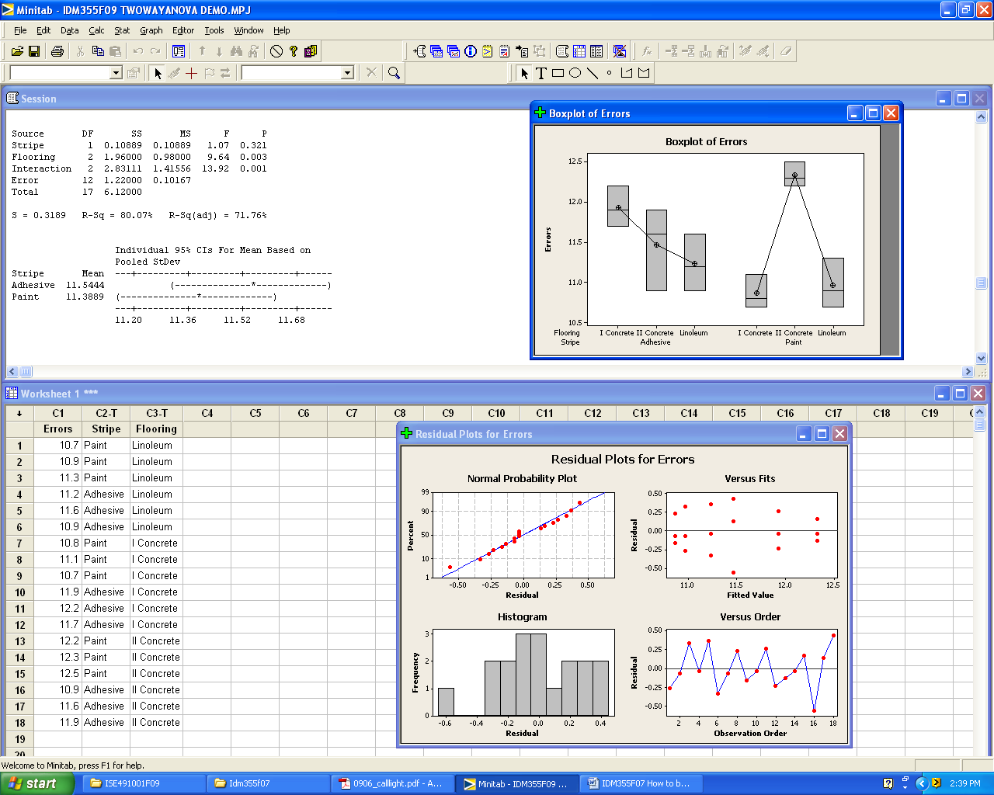
Figure 4. Minitab Output with Optional Graphs

Analysis of Minitab Output

Look at the ANOVA table (Figure 2).
Is the effect of Stripe significant? NO p-value = 0.321
Is the Flooring effect significant? YES p-value = 0.003
Is the interaction between Stripe and Flooring significant? YES p-value = 0.001

Look at the residual plots.
Were there any serious violations of assumptions of normality? NO

What does the boxplot of Errors show?

Since the interaction is significant, you should generate an interaction graph by plotting the means for each factor at each level.

Figure 5. Interaction Plot for a Two-Way ANOVA

Questions to consider:

Does a higher response indicate a better outcome?
The response is errors; lower is better.

Does the effect of Stripe vary for different levels of Flooring?
Yes

What Stripe (Adhesive or Paint) would you recommend for an area that had Concrete I Flooring?
Paint

Would your recommendation change for an area that had Concrete II Flooring?
Yes, adhesive stripes result in fewer errors than painted stripes when applied to Concrete II flooring.

