Interviewee Interviewer

Current Career Information and Authorizations
Where do you work? I work for ESG Operations Inc. which is a private utilities and operations contractor. I also adjunct in the evenings at Mercer University.
What is your current job title? I am currently a Project Manager in Training.

Do you give us your permission to publish your contact information on Dr. Burtner’s website? yes
Do you give us your permission to publish your interview responses on Dr. Burtner’s website? yes
If you would like us to post a picture of you on the job, please send it to Burtner_J@Mercer.edu.
I will also send the picture to the requested address.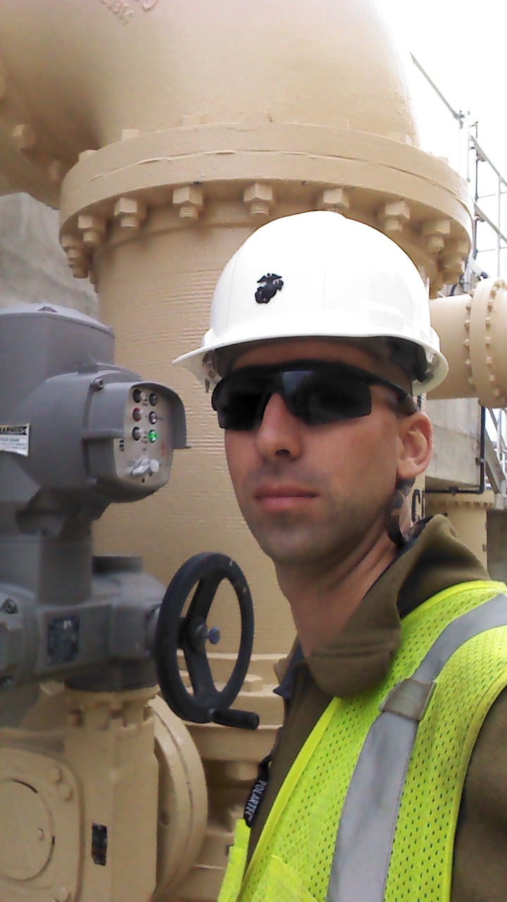

Educational Information
Did you graduate from Mercer and if so when? Graduated Mercer December 2014
What degree did you earn? B.S. Industrial Management
Have you earned any licenses/certifications such as Professional Engineer, Black Belt, Certified Quality Engineer, etc.? I have earned a Class III and Class II waste water license and am currently working toward my P.E.
Did you pursue a Master’s degree after graduation? If so on average how much time would you say a Master’s requires for completion? Do you feel that having a Master’s degree helped you advance in your career? I did not pursue a Masters, but I wish in hindsight that I had taken advantage of Mercer’s 5-year Masters Program. Some of the other managers and engineers have masters but it only helps them in how they apply the experience, not in direct compensation so much. A P.E. goes much farther, but it should be noted that most of the people I work with are Civil/Environmental engineers, environmental scientist, and biologist.
Did you have any internships or co-ops while you were at Mercer? If so, where did you intern and what were your duties? I interned my senior year at ESG’s corporate headquarters in the engineering department where I was responsible for construction and environmental permitting and all CAD drawings for construction and demolition. I also spent two years as a teaching assistant in Mercer’s machine shop, and I did contract work prototyping which is how I landed my senior design project.

Work Environment
What is your routine on a normal day at work? There is no norm, but generally start out at the larger waste water plant in Warner Robins and make sure the operations staff is on point and add any guidance or help where I can. Then I split time writing reports, answering emails and finding solutions to contractor and manufacturer short comings that are hindering our operations. If all that is done, safety checks and process improvement where I can find it.
What skills would you say were essential to your job? CAD and technical writing got my foot in the door, but now I utilize communication and asset management skills most of the time to accomplish my goals.
Are your benefits and compensation competitive with those in similar industries or jobs? Yes
How many hours on average do you work a week? 40-50
How much free time do you have when you leave work? Do you usually work on weekends? I work 7-4 weekdays but I am always on call and weekends and late nights are a reality.
How often do you interact with people outside of the engineering world? Every day, all day.
Are you required to make presentations and write reports as part of your job? Yes
How would you compare your job experience so far to what you expected before you actually started to work; is your job experience what you expected or is the experience completely different? Well I do very little engineering now, and almost exclusively management which is not what I imagined three years ago. I thought I would be in some sort of high-speed machining facility such as L.H. Thompson or the like.
Do you usually work in groups or alone? Equally both.
What is a stressful aspect of your job and what is a satisfying aspect of your job? If I mess up I could go to jail or be sued but it is satisfying knowing that I make water clean and everybody needs it.
Have you had any mentors who were influential in helping you grow in your profession? Yes, two engineers at corporate one of which is a Mercer grad from 2001.
How much room for advancement or promotion is there available at your current company? It’s why they kept me after my internship, to move me up and plant me as a project manager of my own project one day.
Is traveling a requirement of the position you hold and if so how often do you travel and where? I have to travel out of town two or three times a year, but I spend a good bit of time traveling around my current project which includes 2 waste water plants, 7 water plants, and 40 lift stations around town.

Mercer Education Experience
How well did your Mercer education prepare you for your career? Well
Which classes that you took in college do you find to be most helpful on your job? TCO 341, all the IDM classes, Industrial Psychology, and ISE 362.
Which classes were least helpful? Business Strategy, Corporate Finance,

Career Choice/Career Path
What has been your career path since graduation? To have my own Project
Has your family life (marriage, children, parents, etc) influenced your career path? Yes, children definitely complicate the situation both at school and work. I think I would have stayed at Mercer for my graduate degree if I did not have a family that needed me to get the cash flow going again.
What made you choose your specialty in the engineering field? Time, I started out Electrical(which I did not enjoy like I thought), and after I flubbed a class and got off the prescribed Mercer graduation track, IDM gave me a chance to graduate at near the same time with little time lost.
If given the opportunity, would you could go back in time and change your major or specialization? Why or why not? I would have gone IDM or ISE from the beginning and done the 5-year master’s program.
Where do you see yourself 5 to 10 years from now? With my own project

Thank you for participating in the IDM/ISE 288 Spring 2016 Interview Project.

