Introduction to Hypothesis Testing for ETM 591 Fall 2010 ~Part 3

Review of Excel
Statistical Functions
Data Analysis
Graphing

Orientation to Minitab
Worksheet
Session Window

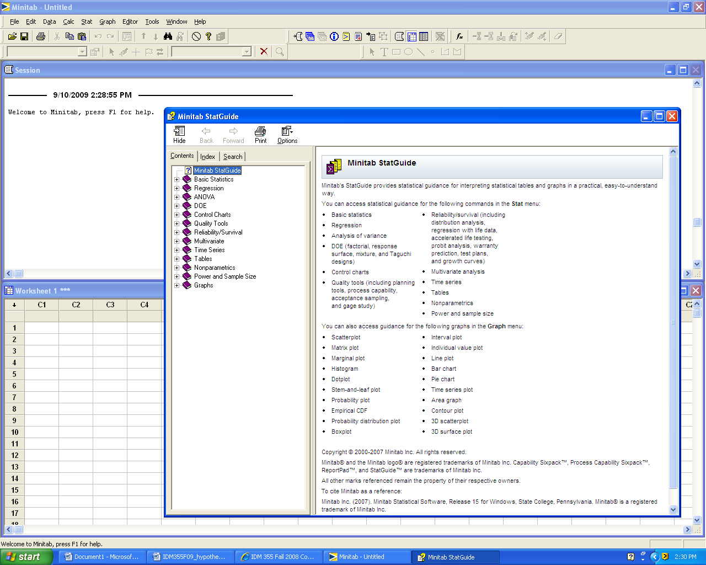

Experimental Designs

Single sample hypothesis test

Two sample hypothesis test

Paired sample hypothesis test

Multiple sample hypothesis test (One-way ANOVA)

Multiple sample hypothesis test (Two-way ANOVA)
Hypothesis Test Template for Two-Way ANOVA

Problem Statement:

Hypotheses:
H₀:
H₁:

H₀:
H₁:

H₀: There is no significant interaction between Factor A and Factor B.
H₁:

Determination of test statistics and p-values: (Copy and Paste Computer Output)

Factor A:______________________
Decision: _________H₀

Conclusion: Use complete sentences. (Refer to problem statement and managerial decision based on p-values)

Factor B: ______________________
Decision: _________H₀

Conclusion: Use complete sentences. (Refer to problem statement and managerial decision based on p-values)

Interaction Effect Between Factor A and Factor B:
Decision: _________H₀

Conclusion: Use complete sentences. (Refer to problem statement and managerial decision based on p-values)

Multiple sample hypothesis test (Two-way ANOVA) To help determine the effect that acidity and bromine have on nitrogen oxide emissions, two levels of acidity and two levels of bromine are established. Factor A is acidity; Factor B is bromine. Results are shown below. Note that the design is balanced with 3 replicates in each cell. Does this data suggest that acidity and bromine level have a significant effect on nitrogen oxide emissions?

 | Bromide High | Bromide Low
Acidity Low | 28.3 | 33.5
Acidity Low | 28.6 | 32.7
Acidity Low | 28.2 | 32.9
Acidity High | 24.6 | 37.2
Acidity High | 24.6 | 37.6
Acidity High | 24.8 | 37.0

Results

Anova: Two-Factor With Replication
SUMMARY | Bromide High | Bromide Low | Total
Acidity Low
Count | 3 | 3 | 6
Sum | 85.100 | 99.100 | 184.200
Average | 28.367 | 33.033 | 30.700
Variance | 0.043 | 0.173 | 6.620
Acidity High
Count | 3 | 3 | 6
Sum | 74.000 | 111.800 | 185.800
Average | 24.667 | 37.267 | 30.967
Variance | 0.013 | 0.093 | 47.671
Total
Count | 6 | 6
Sum | 159.100 | 210.900
Average | 26.517 | 35.150
Variance | 4.130 | 5.483
ANOVA
Source of Variation | SS | df | MS | F | P-value | F crit
Sample | 0.21333 | 1 | 0.21333 | 2.63918 | 0.14291 | 5.317655
Columns | 223.60333 | 1 | 223.60333 | 2766.22680 | 0.00000 | 5.317655
Interaction | 47.20333 | 1 | 47.20333 | 583.95876 | 0.00000 | 5.317655
Within | 0.64667 | 8 | 0.08083
Total | 271.66667 | 11

