Introduction to Hypothesis Testing for ETM 591 Fall 2010 ~Part 1

Review of Excel
Statistical Functions
Data Analysis
Graphing

Orientation to Minitab
Worksheet
Session Window

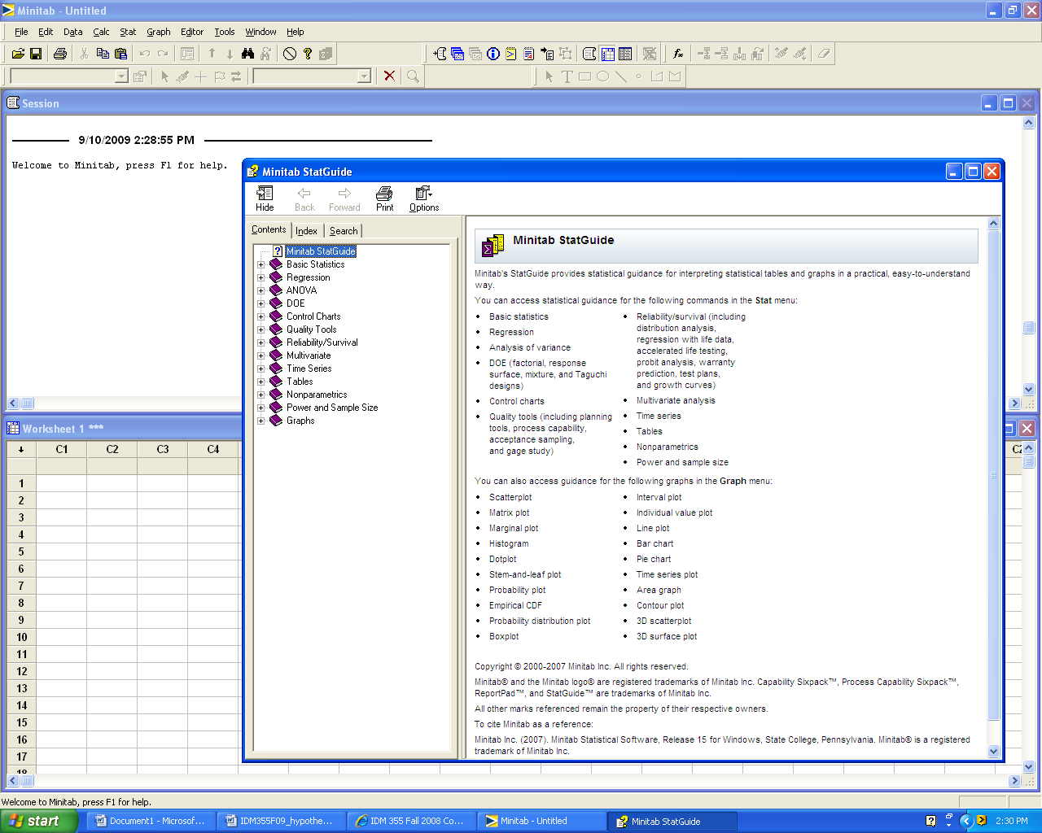

Experimental Designs

Single sample hypothesis test

Two sample hypothesis test

Paired sample hypothesis test

Multiple sample hypothesis test (One-way ANOVA)

Multiple sample hypothesis test (Two-way ANOVA)
Typical Hypothesis Test Template

Problem Statement:

Hypotheses:
H₀:
H₁:

Critical values for determining correct test statistic:

Calculation of test statistic and p-value: (Computer Output)

Graphics: (Choose applicable graphic drawn by hand or computer)

0 0.05 1 (p-value)

Decision: _________H₀

Conclusion: Use complete sentences. (Refer to problem statement and managerial decision based on p-values)
Single sample hypothesis test If a random sample of 20 servings of ready-to-eat cereal has a mean sodium content of 244 milligrams and a standard deviation of 24.5 milligrams, does this data suggest that the average sodium content is greater than 220 milligrams? Assume the distribution of sodium contents to be normal.

Hypotheses:
H₀: μ = 220
H₁: μ > 220

Critical values: *small sample *sigma unknown *one-sided alternate hypothesis
*p-value approach Therefore, there is no value for t critical.

Calculation of test statistic and p-value:
$$n = \text{20} σ \text{unknown} ⇒\text{Use} t t_{\text{calc}}=\frac{ \overline{X}−μ}{s\sqrt{n}} t_{\text{calc}}=\frac{\overset{}{ \text{244}− \text{220} }}{\text{24}\text{.}5\sqrt{\text{20}}} t_{\text{calc}}= 4\text{.}\text{38}$$
There is no value for t_{crit} The p-value associated with t_{calc} = 4.38 is very small. How do we find the exact value?

Method 1: Use a published table of t values such as Table A.4 in Walpole and Myers text. For v=19, we can determine that the p-value is less than 0.0005.

Method 2: We can use an Excel function. Note that Excel uses positive values for t and tells us the area to the right of the selected value of t.
0.000161 | =TDIST(4.38,19,1)

Method 3: We can use the Minitab pull-down menu: Stat/Basic Statistcis/1-Sample t

Test of mu = 220 vs > 220

N Mean StDev SE Mean 95% Lower Bound T P
20 244.000 24.500 5.478 234.527 4.38 0.000

Graphics:
or
0 0.05 1 p-value

Note that the p-value is very close to zero. Therefore, it is highly unlikely that H₀ is true.

Decision: Reject H₀

Conclusion: With a p-value = 0.00016, the data suggest that the mean sodium content is greater than 220 milligrams.

Two sample hypothesis test (summarized data) A random sample of 10 servings of Crowger Corn Flakes has a mean sodium content of 243.89 milligrams and a standard deviation of 2.47 milligrams, A random sample of 10 servings of Publicks Corn Flakes has a mean sodium content of 247.11 milligrams and a standard deviation of 5.35 milligrams. Does this data suggest that two brands differ in terms of average sodium content? Assume the distribution of sodium contents to be normal.

Hypotheses:
H₀: μ _{Crowger} = μ _{Publicks}
H₁: μ _{Crowger} ≠ μ _{Publicks}

Critical values: *small sample *sigma unknown *two-sided alternate hypothesis
*p-value approach Therefore, there is no value for t critical.

Calculation of test statistic and p-value:

Method 1: We can use the Minitab pull-down menu: Stat/Basic Statistcis/2-Sample t

Two-Sample T-Test and CI: CFlakes, PFlakes

Two-sample T for CFlakes vs PFlakes

N Mean StDev SE Mean
CFlakes 9 243.89 2.47 0.82
PFlakes 9 247.11 5.35 1.8

Difference = mu (CFlakes) - mu (PFlakes)
Estimate for difference: -3.22222
95% CI for difference: (-7.54537, 1.10092)
T-Test of difference = 0 (vs not =): T-Value = -1.64 P-Value = 0.129 DF = 11

Graphics:
t = - 1.64

0 0.05 0.10 1 p-value

Decision: Fail to reject H₀

Conclusion: With a p-value = 0.129, the data suggest that there is not a statistically significant difference in the mean sodium content of the two brands.

Two sample hypothesis test (raw data) A quality researcher is interested in comparing the sodium content of two brands of corn flakes. She collects the following data. Does this data suggest that two brands differ in terms of average sodium content? Assume the distribution of sodium contents to be normal.

CFlakes PFlakes
244 254
245 256
246 245
248 244
241 242
241 243
245 243
244 245
241 252

Hypotheses:
H₀: μ _{Crowger} = μ _{Publicks}
H₁: μ _{Crowger} ≠ μ _{Publicks}

Critical values: *small sample *sigma unknown *two-sided alternate hypothesis
*p-value approach ~Therefore, there is no value for t critical.

Calculation of test statistic and p-value:

Method 1: We can use the Minitab pull-down menu: Stat/Basic Statistcis/2-Sample t
Two-Sample T-Test and CI: CFlakes, PFlakes

Two-sample T for CFlakes vs PFlakes

N Mean StDev SE Mean
CFlakes 9 243.89 2.47 0.82
PFlakes 9 247.11 5.35 1.8

Difference = mu (CFlakes) - mu (PFlakes)
Estimate for difference: -3.22222
95% CI for difference: (-7.54537, 1.10092)
T-Test of difference = 0 (vs not =): T-Value = -1.64 P-Value = 0.129 DF = 11

Graphics:

0 0.05 0.10 1 (p-value)

Decision: Fail to reject H₀

Conclusion: With a p-value = 0.129, the data suggest that there is not a statistically significant difference in the mean sodium content of the two brands.

Paired sample hypothesis test
A quality researcher is interested in comparing the sodium content of two brands of corn flakes. Both brands are produced at a cereal plant in Making, Georgia. The researcher collects the following data. The samples are collected in 15-minute intervals beginning at 8:00 am. Does this data suggest that two brands differ in terms of average sodium content? Assume the distribution of sodium contents to be normal.

Time CrFlakes WaFlakes
8:00 244 246
8:15 245 248
8:30 246 245
8:45 246 245
9:00 241 249
9:15 241 248
9:30 245 247
9:45 244 249

The times listed indicate that we should pair the data collected. The Minitab results for a paired sample t-test are shown below.

Paired T-Test and CI: CrFlakes, WaFlakes

Paired T for CrFlakes - WaFlakes

N Mean StDev SE Mean
CrFlakes 8 244.000 2.000 0.707
WaFlakes 8 247.125 1.642 0.581
Difference 8 -3.12500 3.35676 1.18679

95% CI for mean difference: (-5.93132, -0.31868)
T-Test of mean difference = 0 (vs not = 0): T-Value = -2.63 P-Value = 0.034

Graphics:

0 0.05 0.10 1 p-value

Decision: Reject H₀

Conclusion: With a p-value = 0.034, the data suggest that there is a statistically significant difference in the mean sodium content of the two brands.

