Engineering-Related Professional Practice Skills Newsletter
Volume 1, Issue 3 April 2001
Welcome
Professional Practice Skills Newsletter
By Joan Burtner
Assistant Professor, Industrial Engineering
The purpose of this newsletter is to increase your awareness of happenings around the school related to the assessment of learning outcomes. Each issue will spotlight a student who is making a unique contribution to the welfare of our engineering community. Each issue will also feature a faculty member who is making significant contributions to the assessment of student learning. If you would like to nominate someone for the next issue’s Student Spotlight or Featured Faculty article, please e-mail me. Burtner_J@Mercer.edu Ω

Student Spotlight
James Partridge
By Joan Burtner
Assistant Professor, Industrial Engineering
What is the value of an engineering education? How can engineers improve the society they live in? If someone truly wants to make a difference in this world, why choose engineering? This month's Student Spotlight column features James Partridge, a senior engineering student who has wrestled with these issues for the past several years.

James expects to graduate this May with a BSE (specialty: mechanical engineering) and a BA in mathematics. He has kept himself quite busy during his five years at Mercer. He served as president of Tau Beta Pi (the engineering honor society), spent a year studying at the University of Wales in Swansea, and worked during the summer of his junior year in Heidelberg, Germany. In addition, he did volunteer work for the Medical Center and Habitat for Humanity.
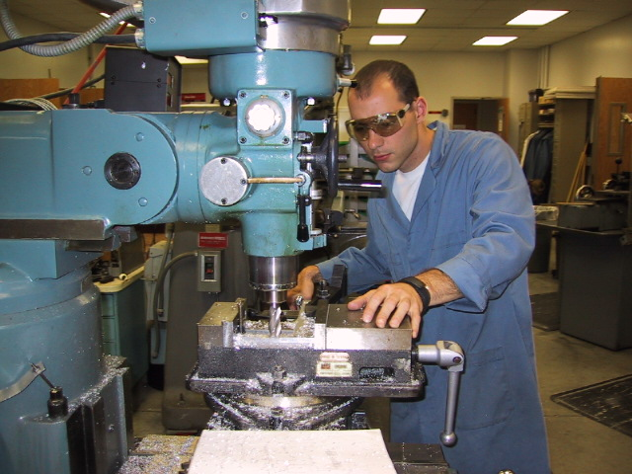
James Partridge working on a project in the Manufacturing Practices Lab in April 2001

Here is what James has to say about the potential value of an engineering education. "The engineering curriculum is demanding and technically thorough, but it alone is not a complete college education. Partaking in activities outside of the classroom is vital for a better understanding of the world and how it works. During my college experience, I have had the opportunity to be an S.I. leader, a F.Y.S. preceptor, study abroad for a year, volunteer at a hospital, and work in Germany one summer. These experiences have strengthened my public speaking skills, independence, and ability to adapt to new environments (and many other areas). With these learned skills, I am well prepared for continuing my education or taking part in the international economy. Experience has strengthened my enjoyment and respect for engineering, as well as prepared me for the future.

Like myself, some students struggle with their reason for selecting engineering as a major. Initially I decided on engineering because my academic talents lie in visualization and mathematics. Over time, I began to think about the impact of my life on humanity, and this theme became more important than my initial reason for selecting engineering. I wondered if a major such as Psychology, Christianity, or Pre-med would have a more evident, positive effect on mankind. I then faced a dilemma of changing majors or remaining in a field where I am successful. This is where experiences played a vital role in my decision. While traveling, seeing structures such as El Temple De La Sagrad Familia in Barcelona showed that beauty and faith can be evoked through the elegant aspects of architecture. Volunteering at a hospital disclosed how electrical, biomedical, and mechanical engineers work with the medical community to preserve and enhance life. Seeing fuel-efficient cars, electric buses, and space conservation in Europe revealed that engineers, through creativity and necessity, are improving and protecting the world around us. Across all fields, the engineering profession offers channels where talent, intelligence, and creativity can be directed."

James has taken the opportunity to place his engineering education in the context of the world around him. It has taken him longer than four years to graduate. He has benefited from the detours he has taken, and so has Mercer. Ω

UPDATE:
Augustin Dantes, who was featured in the EPPS Newsletter V1N2, had an interview with IBM this week. They flew him up to Fishkill, NY and provided him with a bright red Mustang during his stay. He expects to hear from them within the next two weeks. We hope you enjoy those cold winter nights, Augustin! Ω

For an online version of the EPPS Newsletter, visit the Engineering-Related Professional Practices Skills Web site, http://egrweb.mercer.edu/nova/

Inside This Issue
1 | Student Spotlight
1 | Update
2 | Burtner’s Bits
2  continued on page 2 | Featured Faculty
Featured Faculty
Dr. Laura Lackey, P.E.
By Joan Burtner
Assistant Professor, Industrial Engineering
Dr. Laura Lackey, Assistant Professor of Environmental Engineering, started working at the School of Engineering in August 1998. Prior to coming to Mercer, she spent six years as a chemical engineer and project manager for the Tennessee Valley Authority (TVA) Environmental Research Center. Although no longer employed by the TVA, Dr. Lackey maintains an active consulting practice. Her work has led to the development of a unique biodegradation process using closed-loop recycle schemes (US Patent application submitted, 7/23/00).

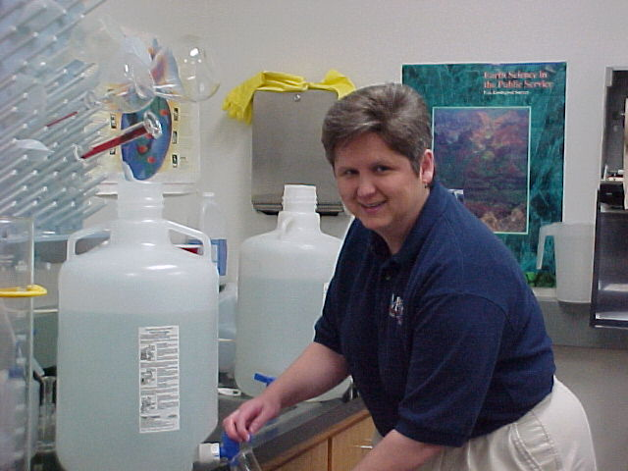
Dr. Laura Lackey running an experiment in the Environmental Engineering Lab in March 2001

In addition to her research expertise, Dr. Lackey has demonstrated her ability to be an exceptionally effective teacher. In a recent election, she was voted School of Engineering Teacher of the Year. This honor shows that she has earned the respect of her colleagues as well as her students. For the past two years, Dr. Lackey has guest lectured during the project management portion of EGR 312 (Engineering Economy). Here are one student's comments in response to the lecture. "From the manner and enthusiasm she used to speak of her numerous projects...I could deduce that Dr. Lackey is one of those gifted people who has always been marvelous at what she does. I most appreciated and was impressed by Dr. Lackey's willingness to be transparent enough to let us know that she had struggled. Her concern for her employees was a refreshing reminder of virtue in a world whose selfishness seems fueled by big-money, government-supported companies."

It is apparent that Mercer University is truly blessed to have a faculty member with the qualities of Dr. Laura Lackey. Ω

continued from page 1

Burtner’s Bits
Are you a team player?
Some people still think that engineering is basically a solo profession in which engineers sit quietly at their computers designing prototypes for others to build. Engineering students at Mercer quickly find out that engineering design is not a solo activity. Today's problems are very complex; solutions require cooperation from teams of technical and non-technical experts. From EGR 107-Freshman Design to EGR 487/488-Senior Design, Mercer's engineering students learn the good (and the bad) of working in teams. This term engineering faculty in EGR 107, MAE 302L, EGR 312, ISE 327, TCO 341, EGR 487, and EGR 488 are using a Self/Peer Team Assessment Survey in order to document students' teamwork skills. By completing this survey accurately and honestly, you are helping us to evaluate and improve our curriculum. Ω

For more information about the EVE department, visit http://www.mercer.edu/engineering/UNDERGRAD_PROGRAMS/EVE/evedefault.htm

