Engineering-Related Professional Practice Skills Newsletter
Volume 1, Issue 2 January 2001
Welcome
Professional Practice Skills Newsletter
By Joan Burtner
Assistant Professor, Industrial Engineering
The purpose of this newsletter is to increase your awareness of happenings around the school related to the assessment of learning outcomes. Each issue will spotlight a student who is making a unique contribution to the welfare of our engineering community. Each issue will also feature a faculty member who is making significant contributions to the assessment of student learning. If you would like to nominate someone for the next issue’s Student Spotlight or Featured Faculty article, please email me at Burtner_J@Mercer.edu Ω

Student Spotlight
Augustin Dantes
By Joan Burtner
Assistant Professor, Industrial Engineering
It is important that engineering students maintain a sense of balance—academic coursework and extracurricular activities are both essential parts of the undergraduate engineering experience. Augustin Dantes has learned the art of balance. He is a member of Mercer’s Junior Varsity Basketball Team. He is active in Mercer's chapter of the National Society of Black Engineers (NSBE) and the Organization of Black Students (OBS). Last summer he was an Avionics Engineering Co-op at Robins Air Force Base. The previous year he worked as an Outside Plant Engineering Co-op at Fluor Daniel Telecom in Atlanta. Augustin plans to graduate this year with a BSE (specialty: electrical engineering).
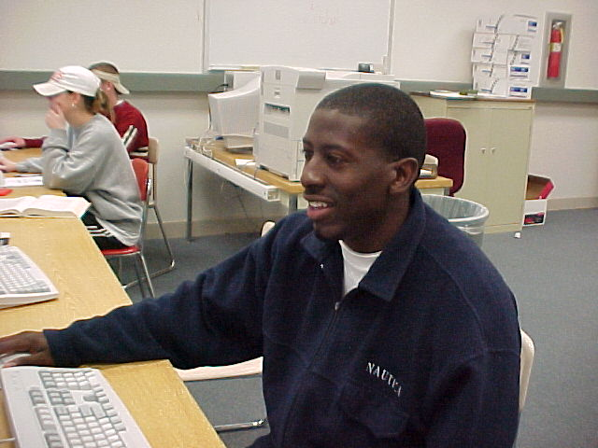
Augustin Dantes hard at work in a School of Engineering computer lab in December 2000
Here is what Augustin has to say about leadership and giving back to the community. "In my involvement with the National Society of Black Engineers (NSBE), I have learned that being a leader is synonymous with being a servant. Being a leader is being a guide, helper, or overseer making sure that tasks get taken care of. In doing so, you must work with reckless abandon for the benefit, pleasure, or well being of others, with disregard to your own condition. If you want to measure how well you lead, reflect on how often the needs of the people around you are met.
Reflecting on my life, I think the most fundamental aspect of having been able to make it this far is the assistance I have received along the way. That realization makes me thankful for all of those who have helped push me to where I am now, and it also brings about a first hand knowledge of how much small things can impact the lives of others. At this point in my life, I don’t have many material resources to call upon to impact those around me. Instead of waiting, however, I can use the one resource I do have to help others. Giving my time and trying to share all I know with others is all that I can do right now to fulfill my duty to society. We were not put here alone, and the whole world benefits when we all work together." Ω

UPDATE:
The EPPS Newsletter V1,N1 Student Spotlight featured Ashlee Smith, a senior biomedical engineering student. I am pleased to announce that Ashlee has accepted a position as an Analyst in the Technical Competency Group at Accenture (formerly known as Andersen Consulting). She will be moving to Atlanta after graduation in May. I'm sure she will represent Mercer well in her new job. Way to go, Ashlee! Ω

For an online version of the Engineering Professional Practices Newsletter, go to http://egrweb.mercer.edu/nova/

Inside This Issue
1 | Student Spotlight
1 | Update
2 | Burtner’s Bits
2  continued on page 2 | Featured Faculty
Featured Faculty
Dr. Marjorie Davis
By Joan Burtner
Assistant Professor, Industrial Engineering
Dr. Marjorie T. Davis, chair of Mercer’s Technical Communication (TCO) Department, has been an integral part of the SoE's assessment process. The Mercer SoE Assessment Task Force (ATF) was created in the summer of 1998; Dr. Davis has chaired the organization from its inception. As chair of the ATF, Dr. Davis was responsible for coordinating seven faculty forums that were delivered to interested faculty during academic year 98-99. Dr. Davis, along with Dr. Aaron Byerley (formerly Associate Dean of the SoE), developed a survey designed to measure seniors' self-reported confidence levels in ABET a-k outcomes. The survey was first administered to EGR 488 students in the spring of 1998. "What startled us is how much the students wanted to tell us. They take the survey seriously." Dr. Davis has coordinated the administration and analysis of the survey each year since it was first offered.
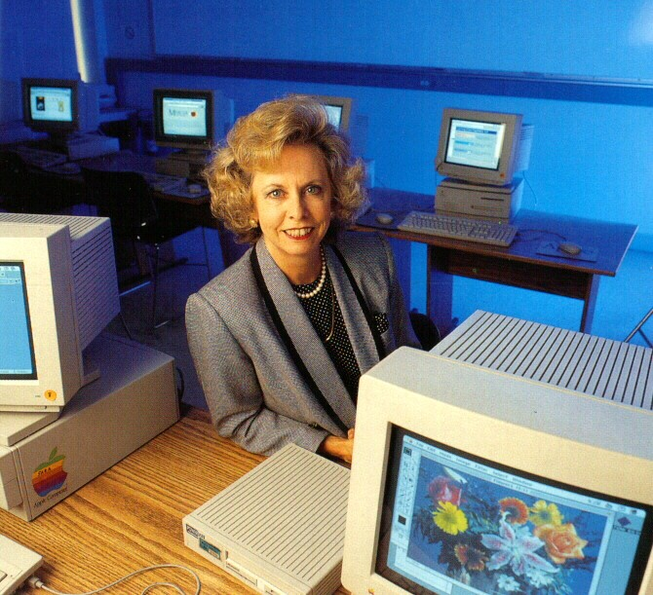
Dr. Marjorie Davis delivering instruction in a SoE computer classroom
Dr. Davis is also active in the professional community outside of Mercer. The Professional Communication Society of IEEE is recommending that technical communication programs seek accreditation through the engineering-related accrediting body of ABET. Dr. Davis has been active on the ad hoc committee to develop the guidelines for program accreditation. Last year she presented a paper on accreditation at the IPCC in Quebec City, Canada.
In an interview in December 2000, I asked Dr. Davis to comment on the comparative value of Mercer's curriculum. "Mercer is a very special place. The focus is on student learning and student success. I believe we are clearly and without doubt the best teaching institution for engineering in the southeast. Our students recognize it and so do their employers. I am pleased and honored to be affiliated with a school of this quality." Ω

Ω

(See Burtner's Bits November 2000 for information about ABET a-k.) Ω

continued from page 1

Burtner’s Bits
What are the MUSE 8?
In the last issue of the EPPS Newsletter, I talked about the eleven learning outcomes associated with ABET's EC 2000 Criterion 3 a-k. As part of our own assessment process, SoE faculty members have developed the following set of eight learning outcomes (the MUSE 8).
- Apply mathematics and science principles to the solution of engineering problems.

- Apply appropriate breadth and depth of skills in identification and analysis of engineering problems.

- Apply appropriate breadth and depth of skills in engineering design and analysis of engineering problems.

- Design and conduct experiments and analyze data.

- Function effectively on interdisciplinary teams.

- Communicate effectively to both specialized and public audiences in a variety of modes.

- Relate the practice of engineering to global contemporary issues, to professional ethics, and to the need for lifelong learning.

- Provide leadership to and contribute to sustaining and improving community.

You may have heard the phrase, "If you don't know where you want to go, how will you know when you get there?" The faculty are using the MUSE 8 as a map of where we want to go. As we continue through our assessment process we will gather evidence to help determine if we are meeting these goals. Ω

During academic year 99-00 a faculty outcome assessment team (FOAT) was developed for each of the MUSE outcomes. The current FOAT assignments are as follows:
1.
2.
3.
4.
5.
6.
7.
8.

For more information about the technical communication department, visit their Web site at http://www.mercer.edu/engineering/UNDERGRAD_PROGRAMS/TCO/tcodefault.htm

