Engineering-Related Professional Practice Skills Newsletter
Volume 1, Issue 1 November 2000
Welcome
Professional Practice Skills Newsletter
By Joan Burtner
Assistant Professor, Industrial Engineering
Students, how many times have you heard your professor talk about the importance of teamwork? What is this ABET a-k thing faculty are talking about? What exactly is Outcome 8? Faculty, how do you measure the ability to function on a multi-disciplinary team? How do you define lifelong learning?
The purpose of this newsletter is to help you answer the questions above by increasing your awareness of happenings around the school related to the assessment of learning outcomes. Each issue will spotlight a student who is making a unique contribution to the welfare of our engineering community. Volume 1, Issue 1 spotlights Ashlee Smith, a senior biomedical engineering student. Each issue will also feature a faculty member who is making significant contributions to the assessment of student learning. Our inaugural issue features Dean Dayne Aldridge.
If you would like to nominate someone for next month’s Student Spotlight or Featured Faculty article, please drop a note in my mailbox or email me Burtner_J@Mercer.edu. Ω
Featured Faculty
Dean Dayne Aldridge
By Joan Burtner
Assistant Professor, Industrial Engineering
In the short time that Dean Aldridge has been at Mercer, he has significantly impacted the way faculty think about student learning outcomes. In the opinion of this writer, Dean Aldridge's extensive experience as an engineering educator as well as his leadership in the field of accreditation of engineering education programs makes him the right man at the right time for the position of dean of our school. But there is no need to just take my word for it…he is recognized by colleagues across the country for his accomplishments in the field of engineering education. He is frequently an invited speaker at national accreditation conferences. (See, for example, The ABET Bulletin Board, June 2000, V2 N1). In recognition of his service to the engineering education profession, he has been named a Fellow of IEEE, ASEE, and ABET. In addition, he is Past Chair of the Engineering Accreditation Commission. Through his guidance, as well as the hard work of students and faculty, our curriculum will reflect the spirit of ABET a-k. (See Burtner's Bits for information about ABET a-k.) Ω

Ω

.

Student Spotlight
Ashlee Smith
By Joan Burtner
Assistant Professor, Industrial Engineering
It is important that engineering students maintain a sense of balance—academic coursework and extracurricular activities are both essential parts of the undergraduate engineering experience. Ashlee Smith represents the best of both worlds; she has an excellent academic record and still finds time to pursue a variety
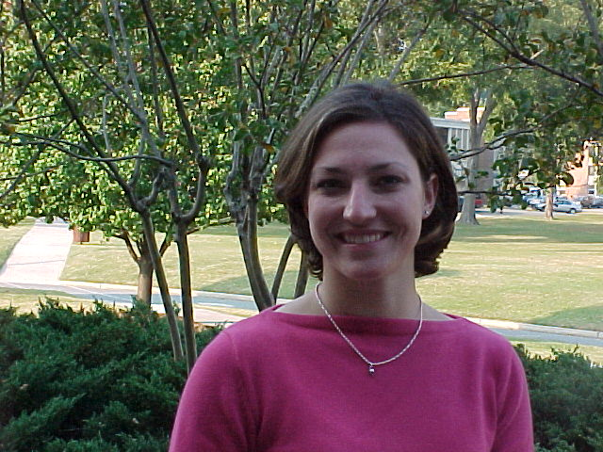
Ashlee Smith poses in front of the Engineering Building in October 2000.
of extracurricular activities. Ashlee is president of Phi Mu sorority and past-president of the Mercer chapter of the Society of Women Engineers. She has been active in intramural sports and has participated in service activities such as Mercer First and Neighborhood Clean-up. Ashlee was instrumental in coordinating the first SWE-Alumni Association Career Forum that was conducted during E-Week 2000. Ashlee has also gained valuable work experience by spending two summers as an intern in the Patient Matched Implants Department at Biomet, Inc. in Warsaw, Indiana. Here is what Ashlee has to say about the benefit of getting involved in a variety of campus activities.
"I have always heard that it was hard to be involved and be an engineer. That is true. There are many days and nights that go by where sleep is on the bottom of my list of things to do that day, but my involvement on campus through numerous activities outside of the engineering school has helped my career as an engineer. I believe that being a leader is something that is not taught in the classroom, but something that is enhanced by involvement outside the classroom. I have also learned valuable time management skills and other skills that have helped me handle many different tasks at once. I believe these values (leadership skills, communications skills, teamwork, time management, etc.) make a college education most beneficial. Being involved and staying busy has helped me keep my motivation and it has enhanced my college experience." Ω

Inside This Issue
1 | Welcome
1 | Student Spotlight
2 | Featured Faculty
2  continued on page 2 | Burtner’s Bits

continued from page 1

Burtner’s Bits
What is ABET a-k?
The Accreditation Board for Engineering and Technology (ABET) is responsible for the specialized accreditation of educational programs in engineering offered in the US. The BSE degree that Mercer offers is ABET-accredited. Recently, ABET adopted new guidelines which are known as ABET Engineering Criteria 2000 (EC2000). EC2000 Criterion 3 focuses on the following eleven (a-k) learning outcomes:
"(a) an ability to apply knowledge of mathematics, science, and engineering; (b) an ability to design and conduct experiments as well as to analyze and interpret data; (c) an ability to design a system, component, or process to meet desired needs; d) an ability to function on multidisciplinary teams; (e) an ability to identify, formulate, and solve engineering problems; (f) an understanding of professional and ethical responsibility; (g) an ability to communicate effectively; (h) the broad education necessary to understand the impact of engineering solutions in a global/societal context; (i) a recognition of the need for and an ability to engage in lifelong learning; (j) a knowledge of contemporary issues; and (k) an ability to use the techniques, skills, and modern engineering tools necessary for engineering practice ." (American Society for Engineering Education, 1998, p.14) Ω
Reference: American Society for Engineering Education. (1998). How do you measure success? Designing effective processes for assessing engineering education. Washington, DC: Author.

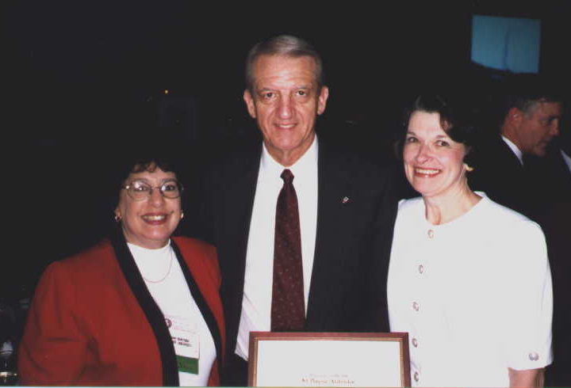
Dean Dayne Aldridge is named ASEE Fellow at the ASEE Annual Conference in Charlotte in June 1999. Also attending the award ceremony are (L) Joan Burtner and (R) Nancy Aldridge.
For more information about ABET, visit their Web site at http://www.abet.org/abet_brochure.htm

