Conducting a One Way ANOVA in Minitab 15
- Enter data in the worksheet. Be sure to include labels in the row directly below C1 C2, etc. Begin the data values in row 1.
- Go to the pull-down menu. Select Stat/ANOVA/One-way (Unstacked)
- Specify responses in the appropriate box.
- Select Comparisons. Choose Tukey.
- Select Graphs. Choose 3-in-1.
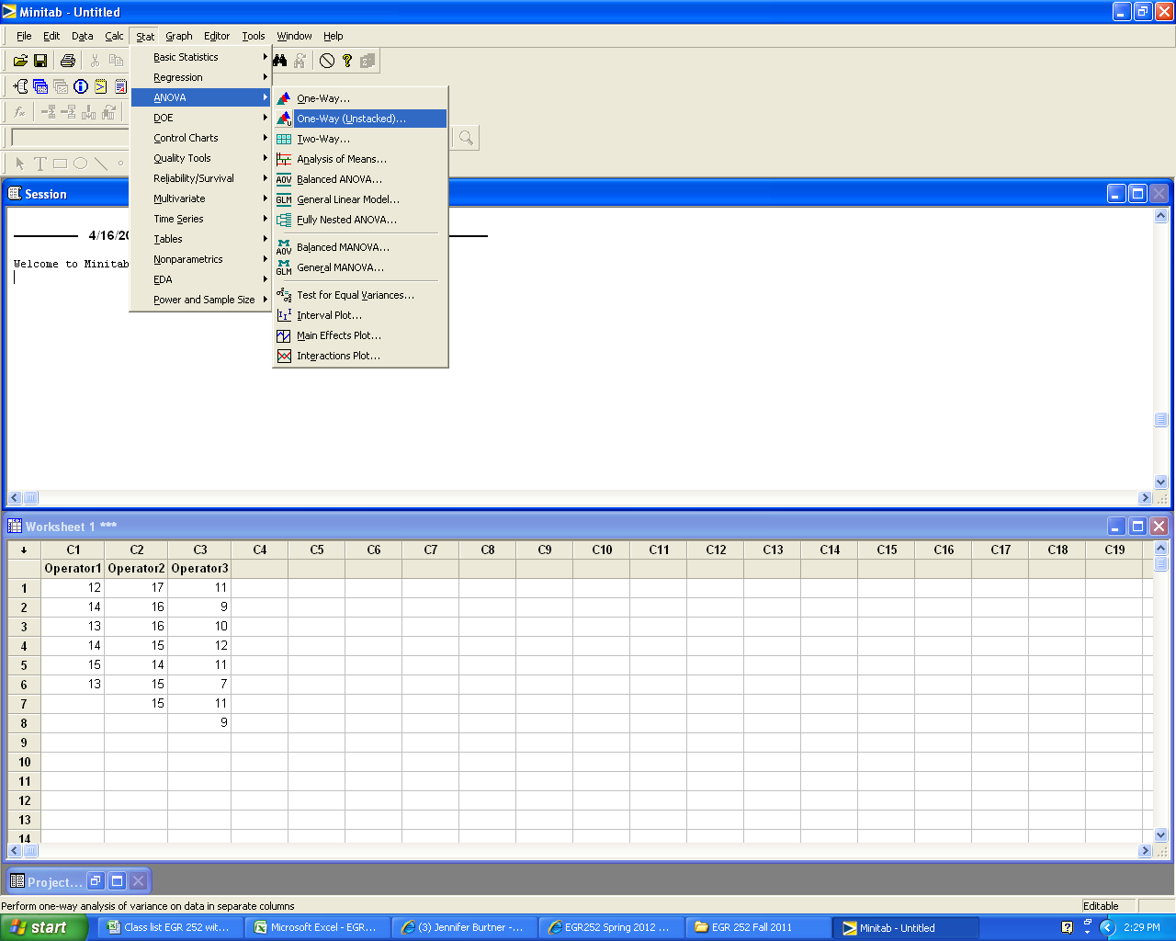

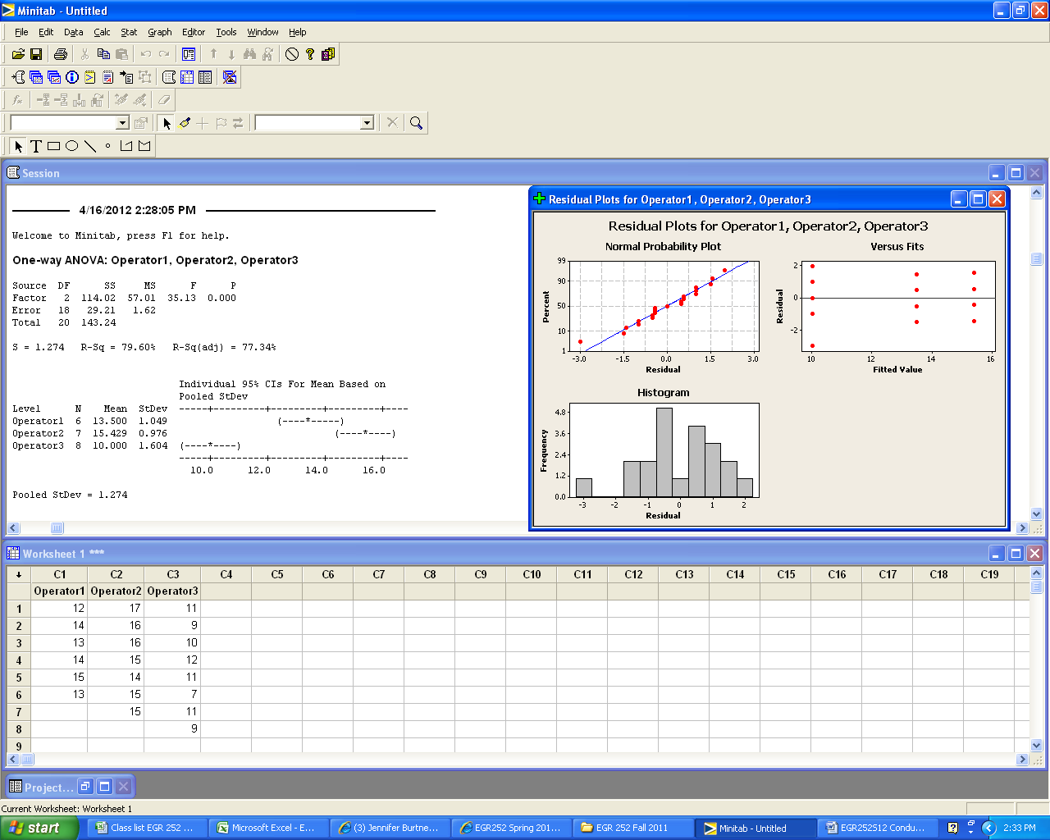
A review of the Residual Plots indicates that there are no serious violations of model assumptions. (The residuals are somewhat normally distributed.)
Tukey Results
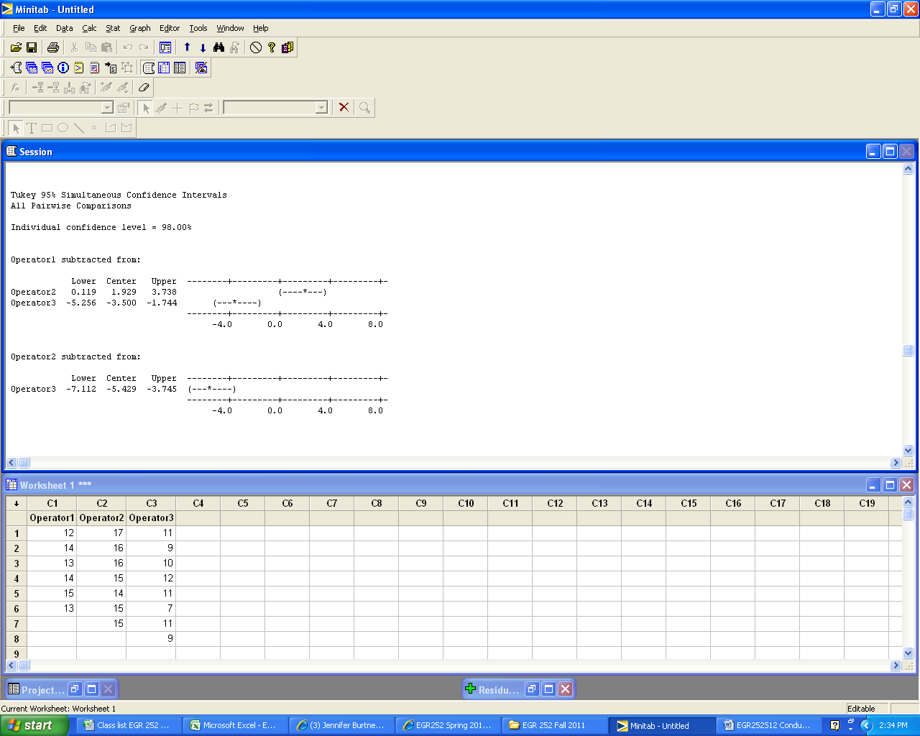

The Tukey confidence interval for Operator2-Operator1 is (0.119, 3.738). Both of these values are positive. Thus we conclude that the difference between the mean times for Operator1 and Operator2 are statistically significant. The average time for Opeator2 is greater than for Operator1.

