Hypothesis Test Template: Single Factor Design
Solution Based on Lecture Problem
NAME Dr. Burtner

Problem Statement
A sample of 20 cars driven under varying highway conditions achieved fuel efficiencies as follows:
Sample mean x = 34.271 mpg
Sample std dev s = 2.915 mpg
Test the hypothesis that the population mean equals 35.0 mpg vs. μ < 35.

Critical values for determining correct test statistic for a single factor design:
Number of samples (One, two, three or more) One sample.
Is the population standard deviation known for all samples? Yes No
Number of data points in each sample (Specify) There is one sample of size n=20.

Is there a predetermined significance level (alpha)? Yes No

Design: This is a one sample t-test design.________________________________

Data Input:
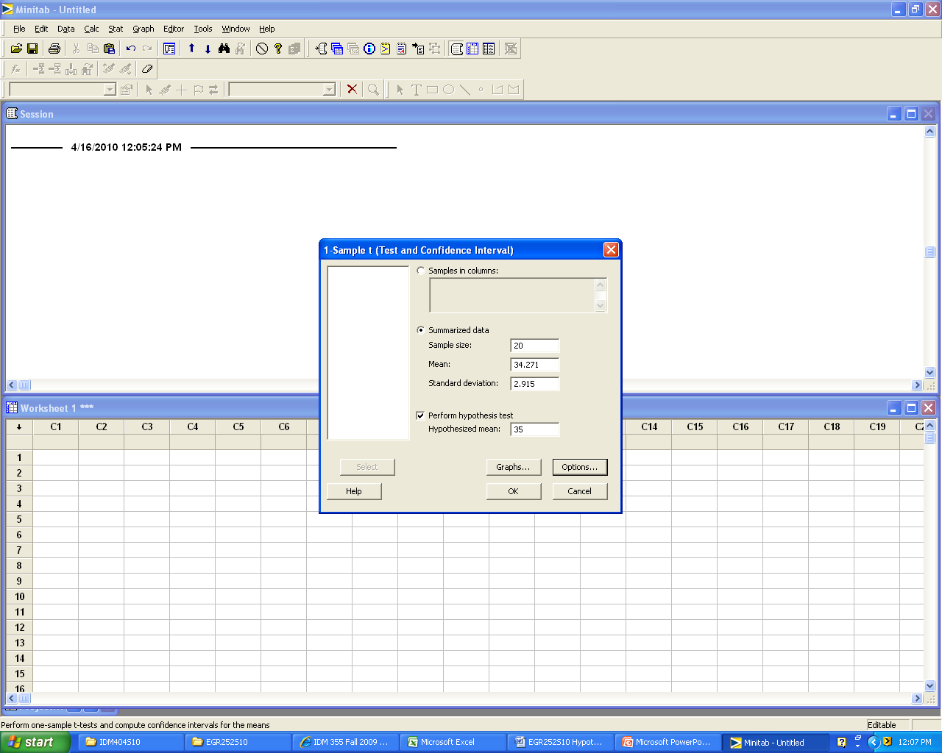

Hypotheses:
H₀: μ = 35
H₁: μ < 35

Calculation of test statistic and p-value: (Hand or Computer Output)
One-Sample T

Test of mu = 35 vs < 35

95% Upper
N Mean StDev SE Mean Bound T P
20 34.271 2.915 0.652 35.398 -1.12 0.139

Graphics: (Choose applicable graphic drawn by hand or computer)
0 0.05 1 (p-value)

Decision: Fail to reject_________H₀

Conclusion: Use complete sentences. (Refer to problem statement and managerial decision based on p-values)
Based on the sample data, we conclude that the mean mileage for the cars driven under varying highway conditions is not less than 35 mpg.

