EGR 252 Minitab Tutorial ANOVA 1

Problem: A manufacturing engineer collected the following data on assembly times
for three different operators (O1, O2, and O3) working on a given production line. Assembly time was recorded to the nearest second. Do the data indicate that the mean assembly time differs for the three operators?

O1 | O2 | O3
12 | 17 | 11
14 | 16 | 9
13 | 16 | 10
14 | 15 | 12
15 | 14 | 11
13 | 15 | 7
 | 15 | 11
 |  | 9
Figure 1. Assembly Data

1. Enter the data into a Minitab worksheet. Be sure to place column labels in the gray cells below the C1 C2 C3 cells. Select ANOVA / One-Way (Unstacked)…from the pull-down menu. See Figure 2.

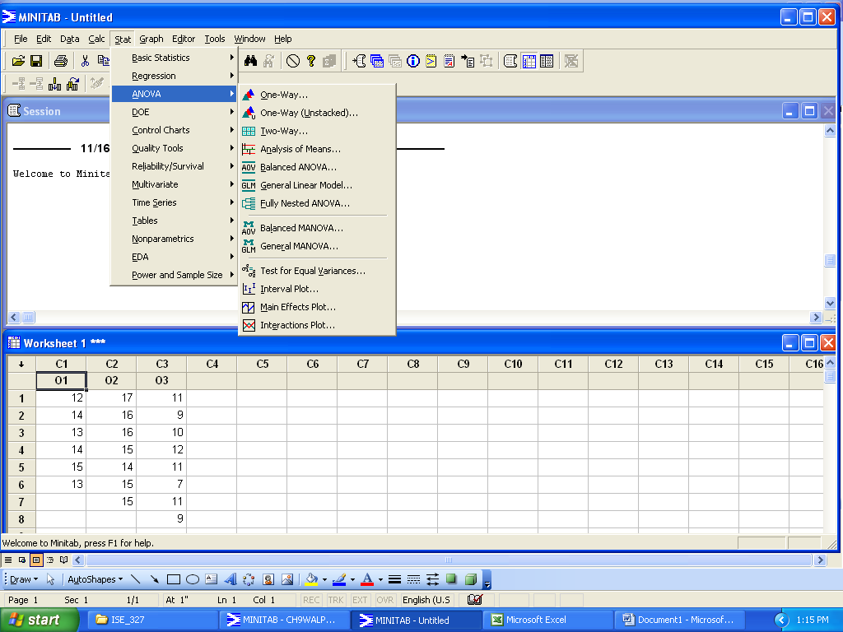
Figure 2. Minitab ANOVA Pull-down Menu
2. Specify that the data appear in separate columns. Enter the names of the columns that contain the data in the Responses dialog box. See Figure 3.

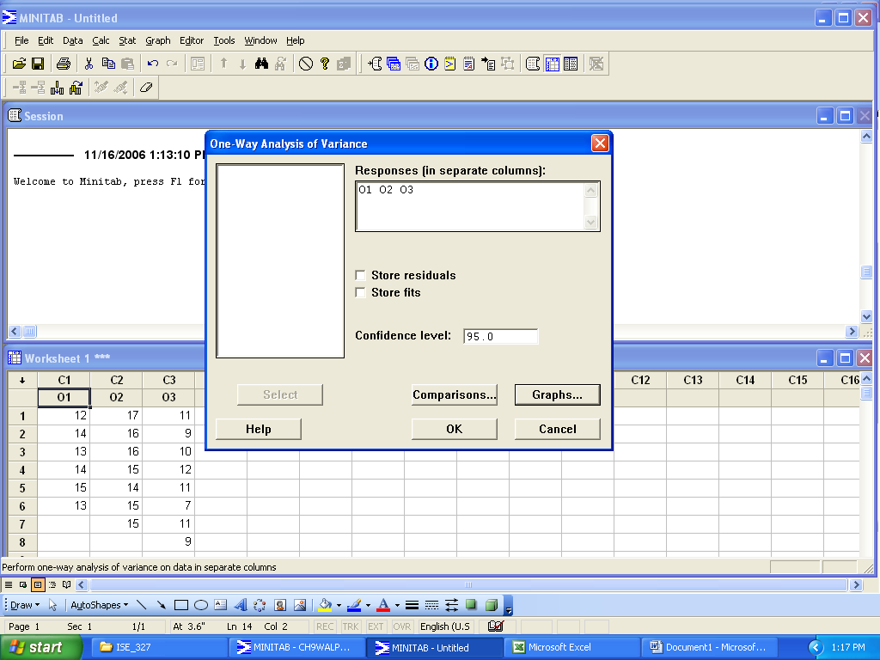
Figure 3. Minitab Responses Dialog Box
3. Select Graphs… / Three in one / OK
Select OK at the next dialog box.
Your output should look something like this:
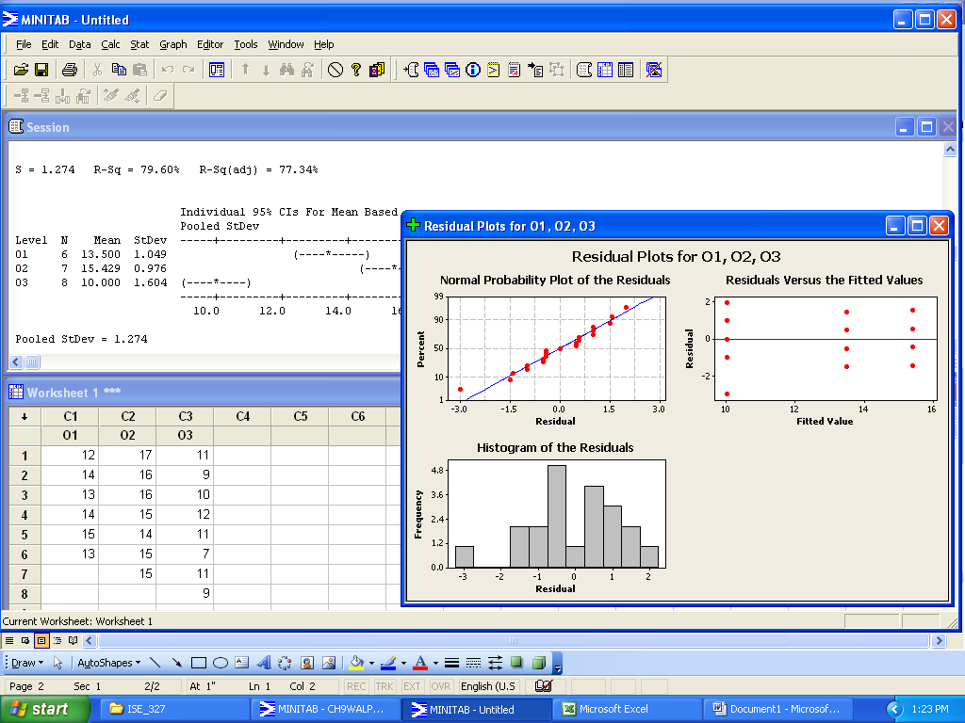
Figure 4. Minitab Residual Plots for a One-Way ANOVA

Note that you can copy the residual plots and paste them into a Word file. The plots will be pictures in Word. You can change the size and placement, but you cannot edit the content.

You can also copy and paste data from the worksheet window. The data will be in table format when you paste it in Word. By default the table will not have grid lines, but Word will recognize the pasted material as a table. You can select the data you pasted and format it to look like a table with gridlines, borders, etc.

Finally, you can copy and paste the content of the session window into a Word file. However, some of the formatting will be lost.

4. Select Comparisons… / Tukey’s if you need to conduct a post-hoc analysis of differences between the groups.

5. For EGR 252 Homework: Annotate the Minitab computer printout with hypotheses, graphics, decisions and conclusions.

