Chi-Square Goodness-of-Fit Test using Minitab 15

Problem: You are running a process that typically produces 100 red, 200 blue, 200 green and 200 yellow candies for every batch of 700 candies. During a routine quality check, you take a random sample of 70 candies from the batch. The sample counts for red, blue, green and yellow candies are 12, 22, 14, and 22 respectively. Is there reason to believe the proportions have changed significantly?

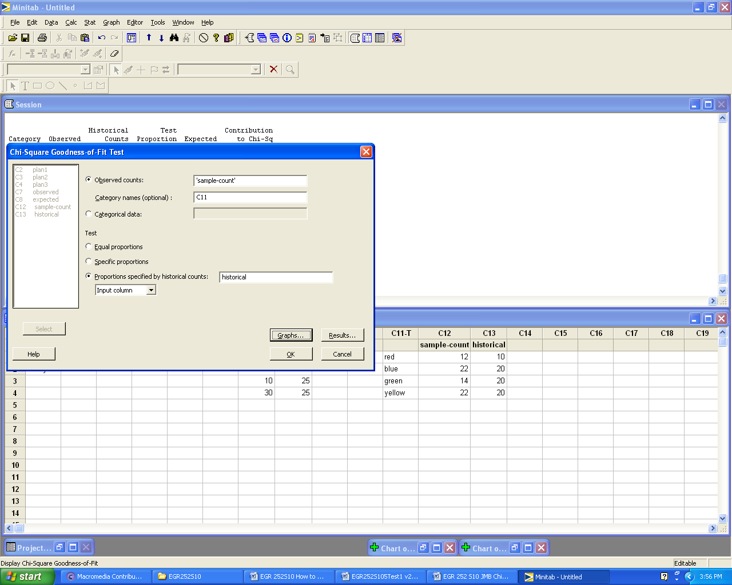

Chi-Square Goodness-of-Fit Test for Observed Counts in Variable: sample-count

Using category names in C11

Historical Test Contribution
Category Observed Counts Proportion Expected to Chi-Sq
red 12 10 0.142857 10 0.4
blue 22 20 0.285714 20 0.2
green 14 20 0.285714 20 1.8
yellow 22 20 0.285714 20 0.2

N DF Chi-Sq P-Value
70 3 2.6 0.457

Chi-Square Goodness-of-Fit Test using Minitab 15 (continued)

Chart of Observed and Expected Values

Chart of Contribution to the Chi-Square Value by Category

Note: Assumption: Expected values at least 5 for each cell

H0: The population proportions for the categories fit historical proportions.
H1: The population proportions for the categories are significantly different from historical proportions.
Decision: Fail to reject H0
Conclusion: Since the p-value is not less than our assumed significance level of 0.05, we conclude the proportions are not significantly different from the historical proportions in the population.
Chi-Square Test using Minitab 15
Chi-Squared Test for Independence (Walpole)

Problem: Use the survey results in the table below to test the hypothesis that Pay Status and Plan are independent. Use alpha = 0.05.
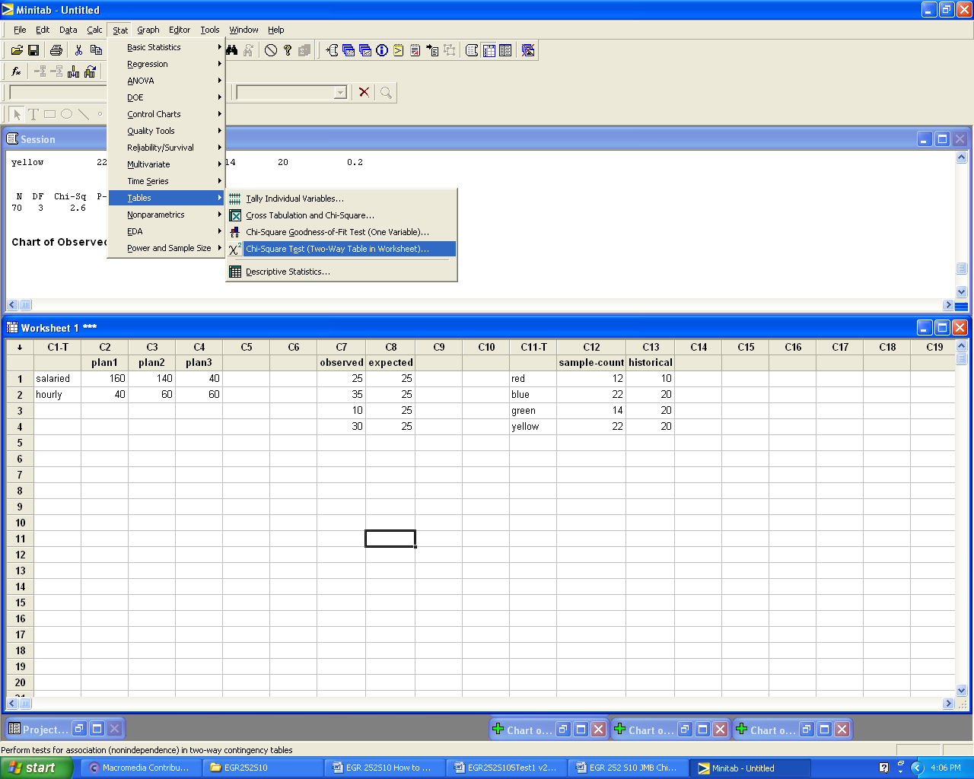

Minitab Input (black text)
Pay Status | plan1 | plan2 | plan3
salaried | 160 | 140 | 40
hourly | 40 | 60 | 60

Minitab Output
Chi-Square Test: plan1, plan2, plan3
Expected counts are printed below observed counts
Chi-Square contributions are printed below expected counts
plan1 plan2 plan3 Total
1 160 140 40 340
136.00 136.00 68.00
4.235 0.118 11.529
2 40 60 60 160
64.00 64.00 32.00
9.000 0.250 24.500
Total 200 200 100 500
Chi-Sq = 49.632, DF = 2, P-Value = 0.000

H0: Pay Status and Plan are independent
H1: Pay Status and Plan are not independent
Decision: Reject H0
Conclusion: Since the p-value is less than our significance level of 0.05, we conclude Pay Status and Plan are not independent.

Chi-Square Test using Minitab 15
Chi-Squared Test for Homogeneity
(Problem Statement Ch 10 Walpole)

Data for Minitab

Dem Rep Ind
82 70 62
93 62 67
25 18 21

Output from Minitab

Chi-Square Test: Dem, Rep, Ind

Expected counts are printed below observed counts
Chi-Square contributions are printed below expected counts

Dem Rep Ind Total
1 82 70 62 214
85.60 64.20 64.20
0.151 0.524 0.075

2 93 62 67 222
88.80 66.60 66.60
0.199 0.318 0.002

3 25 18 21 64
25.60 19.20 19.20
0.014 0.075 0.169

Total 200 150 150 500

Chi-Sq = 1.527, DF = 4, P-Value = 0.822

Note that Minitab 15 does not use row titles. You will need to annotate your output by specifying the categories for rows 1, 2, and 3 as shown in the course textbook.

See Walpole for HO H1 Decision and Conclusion

