Dr. Joan Burtner 2015 Hypothesis Testing Examples ~Part 2

Review of Excel
Statistical Functions
Data Analysis
Graphing

Orientation to Minitab
Worksheet
Session Window
Help Function including Data, Output and Interpretation

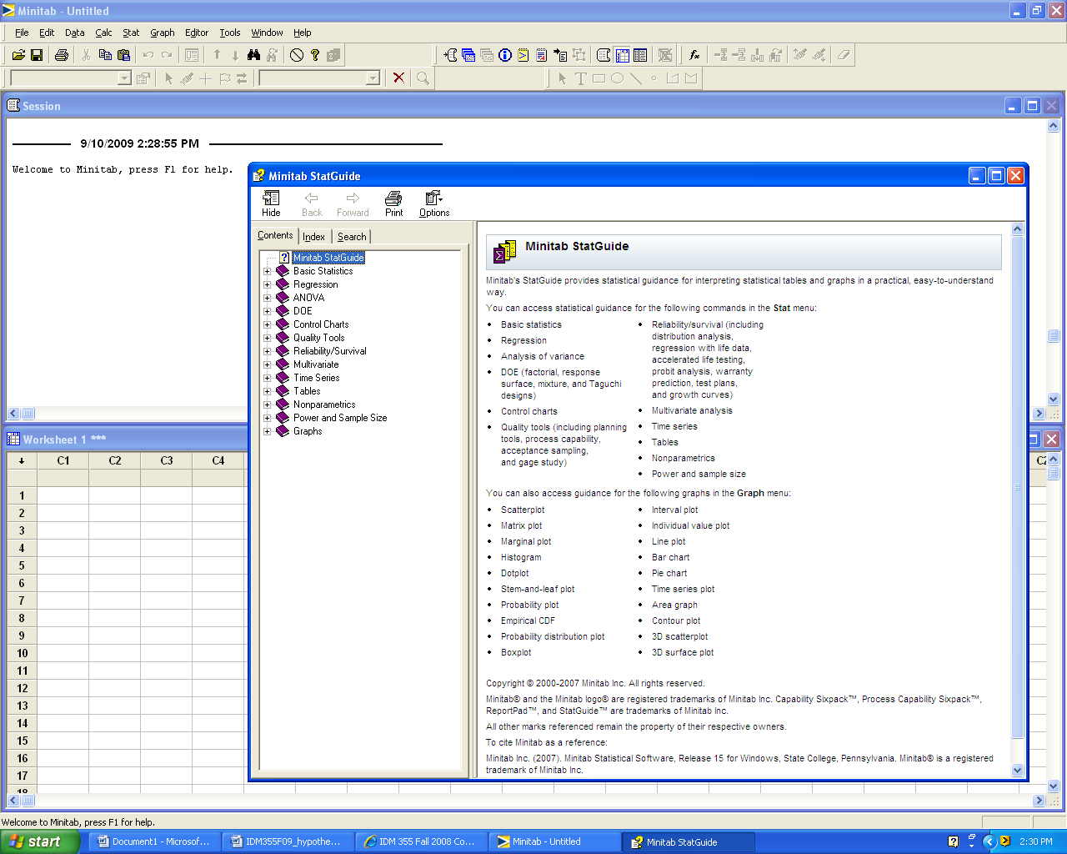

Experimental Designs

Single factor three-or-more sample hypothesis test (One-way ANOVA)

Two factor multiple sample hypothesis test (Two-way ANOVA)
Single Factor Hypothesis Testing Template with Definitions

Problem Statement:

Response: (What is being measured?) ___________________________

Factor and Levels (What are the groups or categories that are being compared?)

Hypotheses:
H₀:
H₁:

Justification of correct experimental design and test statistic:

Computer Output (Include calculated test statistic, p-value and ANOVA Table if applicable)

Graphic: (Place an arrow at the approximate location of the p-value.)

0 0.05 0.10 0.15 1 (p-value)

Decision: ________________H₀

Conclusion: Use complete sentences. (Refer to problem statement and managerial decision based on p-values)
______________________________________________________________________________________________________________________________________________________________________________________________________________________________________________________________________________________________________________________________________________________________________________________________________

Dr. Burtner Fall2015 Single Factor ANOVA Hypothesis Testing Example

Problem Statement:
A quality researcher is interested in comparing the sodium content (measured in milligrams) of three brands of corn flakes. All three brands are produced at a cereal plant in Georgia. The researcher collects the following data. Does this data suggest that brands differ in terms of average sodium content? Assume the distribution of sodium contents to be normal.

SimplyFlakes
244
245
246
246
241
241
245
244
BettyFlakes
240
241
246
242
241
241
242
241
KellyFlakes
246
243
245
245
243
242
247
243

Response: (What is being measured?) sodium mg

Factor and Levels (What are the groups or categories that are being compared?)
Factor: Cereal Brand Levels: SimplyFlakes, BettyFlakes, KellyFlakes

Hypotheses:
H₀: μ _{Simply} = μ _{Betty} = μ _{Kelly}
H₁: At least two of the mean sodium contents differ.
or
H₀: μ _{Simply} = μ _{Betty} = μ _{Kelly}
H₁: Not all of the mean sodium contents are the same.

Justification of correct experimental design and test statistic:
One factor, three levels, normally-distributed data: Use F statistic

Computer Output (Include calculated test statistic, p-value and ANOVA Table if applicable)

One-way ANOVA: SimplyFlakes, BettyFlakes, KellyFlakes

Source DF SS MS F P
Factor 2 30.33 15.17 4.36 0.026
Error 21 73.00 3.48
Total 23 103.33

Individual 95% CIs For Mean Based on
Pooled StDev
Level N Mean StDev -------+---------+---------+---------+--
SimplyFlakes 8 244.00 2.00 (--------*--------)
BettyFlakes 8 241.75 1.83 (--------*--------)
KellyFlakes 8 244.25 1.75 (--------*--------)
-------+---------+---------+---------+--
241.5 243.0 244.5 246.0

Pooled StDev = 1.86

Tukey 95% Simultaneous Confidence Intervals
All Pairwise Comparisons

Individual confidence level = 98.00%

SimplyFlakes subtracted from:

Lower Center Upper ---------+---------+---------+---------+
BettyFlakes -4.597 -2.250 0.097 (--------*--------)
KellyFlakes -2.097 0.250 2.597 (--------*--------)
---------+---------+---------+---------+
-2.5 0.0 2.5 5.0

BettyFlakes subtracted from:

Lower Center Upper ---------+---------+---------+---------+
KellyFlakes 0.153 2.500 4.847 (--------*--------)
---------+---------+---------+---------+
-2.5 0.0 2.5 5.0

Graphic:

0 0.05 0.10 0.15 1 p-value

Decision: Reject H₀

Conclusion:
Based on a p-value = 0.026, the data suggest that there is a statistically significant difference in the mean sodium content of at least two of the three brands.
or
Based on a p-value = 0.026, the data suggest that the mean sodium content of the three brands are not all the same.

Based on the Tukey 95% Simultaneous Confidence Intervals, we conclude that the mean sodium content of SimplyFlakes is not significantly different from the mean sodium content of BettyFlakes and that the mean sodium content of SimplyFlakes is not significantly different from the mean sodium content of KellyFlakes.

However, the data suggest that the mean sodium content of BettyFlakes and KellyFlakes are significantly different. KellyFlakes have significantly higher mean sodium content than BettyFlakes.

****
*******************

Two Factor Hypothesis Testing Template

Problem Statement:

Response: (What is being measured?)

Experimental Design: (2X2, 2X3, 3X3, etc) ___________

Factors and levels:

Factor 1:________________________

Levels ________________________ ________________________ ________________________

Factor 2:________________________

Levels ________________________ ________________________ ________________________

Hypotheses:

Factor 1:________________________

H0 ______________________________

H1 ______________________________

Factor 2:________________________

H0 ______________________________

H1 ______________________________

Interaction between ________________________ and ____________________

H0 ______________________________

H1 ______________________________

Minitab or Excel Input (correctly formatted data)
(Copy and Paste from Worksheet using Courier New 10 point font)

Minitab or Excel Output (ANOVA Table, Tukey confidence intervals, etc)
(Copy and Paste from Worksheet using Courier New 10 point font)

Interpretation of Results

Factor 1 ______________________

p-value

Decision: _________________________

Conclusion: _________________________________________________________________________________________________________________________________________________________________________________________________________________________________

Factor 2 ______________________

p-value

Decision: _________________________

Conclusion: _________________________________________________________________________________________________________________________________________________________________________________________________________________________________

Interaction between ______________________

p-value

Decision: _________________________

Conclusion: _________________________________________________________________________________________________________________________________________________________________________________________________________________________________

Dr. Burtner Fall2015 Two Factor Hypothesis Testing Example

Problem Statement:
A quality researcher is interested in comparing the sodium content (measured in milligrams) of three brands of corn flakes produced at a cereal plant in Georgia. The researcher suspects that the sodium content differs as a function of shift (day vs. night) as well as brand. Do the data suggest that brands and/or shifts have a significant effect on average sodium content? Assume the data are normally distributed.

Response: (What is being measured?) sodium mg

Experimental Design: (2X2, 2X3, 3X3, etc) 3X2

Factors and levels:

Factor 1: Brand
Levels: Kelly Flakes Betty Flakes Simply Flakes

Factor 2: Shift
Levels: Day Night

Hypotheses:

Factor 1: Brand

H₀: μ _{Simply} = μ _{Betty} = μ _{Kelly}
H₁: At least two of the means differ.

Factor 2: Shift

H₀: μ _{Day} = μ _{Night}
H₁: μ _{Day} ≠ μ _{Night}

Interaction between Brand and Shift:

H₀: There is no significant interaction between brand and shift.
H₁: There is significant interaction between brand and shift.

Minitab or Excel Input
(Copy and Paste from Worksheet using Courier New 12 point font)

Sodium_mg | Brand | Shift
244 | Simply | Day
245 | Simply | Day
246 | Simply | Day
246 | Simply | Day
241 | Simply | Night
241 | Simply | Night
245 | Simply | Night
244 | Simply | Night
240 | Betty | Day
241 | Betty | Day
246 | Betty | Day
242 | Betty | Day
241 | Betty | Night
241 | Betty | Night
242 | Betty | Night
241 | Betty | Night
246 | Kelly | Day
243 | Kelly | Day
245 | Kelly | Day
245 | Kelly | Day
243 | Kelly | Night
242 | Kelly | Night
247 | Kelly | Night
243 | Kelly | Night

Minitab or Excel Output
(Copy and Paste from Worksheet using Courier New 12 point font)

Two-way ANOVA: Sodium_mg versus Brand, Shift

Source DF SS MS F P
Brand 2 30.333 15.1667 4.83 0.021
Shift 1 13.500 13.5000 4.30 0.053
Interaction 2 3.000 1.5000 0.48 0.628
Error 18 56.500 3.1389
Total 23 103.333

Interpretation of Results

Factor 1 Brand

p-value 0.021

Decision: Reject the null hypothesis

Conclusion:
Based on a p-value = 0.021, the data suggest that there is a statistically significant difference in the mean sodium content of at least two of the three brands. A Tukey analysis should be conducted to determine which pairs of means are statistically different.

Factor 2 Shift

p-value 0.053

Decision: Fail to reject the null hypothesis

Conclusion:
Based on a p-value = 0.053, the data suggest that there is no statistically significant difference in the mean sodium content based on shift.

Interaction between Brand and Shift

p-value 0.628

Decision: Fail to reject the null hypothesis

Conclusion:
Based on a p-value = 0.628, we conclude that there is no statistically significant interaction between brand and shift.

