Introduction to Hypothesis Testing Using Minitab and Excel Fall 2015 ~Part 1

Review of Excel
Statistical Functions
Data Analysis
Graphing

Orientation to Minitab 16
Worksheet
Session Window

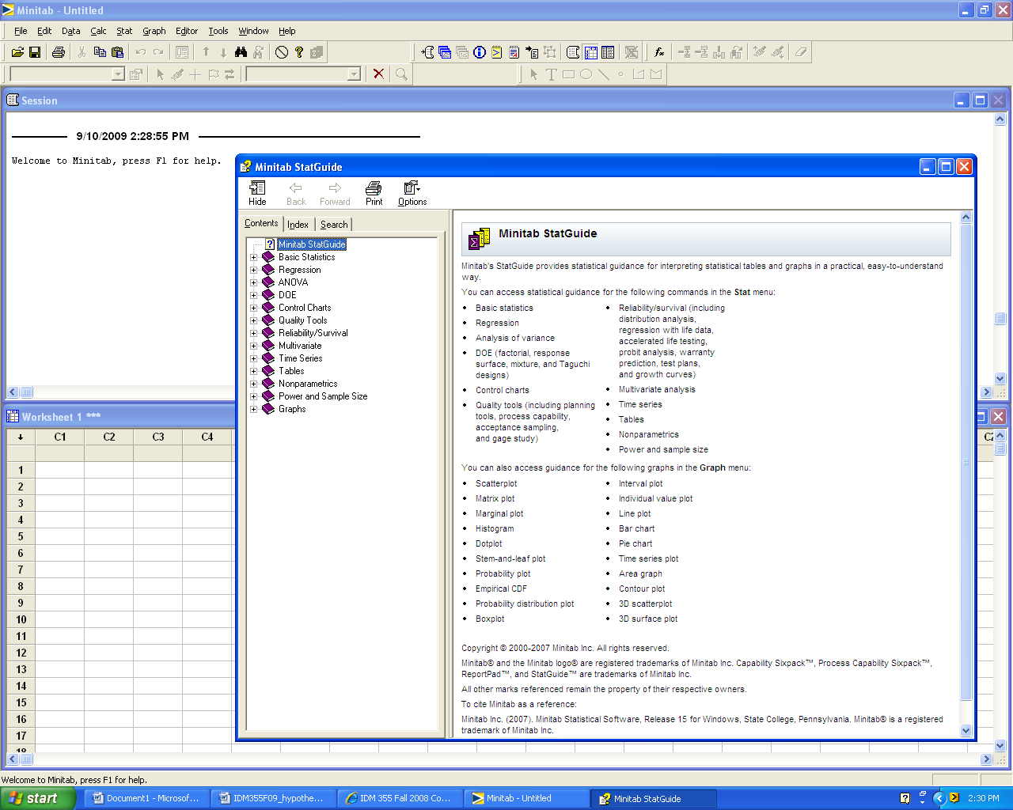

Experimental Designs

Single sample hypothesis test

Two sample hypothesis test

Paired sample hypothesis test

Multiple sample hypothesis test (One-way ANOVA)

Multiple sample hypothesis test (Two-way ANOVA)
Hypothesis Testing
Single Factor Template with Definitions

Problem Statement:

Factor Levels (What are the groups or categories that are being compared?)

Response: (What is being measured?)

Hypotheses:
H₀:
H₁:

Critical values for determining correct test statistic:

Calculation of test statistic and p-value: (Computer Output)

Graphics: (Place an arrow at the approximate location of the p-value.)

0 0.05 1 (p-value)

Decision: _________H₀

Conclusion: Use complete sentences. (Refer to problem statement and managerial decision based on p-values)
Single sample hypothesis test If a random sample of 20 servings of ready-to-eat cereal has a mean sodium content of 244 milligrams and a standard deviation of 24.5 milligrams, does this data suggest that the average sodium content is greater than 220 milligrams? Assume the distribution of sodium contents to be normal.

Factor Level(s) (What are the groups or categories?)
Cereal (single factor)

Response: (What is being measured?)
Sodium content (mg)

Hypotheses:
H₀: μ = 220
H₁: μ > 220

Critical values for determining correct test statistic (t, z, F, etc.):
*small sample *sigma unknown *one-sided alternate hypothesis *p-value approach ---Therefore, use t.

Calculation of test statistic and p-value:

We can calculate t using an equation:
$$n = \text{20} σ \text{unknown} ⇒\text{Use} t t_{\text{calc}}=\frac{ \overline{X}−μ}{s\sqrt{n}} t_{\text{calc}}=\frac{\overset{}{ \text{244}− \text{220} }}{\text{24}\text{.}5\sqrt{\text{20}}} t_{\text{calc}}= 4\text{.}\text{38}$$

The p-value associated with t_{calc} = 4.38 is very small. How do we find the exact p-value?

Method 1: We can use an Excel function. Note that Excel uses positive values for t and tells us the area to the right of the calculated value of t. For a one-sided hypothesis using a t-calc value of 4.38 with 19 degrees of freedom, the tdist function yields the following result.

0.000161 | =TDIST(4.38,19,1)
Therefore the p-value is 0.00016

Method 2: We can use the Minitab pull-down menu: Stat/Basic Statistcis/1-Sample t

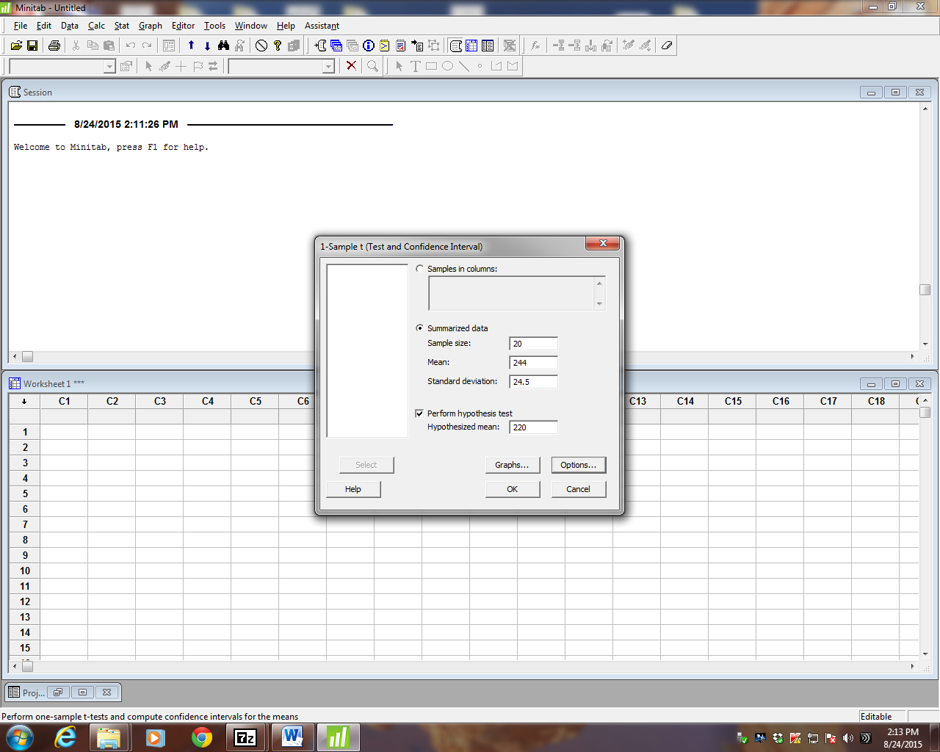

Minitab 16 Computer Output:

Test of mu = 220 vs > 220

N Mean StDev SE Mean 95% Lower Bound T P
20 244.000 24.500 5.478 234.527 4.38 0.000

Graphics:
**OR**
0 0.05 0.25 0.50 1 p-value
Note that the p-value is very close to zero. Therefore, it is highly unlikely that H₀ is true.

Decision: Reject H₀

Conclusion: With a p-value = 0.00016, the data suggest that the population mean sodium content is greater than 220 milligrams.

****Note that there is no built-in function for a one-sample t-test in Excel.****

Two sample hypothesis test (summarized data) A random sample of 9 servings of Crowger Corn Flakes has a mean sodium content of 243.89 milligrams and a standard deviation of 2.47 milligrams, A random sample of 9 servings of Publicks Corn Flakes has a mean sodium content of 247.11 milligrams and a standard deviation of 5.35 milligrams. Does this data suggest that two brands differ in terms of average sodium content? Assume the distribution of sodium contents to be normal.

Factor Level(s) (What are the groups or categories?)
Cereal Brand: Crowger or Publicks

Response: (What is being measured?)
Sodium content (mg)

Hypotheses:
H₀: μ _{Crowger} = μ _{Publicks}
H₁: μ _{Crowger} ≠ μ _{Publicks}

Critical values for determining correct test statistic:
*small sample *sigma unknown *two-sided alternate hypothesis
*p-value approach Therefore, there is no value for t critical.

Calculation of test statistic and p-value:

Method 1: We can use the Minitab pull-down menu: Stat/Basic Statistcis/2-Sample t and choose the summarized data option.

Two-Sample T-Test and CI: CFlakes, PFlakes

Two-sample T for CFlakes vs PFlakes

N Mean StDev SE Mean
CFlakes 9 243.89 2.47 0.82
PFlakes 9 247.11 5.35 1.8

Difference = mu (CFlakes) - mu (PFlakes)
Estimate for difference: -3.22222
95% CI for difference: (-7.54537, 1.10092)
T-Test of difference = 0 (vs not =): T-Value = -1.64 P-Value = 0.129 DF = 11

Graphics:

p = 0.129

0 0.05 0.10 1 p-value

Decision: Fail to reject H₀

Conclusion: With a p-value = 0.129, the data suggest that there is no statistically significant difference in the mean sodium content of the two brands.

Two sample hypothesis test (raw data) A quality researcher is interested in comparing the sodium content of two brands of corn flakes. She collects the following data. Does this data suggest that two brands differ in terms of average sodium content? Assume the distribution of sodium contents to be normal.

CFlakes PFlakes
244 254
245 256
246 245
248 244
241 242
241 243
245 243
244 245
241 252

Hypotheses:
H₀: μ _{Crowger} = μ _{Publicks}
H₁: μ _{Crowger} ≠ μ _{Publicks}

Critical values: *small sample *sigma unknown *two-sided alternate hypothesis
*p-value approach ~Therefore, there is no value for t critical.

Calculation of test statistic and p-value:

Method 1: We can use the Minitab pull-down menu: Stat/Basic Statistcis/2-Sample t

Two-Sample T-Test and CI: CFlakes, PFlakes

Two-sample T for CFlakes vs PFlakes

N Mean StDev SE Mean
CFlakes 9 243.89 2.47 0.82
PFlakes 9 247.11 5.35 1.8

Difference = mu (CFlakes) - mu (PFlakes)
Estimate for difference: -3.22222
95% CI for difference: (-7.54537, 1.10092)
T-Test of difference = 0 (vs not =): T-Value = -1.64 P-Value = 0.129 DF = 11

Graphics:

0 0.05 0.10 1 (p-value)

Decision: Fail to reject H₀

Conclusion: With a p-value = 0.129, the data suggest that there is no statistically significant difference in the mean sodium content of the two brands.
Method 2: We can use the Data Analysis function in Excel. Be sure to use the unequal variances option unless you are told the variances are “equal”.

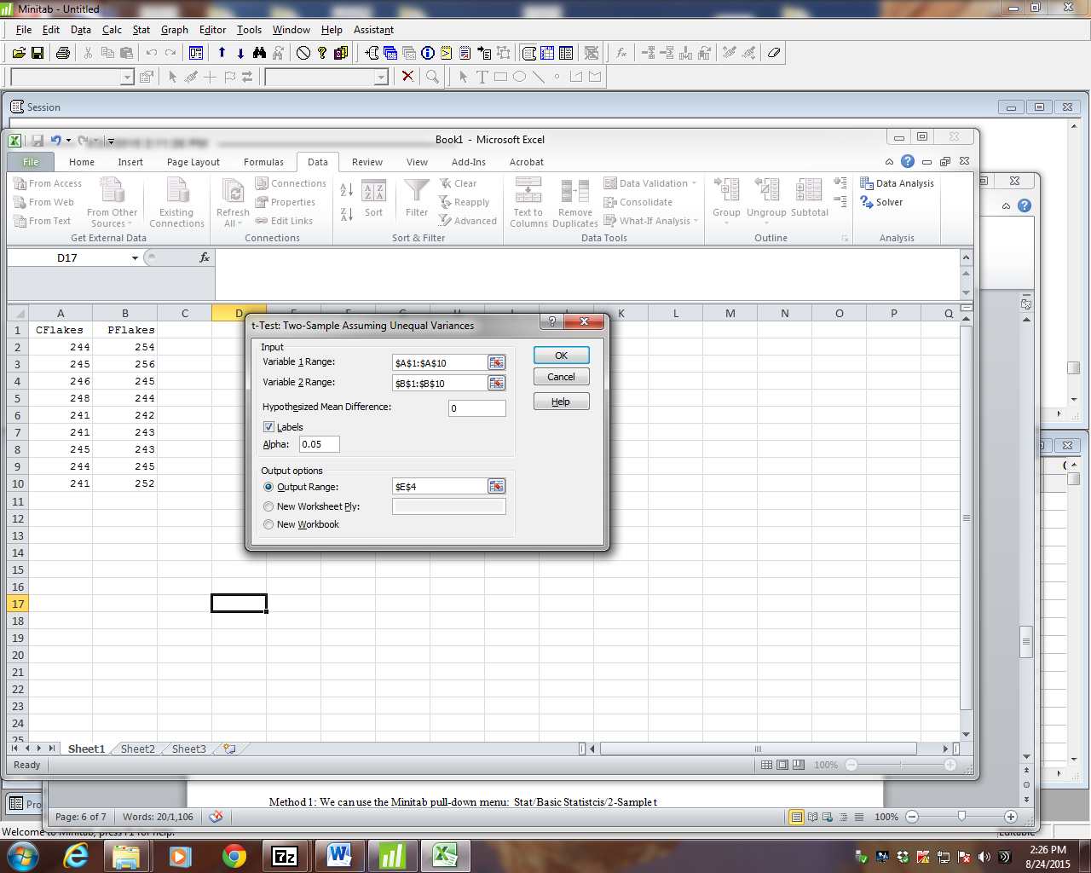

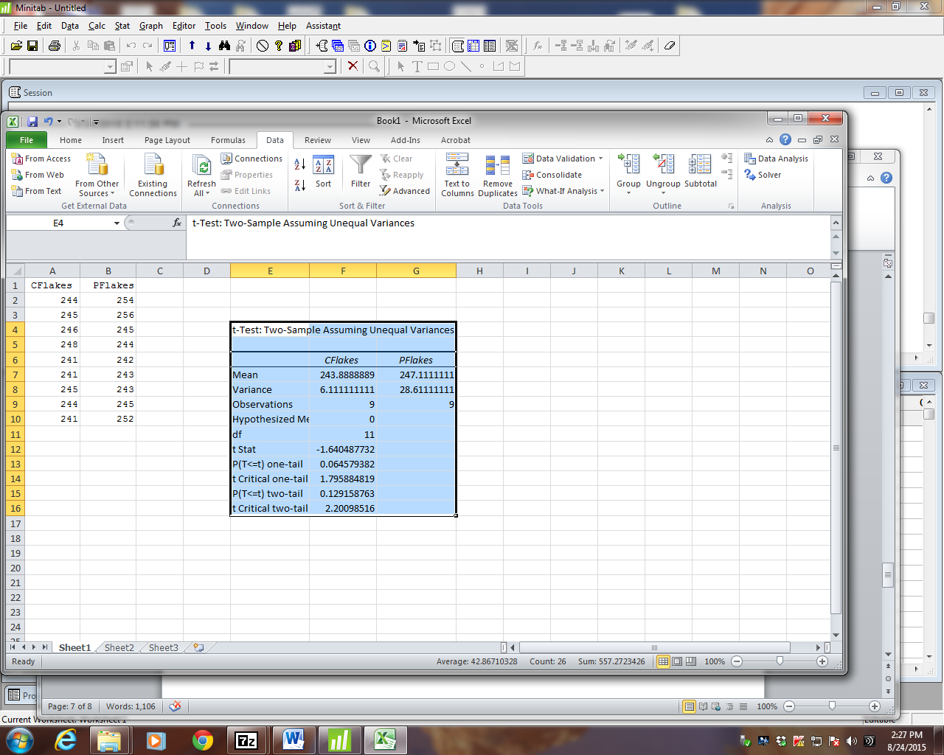

Note that Excel does not ask for the alternate hypothesis. The output includes results for both the one-tail and the two-tail alternate hypotheses. You must choose the correct p-value when completing the hypothesis testing template.
Paired sample hypothesis test
A quality researcher is interested in comparing the sodium content of two brands of corn flakes. Both brands are produced at a cereal plant in Making, Georgia. The researcher collects the following data. The samples are collected in 15-minute intervals beginning at 8:00 am. Does this data suggest that two brands differ in terms of average sodium content? Assume the distribution of sodium contents to be normal.

Time CrFlakes WaFlakes
8:00 244 246
8:15 245 248
8:30 246 245
8:45 246 245
9:00 241 249
9:15 241 248
9:30 245 247
9:45 244 249

The times listed indicate that we should pair the data collected. The Minitab results for a paired sample t-test are shown below.

Paired T-Test and CI: CrFlakes, WaFlakes

Paired T for CrFlakes - WaFlakes

N Mean StDev SE Mean
CrFlakes 8 244.000 2.000 0.707
WaFlakes 8 247.125 1.642 0.581
Difference 8 -3.12500 3.35676 1.18679

95% CI for mean difference: (-5.93132, -0.31868)
T-Test of mean difference = 0 (vs not = 0): T-Value = -2.63 P-Value = 0.034

Graphics:

0 0.05 0.10 1 p-value

Decision: Reject H₀

Conclusion: With a p-value = 0.034, the data suggest that there is a statistically significant difference in the mean sodium content of the two brands.

Excel Input and Output for the Same Paired Sample T-test

Time | CrFlakes | WaFlakes |  | t-Test: Paired Two Sample for Means
8:00 | 244 | 246
8:15 | 245 | 248 |  |  |  | CrFlakes | WaFlakes
8:30 | 246 | 245 |  |  | Mean | 244 | 247.125
8:45 | 246 | 245 |  |  | Variance | 4 | 2.696
9:00 | 241 | 249 |  |  | Observations | 8 | 8
9:15 | 241 | 248 |  |  | Pearson Correlation | 0.6959811
9:30 | 245 | 247 |  |  | Hypothesized Mean Diff. | 0
9:45 | 244 | 249 |  |  | df | 7
 |  |  |  |  | t Stat | -2.6331424
 |  |  |  |  | P(T<=t) one-tail | 0.0168790
 |  |  |  |  | t Critical one-tail | 1.8945786
 |  |  |  |  | P(T<=t) two-tail | 0.0337581
 |  |  |  |  | t Critical two-tail | 2.3646242

Note that you may reformat the output values (reduce the number of decimal places) for ease of reading; however, Excel retains the original level of precision.

Also note that Excel does not use the pairing data column (Time). You only need to indicate the two columns of collected data.

