Dr. Joan Burtner 2018 Hypothesis Testing Examples ~Two-way ANOVA
Updated for Minitab 17

Review of Excel
Statistical Functions
Data Analysis
Graphing

Orientation to Minitab
Worksheet
Session Window
Help Function including Data, Output and Interpretation

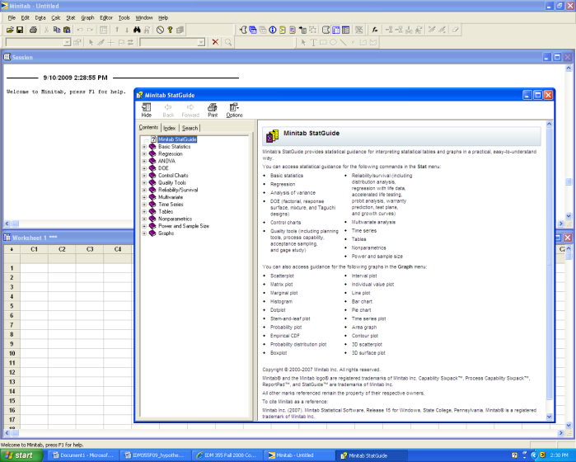

Experimental Design

Two factor multiple sample hypothesis test (Two-way ANOVA)

Select Stat/ANOVA/Balanced ANOVA/
Enter Response
Specify Model
Factor1 Factor2 Factor1*Factor2
Select OK

Two Factor Hypothesis Testing Template

Problem Statement:

Response: (What is being measured?)

Experimental Design: (2X2, 2X3, 3X3, etc) ___________

Factors and levels:

Factor 1:________________________

Levels ________________________ ________________________ ________________________

Factor 2:________________________

Levels ________________________ ________________________ ________________________

Hypotheses:

Factor 1:________________________

H0 ______________________________

H1 ______________________________

Factor 2:________________________

H0 ______________________________

H1 ______________________________

Interaction between ________________________ and ____________________

H0 ______________________________

H1 ______________________________

Minitab or Excel Input
(Copy and Paste from Worksheet using Courier New 10 point font)

Minitab or Excel Output
(Copy and Paste from Worksheet using Courier New 10 point font)

Interpretation of Results

Factor 1 ______________________

p-value

Decision: _________________________

Conclusion: _________________________________________________________________________________________________________________________________________________________________________________________________________________________________

Factor 2 ______________________

p-value

Decision: _________________________

Conclusion: _________________________________________________________________________________________________________________________________________________________________________________________________________________________________

Interaction between ______________________

p-value

Decision: _________________________

Conclusion: _________________________________________________________________________________________________________________________________________________________________________________________________________________________________

Dr. Burtner Spring 2018 Two Factor Hypothesis Testing Example

Problem Statement:
A quality researcher is interested in comparing the sodium content (measured in milligrams) of three brands of corn flakes produced at a cereal plant in Georgia. The researcher suspects that the sodium content differs as a function of shift (day vs. night) as well as brand (Kelly, Betty, Simply). Do the data suggest that brands and/or shifts have a significant effect on average sodium content? Assume the data are normally distributed.

Response: (What is being measured?) sodium mg

Experimental Design: (2X2, 2X3, 3X3, etc) 3X2 (There are 3 levels of Factor1 and 2 levels of Factor2.)

Factors and levels:

Factor 1: Brand
Levels: Kelly Flakes Betty Flakes Simply Flakes

Factor 2: Shift
Levels: Day Night

Hypotheses:

Factor 1: Brand

H₀: μ _{Simply} = μ _{Betty} = μ _{Kelly}
H₁: At least two of the means are not equal.

Factor 2: Shift

H₀: μ _{Day} = μ _{Night}
H₁: μ _{Day} ≠ μ _{Night}

Interaction between Brand and Shift:

H₀: There is no significant interaction between brand and shift.
H₁: There is significant interaction between brand and shift.

Minitab Input
(Copy and Paste from Worksheet using Courier New 10 point font)

Sodium_mg | Brand | Shift
244 | Simply | Day
245 | Simply | Day
246 | Simply | Day
246 | Simply | Day
241 | Simply | Night
241 | Simply | Night
245 | Simply | Night
244 | Simply | Night
240 | Betty | Day
241 | Betty | Day
246 | Betty | Day
242 | Betty | Day
241 | Betty | Night
241 | Betty | Night
242 | Betty | Night
241 | Betty | Night
246 | Kelly | Day
243 | Kelly | Day
245 | Kelly | Day
245 | Kelly | Day
243 | Kelly | Night
242 | Kelly | Night
247 | Kelly | Night
243 | Kelly | Night

Minitab Output
(Copy and Paste from Worksheet using Courier New 10 point font)

ANOVA: Sodium_mg versus Brand, Shift

Factor Type Levels Values
Brand fixed 3 Betty, Kelly, Simply
Shift fixed 2 Day, Night

Analysis of Variance for Sodium_mg

Source DF SS MS F P
Brand 2 30.333 15.167 4.83 0.021
Shift 1 13.500 13.500 4.30 0.053
Brand*Shift 2 3.000 1.500 0.48 0.628
Error 18 56.500 3.139
Total 23 103.333

Since the p-value indicates that Brand is significant, we will use Minitab 17 to conduct a Tukey Analysis for Brand.

Select Stat/ANOVA/One-way/
Enter Response: Sodium
Enter Factor: Brand

Select Comparisons
Tukey
Interval Plot
Tests

The results are shown below:

Tukey Pairwise Comparisons

Tukey Simultaneous Tests for Differences of Means

Difference of Difference SE of Adjusted
Levels of Means Difference 95% CI T-Value P-Value
Kelly - Betty 2.500 0.932 ( 0.153, 4.847) 2.68 0.036
Simply - Betty 2.250 0.932 (-0.097, 4.597) 2.41 0.062
Simply - Kelly -0.250 0.932 (-2.597, 2.097) -0.27 0.961

Interpretation of Results

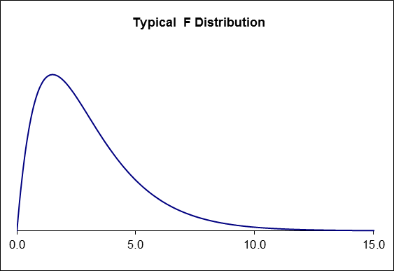
Factor 1 Brand

p-value 0.021

Decision: Reject the null hypothesis

Conclusion:
Based on a p-value = 0.021, the data suggest that there is a statistically significant difference in the mean sodium content of at least two of the three brands. Based on the Tukey analysis shown above, the mean sodium contents of Kelly Flakes and Betty Flakes are significantly different. There is no significant difference between the mean sodium content of Kelly Flakes and Simply Flakes. There is no significant difference between the mean sodium content of Simply Flakes and Betty Flakes.

Factor 2 Shift

p-value 0.053

Decision: Fail to reject the null hypothesis

Conclusion:
Based on a p-value = 0.053, the data suggest that there is no statistically significant difference in the mean sodium content based on shift.

Interaction between Brand and Shift

p-value 0.628

Decision: Fail to reject the null hypothesis

Conclusion:
Based on a p-value = 0.628, we conclude that there is no statistically significant interaction between brand and shift.

