Dr. Joan Burtner Spring 2017 Hypothesis Testing Examples
One-way ANOVA and Testing for Normality
Updated for Minitab 17

Review of Excel
Statistical Functions
Data Analysis
Graphing

Orientation to Minitab
Worksheet
Session Window
Help Function including Data, Output and Interpretation

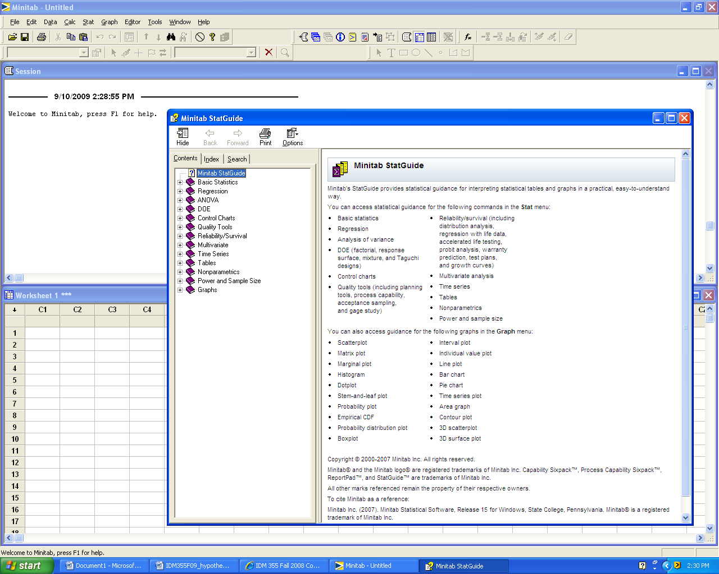

Experimental Design

Single factor three-or-more sample hypothesis test (One-way ANOVA)

Use Minitab 17 to conduct a One-way ANOVA and Tukey Analysis

Select Stat/ANOVA/One-way/
Enter Response:
Enter Factor:
Select Comparisons
Tukey
Interval Plot
Tests
Single Factor Hypothesis Testing Template with Definitions

Problem Statement:

Response: (What is being measured?) ___________________________

Factor and Levels (What are the groups or categories that are being compared?)

Hypotheses:
H₀:
H₁:

Justification of correct experimental design and test statistic:

Computer Output (Include calculated test statistic, p-value and ANOVA Table if applicable)

Graphic: (Place an arrow at the approximate location of the p-value.)

0 0.05 0.10 0.15 1 (p-value)

Decision: ________________H₀

Conclusion: Use complete sentences. (Refer to problem statement and managerial decision based on p-values)
______________________________________________________________________________________________________________________________________________________________________________________________________________________________________________________________________________________________________________________________________________________________________________________________________

Dr. Burtner Fall 2016 Single Factor Hypothesis Testing Example

Problem Statement:
A quality researcher is interested in comparing the sodium content (measured in milligrams) of three brands of corn flakes. All three brands are produced at a cereal plant in Georgia. The researcher collects the following data. Does this data suggest that brands differ in terms of average sodium content? Assume the distribution of sodium contents to be normal.

SimplyFlakes
244
245
246
246
241
241
245
244
BettyFlakes
240
241
246
242
241
241
242
241
KellyFlakes
246
243
245
245
243
242
247
243

Response: (What is being measured?) sodium mg

Factor and Levels (What are the groups or categories that are being compared?)
Factor: Cereal Brand Levels: SimplyFlakes, BettyFlakes, KellyFlakes

Hypotheses:
H₀: μ _{Simply} = μ _{Betty} = μ _{Kelly}
H₁: At least two of the means are not equal. (Walpole text wording)

Justification of correct experimental design and test statistic:
One factor, three levels, normally-distributed data: Use F statistic

Computer Output (Include calculated test statistic, p-value and ANOVA Table if applicable)

Minitab 17 Output:
One-way ANOVA: Sodium_mg versus Brand

Method

Null hypothesis All means are equal
Alternative hypothesis At least one mean is different
Significance level α = 0.05

Equal variances were assumed for the analysis.

Factor Information

Factor Levels Values
Brand 3 Betty, Kelly, Simply

Analysis of Variance

Source DF Adj SS Adj MS F-Value P-Value
Brand 2 30.33 15.167 4.36 0.026
Error 21 73.00 3.476
Total 23 103.33

Model Summary

S R-sq R-sq(adj) R-sq(pred)
1.86445 29.35% 22.63% 7.73%

Means

Brand N Mean StDev 95% CI
Betty 8 241.750 1.832 (240.379, 243.121)
Kelly 8 244.250 1.753 (242.879, 245.621)
Simply 8 244.000 2.000 (242.629, 245.371)

Pooled StDev = 1.86445

Tukey Pairwise Comparisons

Tukey Simultaneous Tests for Differences of Means

Difference of Difference SE of Adjusted
Levels of Means Difference 95% CI T-Value P-Value
Kelly - Betty 2.500 0.932 ( 0.153, 4.847) 2.68 0.036
Simply - Betty 2.250 0.932 (-0.097, 4.597) 2.41 0.062
Simply - Kelly -0.250 0.932 (-2.597, 2.097) -0.27 0.961

Individual confidence level = 98.00%

Graphic:

0 0.05 0.10 0.15 1 p-value

Decision: Reject H₀

Conclusion: Based on a p-value = 0.026, the data suggest that there is a statistically significant difference in the mean sodium content of at least two of the three brands.

Based on the Tukey 95% Simultaneous Confidence Intervals, we conclude that the mean sodium content of SimplyFlakes is not significantly different from the mean sodium content of BettyFlakes and that the mean sodium content of SimplyFlakes is not significantly different from the mean sodium content of KellyFlakes.

However, the data suggest that the mean sodium content of BettyFlakes and KellyFlakes are significantly different. KellyFlakes have significantly higher mean sodium content than BettyFlakes.

****
*******************
Testing for Normality Using Minitab 17

Normality tests are goodness-of-fit hypothesis tests.

H0: The data are normally distributed.
H1: The data are not normally distributed.

H0: The data follow a normal distribution.
H1: The data do not follow a normal distribution.

Consider the following data set. Are the data normally distributed?
Sodium_content
251
249
246
247
242
241
245
244
240
241
246
242
243
241
242
244
246
248
245
245
243
248
247
249

Method: Select Stat/Basic Statistics/Normality Test

Choose Anderson-Darling
or
Choose Ryan-Joiner
or
Choose Kolmogorov-Smirnov

It is best to do all three and compare results.
Minitab shows the results of the normality test in the form of a graph as well as relevant statistics.

KS 0.116 P-Value > 0.150

Decision: Fail to reject the null hypothesis

Conclusion: The sodium content data follow a normal distribution.

AD 0.293 P-Value 0.574

Decision: Fail to reject the null hypothesis

Conclusion: The sodium content data are normally distributed.

