Attribute Control Chart Examples Fall 2011
Thirteen samples of size n=100 each were collected. The number of defective items for each sample are shown below.
Sample Number of
# Defectives
1 5
2 4
3 3
4 3
5 2
6 4
7 4
8 4
9 2
10 5
11 2
12 6
13 3

Use Minitab to build a P chart and evaluate the process control.

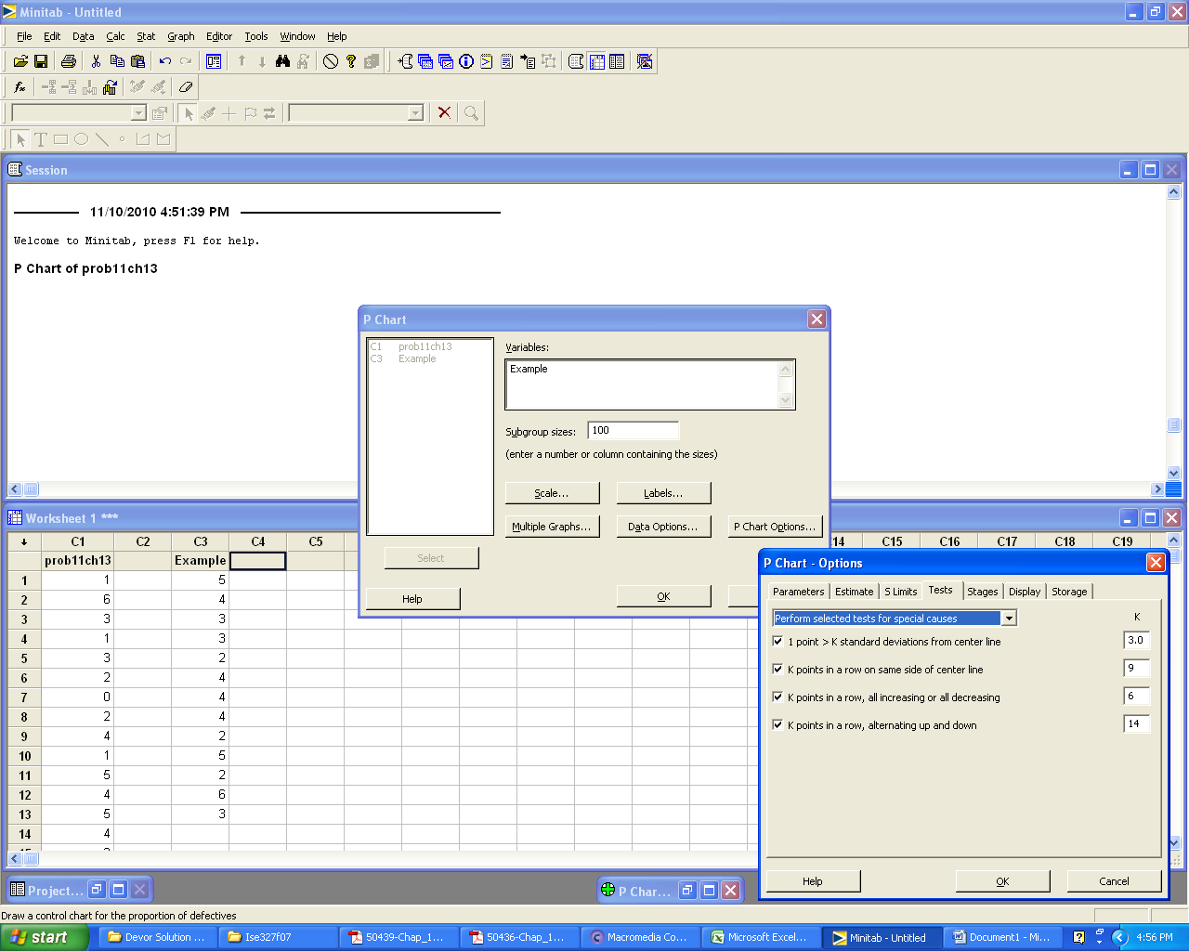
Results:
The y-axis of the P chart is the proportion defective for each sample.

The process does not exhibit any out-of-control characteristics.

Given the following data on defects and sample size, use Minitab to build a C chart and evaluate the process control.

Example
DataC SizeC
2 50
1 50
3 50
4 50
2 50
4 50
6 50
4 50
2 50
5 50
2 50
5 50
3 50

Note that there were 13 samples of size n=50 taken.
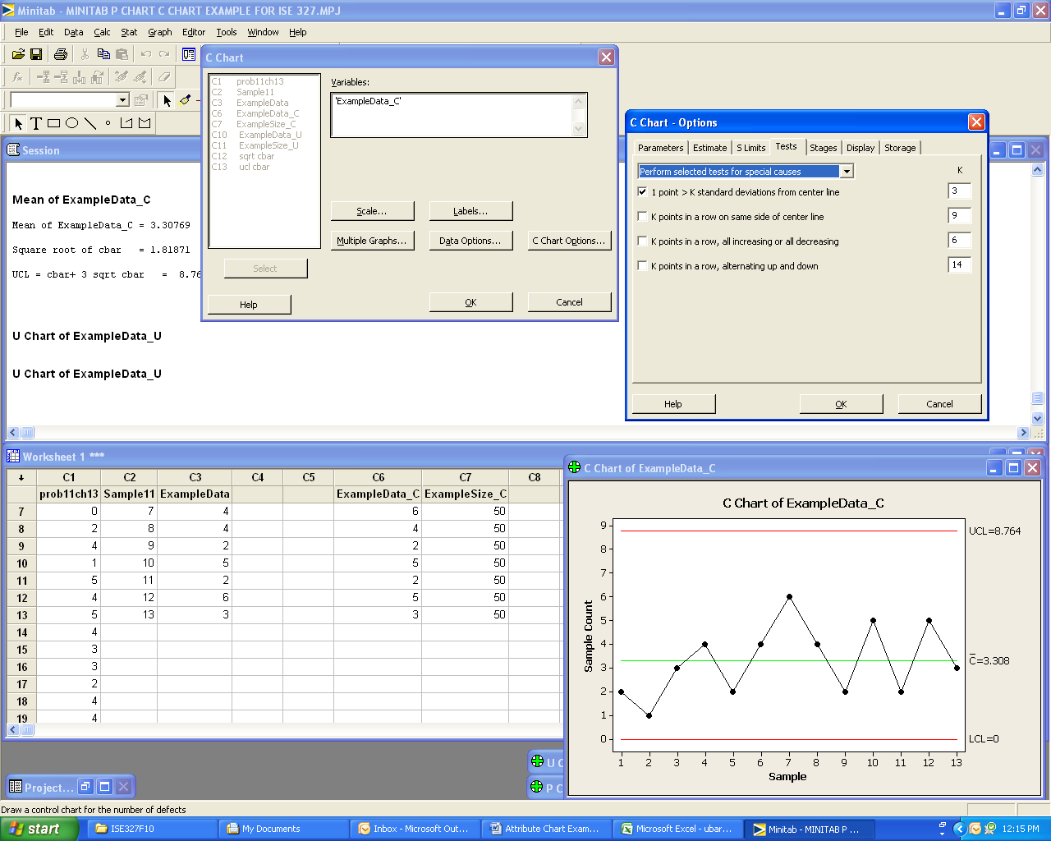
Note that Minitab does not ask for the sample size. As is the case for P charts, you are given the option of performing tests for special causes.
Results:
Sum of ExampleData_C = 43

Mean of ExampleData_C = 43/13 = 3.30769 = cbar

Square root of cbar = 1.81871

UCL = cbar+ 3 sqrt cbar = 8.76381

Note that the sample size information is not used for calculating C bar or the control limits. C bar is calculated as the sum of the defects divided by the samples taken. In this example C bar = 31/13.

Note the label on the y-axis of the Minitab C chart. The Sample Count is the number of defects in each of the thirteen samples.
Given the following data on defects and sample size, use Minitab to build a U chart and evaluate the process control. The U chart measures defects per unit and is used when the number of units inspected varies from one sample to another.

DataU SizeU
5 50
4 60
3 40
5 40
5 50
5 60
5 30
4 30
3 30
1 30
1 30
6 50
3 50
2 50
5 60
2 60
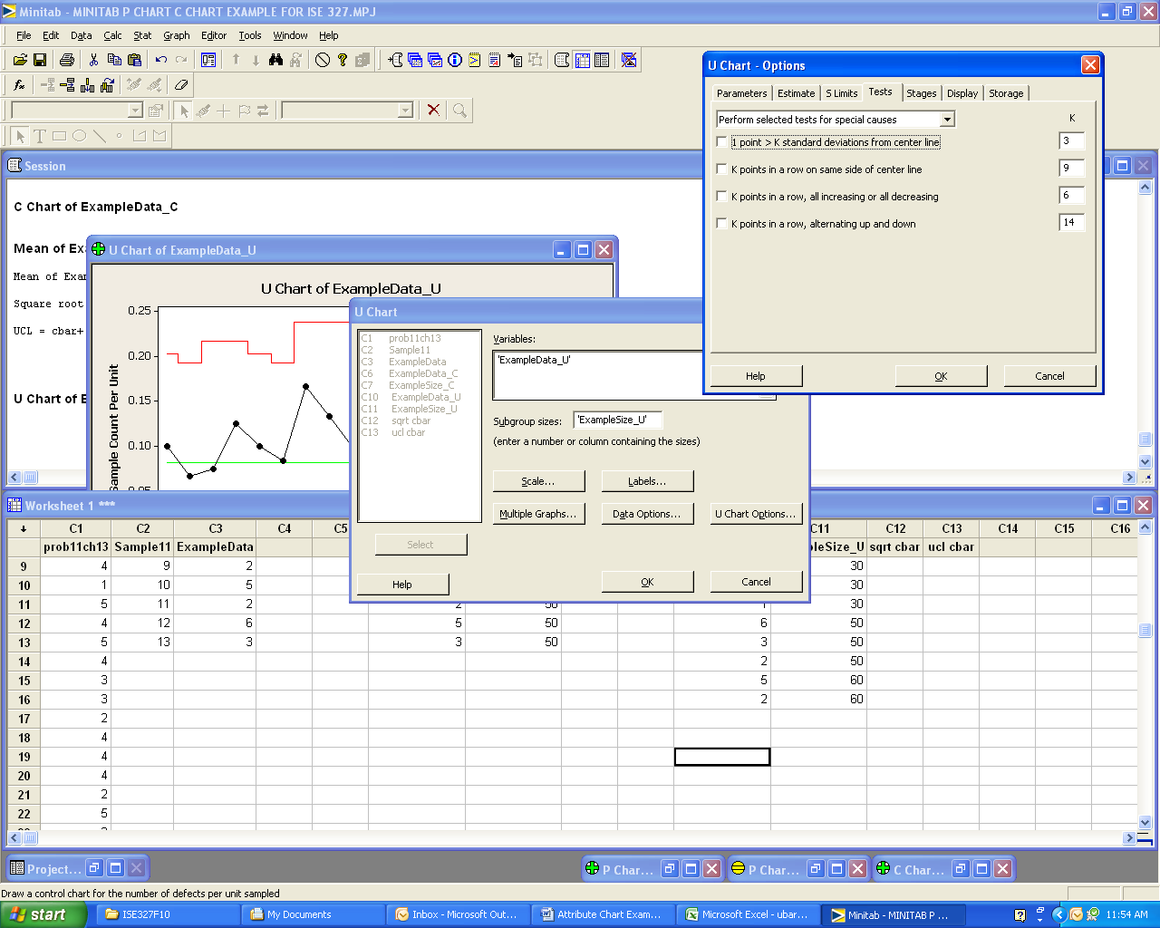
The centerline of the U chart is the overall U bar (total defects / total items sampled).

Note the label on the y-axis of the U charts (defects per unit). Also note that the two charts appear to be alike, even though one tested for all special causes and the other tested for none.

