An Approach to Develop and Measure Engineering Visualization in an Introductory Mechanics Course using Computer-Aided Learning Modules

Hodge Jenkins
Department of Mechanical and Industrial Engineering
Mercer University School of Engineering

Joan Burtner
Department of Mechanical and Industrial Engineering
Mercer University School of Engineering

Abstract
Sophomore engineering students have little preparation for visualization of three-dimensional concepts such as stress and deformation. In an attempt to address this situation computer-aided learning modules using commercial engineering software were designed to improve sophomore students’ visualization and conceptualization skills in an introductory mechanics course. This manuscript provides details of the instructional approach of each module and an evaluation of student performance on conceptual quizzes, homework and exams before and after module implementation. The study of the module effectiveness was based on measured efforts of students enrolled in two sections of an introductory mechanics course (EGR 232, Statics/Solid Mechanics). Both sections of the course were taught by the same professor. One section received instruction using two computer-aided engineering multimedia modules; the other section had only one module. Three conceptual quizzes were specifically designed to measure module success for all students. Results indicated that participation in the computer-aided engineering modules had a significant effect on several aspects of course performance. Potential revisions to the course in light of these and other results are discussed.

Keywords: mechanics of materials, statics, visualization, computer-aided engineering.

Introduction

There should be no doubt to engineering educators that many sophomore and freshman students lack the necessary visualization skills to perform at their best in the introductory courses of most engineering curricula. The difficulty for engineering faculty appears to be how to introduce and develop visualization skills in these students. Many university engineering departments have removed course requirements for drafting (computer-aided or manual) from degree programs to reduce credit hours. Furthermore, some educators have equated drafting to manual skills, not to specialized visualization and communication. At the same time, fewer and fewer K-12 programs that supply engineering students provide or require drafting or CAD courses. Thus, current engineering students have had little or no prior development of three-dimensional visualization.

University text books, written and designed by experienced engineers, assume that students have visualization skills, as evident in the figures of the texts. Oblique and isometric three-dimensional visualizations are standard in introductory engineering statics/mechanics texts. Concepts such as cut-through sectional views are also present in the texts. Clearly without the necessary understanding of these depictions, students cannot fully comprehend the associated engineering concepts.

Thus, the motivation of our efforts was to develop a computer-graphics based learning module, using existing engineering software that would aid students in learning to visualize three-dimensional stresses in a body. Stress and the variation of stress within a body can be a difficult concept to envision, understand, and master. Physical models do not necessarily add to understanding, as stress is internal to a body. Thus, computer-aided engineering software with its associated 3-D graphics is an indispensable tool for students to picture and comprehend stress distributions inside of an object.

Current mechanical engineering education literature includes many reports of novel efforts to increase student learning by supplementing traditional classroom activities with various forms of multimedia and alternative technology-based instruction. A recent study [1] has shown that computer-based instructional technology resulted in significantly higher student performance than traditional lecture formats. Conclusions, based on those results, attributed the improvement to increases in Time on Task, Student Interest, and Instructor Interest. Other studies have incorporated non-graphical, computer-aided engineering (CAE) into the beginning mechanics curriculum via a structured programming approach with software based on linear algebra and ordinary differential equations [2]. Computer interaction in this approach was more algorithmic and less visually stimulating. Results were inconclusive and allude to the possibility that the software may detract from understanding the basic course concepts. In another study, preliminary results comparing the effectiveness of traditional lecture versus a computer-based finite element analysis tutor in a junior level mechanical engineering course showed that the ability of the computer-based instruction students to identify appropriate symmetries and boundary conditions was 30% better than the students who received traditional instruction [3]. In this study the primary purpose of a computer-based module was to provide an experience equivalent (or better) to in-person delivery.

Computer-based instruction has also focused on improvement of conceptualization, visualization, and problem solving skills. It is apparent from several studies that spatial ability development for visualization is crucial to the success of an engineering student or professional engineer involved in designing, manufacturing, construction, and other graphically-related pursuits. [4] Furthermore, studies indicate that visualization skills can be improved through hands-on activities and innovative computer courseware. It has been shown that students who have received as little as one day of instruction on spatial strategies were significantly less likely to fail an introductory engineering course. In a study that spanned four years and involved over 500 students, Hsi et al [4] concluded that spatial strategy instruction contributes to confidence in engineering and improves problem solving ability. Sorby [5] suggests that spatial visualization instruction may also have long term benefits in terms of higher retention rates in engineering for students who participate in such instruction. Taken in total, the studies cited above suggest that multimedia modules should be considered as part of any course that is designed to improve students’ abilities to perform computer-aided design.

Recent efforts in visualization modules in a statics course have focused on the visualization of forces between inanimate objects. [6] Physical models as well as computer visualizations were successfully used in the modules to measurably improve student learning.

Many other published studies include detailed descriptions of the learning modules; few include detailed statistical analysis based on sound engineering education principles. The difficulties associated with administering true educational experiments are well documented [7-11]. Few institutions have exercised the luxury of using random assignment to experimental and control conditions. Although true experimentation is the ideal goal, it is often the case that the educational research design must be quasi-experimental in nature.

Computer-Aided Engineering Learning Modules
The Mercer University School of Engineering established a computational laboratory, the Keck Engineering Analysis Center (KEAC), to serve as a center for advanced engineering scholarship and to enhance the undergraduate experience for students preparing for careers as practicing engineers. The laboratory houses workstations outfitted with state-of-the-art engineering software. Faculty from mechanical engineering, biomedical engineering, computer engineering, and industrial engineering have developed multimedia modules based on software that is available in KEAC. This paper describes with some detail the contents of two modules in a sophomore-level introductory mechanics course and reports on the measured effectiveness of these learning modules. Details about other aspects of the evaluation of the Keck Project have been reported earlier [12].

The work reported here describes the content and measured efficacy of two modules that were developed by the first author and implemented in two sections of EGR 232 in the fall 2004 term. The modules used solid modeling and finite element analysis (FEA) software and were presented in the Keck facility. Since the Mercer EGR 232 course is designed to cover learning objectives for two broad topics (Statics and Mechanics of Materials) that are typically treated as separate courses elsewhere, the time available for learning software is limited. Therefore, the first author carefully designed two in-class modules with accompanying out of class homework assignments to provide students with a brief introduction to Pro/Engineer and Pro/Mechanica. Modules had several elements: tutorials, homework, pre-made computer models, and associated homework. A written description of the modules and their intended use for faculty was developed. The module tutorials were developed to be self-taught or used in a classroom demonstration. The materials covered in the two modules were supplemental to the information provided in the classroom lectures. It was hoped that students would improve their visualization skills and gain insight into the concepts of stress, strain and deflection after exposure to the interactive learning methodology.

Course Background and Learning Objectives
EGR 232, Statics/Solid Mechanics, is taught as an integrated approach to the two subject areas. The three-credit hour course is the first core engineering mechanics subject in the sophomore year. Topics included in the course are: Newton's laws, force, moments, vectors, rigid body equilibrium, beams, trusses, centroids, stress, strain, material properties, axial deformation, stresses and deformation in beams and shafts, as well as column buckling. Traditionally, the course has been a classic lecture and recitation style class, focusing on manually generated student product consisting of homework, quizzes, and exams. The addition of the two software modules to select sections of the course in fall 2003 presented significant departures from lecture classes, increasing student interest and leading the students to explore independently. Preliminary versions of the two course modules were introduced and refined during the fall 2003 semester; the current version used for measurement of effectiveness was implemented in the fall 2004 semester. The use of class time for software tutorials and demonstrations was limited to two in-class computer lab sessions (one per module). Out-of-class homework assignments and supplemental tutorial/question sessions were also provided for both modules. Integration of design and analysis is a common theme of the modules and is apparent from the in-class exercises and related homework assignments. Tutorials and assignments may be found in the KEAC web page on the Mercer University School of Engineering web site [13].

Helping students visualize various stresses and deflections was the primary focus of the modules. Visualization of forces, moments, reactions, deflections, as well as internal stresses of bodies present significant difficulties for students in EGR 232. It was hypothesized that the graphic nature of the modeling and analysis software provided a ready means of visualization of stress fields, deformation, strain in equilibrium. The modules were also conceived as a means for students to gain experience in the role of analysis in design. Very basic engineering skills were also enforced through the software modules, such as the importance of coordinate systems and unit selection. The combined learning objectives for the two modules are listed below.

Table 1. Learning goals for EGR 232 modules

- Students will gain insight into stress, strain and deflection analysis, only available through interactive learning.
- Students will improve visualization skills and gain an approach to rapidly interpret and assess multiple solutions (designs).
- Students will see the connection between design and analysis through an integrated approach.
- Students will develop rudimentary skills in CAE software for 3-D solid modeling, static force and stress analyses through use and appropriate application.
- Student will also learn the limitations and potential errors associated with CAE tools.

Module 1 Description
In the first module, students were introduced to the 3-D solid modeling software (Pro/Engineer) via a uniaxially loaded member (uniform axial normal stress). The basis of the module instruction was rudimentary solid modeling, design intent, and unit alternatives. Each student created a solid model constructed by a single protrusion feature to extrude a uniform square member of constant area (e.g., 1-in by 1-in area, 8-inches long as seen in Figure 1).

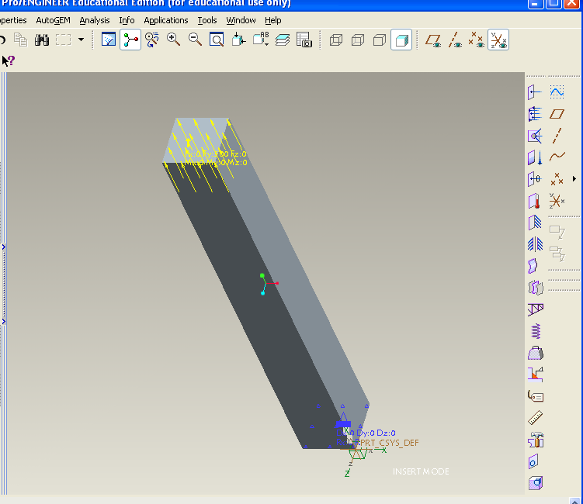
Figure 1. Axially loaded beam model shown with appropriate loading and constraints. (Screen image from Pro/Mechanica software).

A significant challenge with a solid modeling approach was that most of the students were not familiar with solid modeling software. In the initial implementation, 86% of the students indicated that they had not performed solid modeling prior to the class.

After solid modeling, students proceeded to learn and apply integrated geometric/finite element analysis software (Pro/Mechanica) for static load analysis. Material assignment, constraints, and force application were presented. Students were able to see the resulting stress fields of uniform surface loading in Figure 2. Figure 2 depicts the proper model with surface axial loading of 500 pounds, and a base surface constrained in all six degrees of freedom.

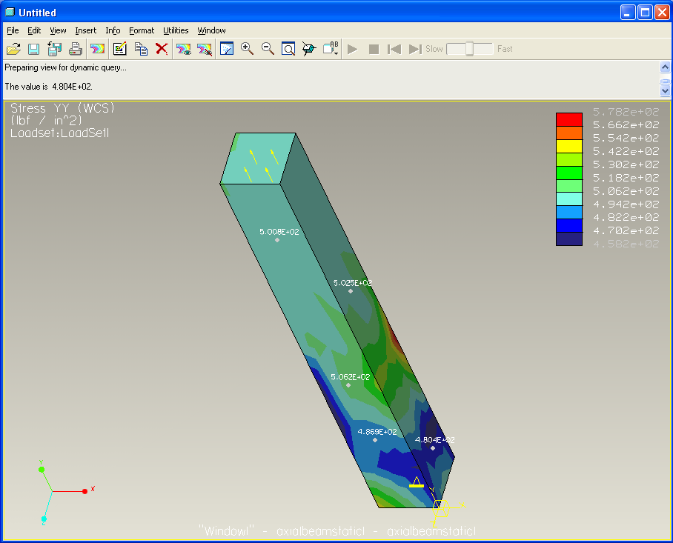
Figure 2. Axially normal loaded beam model stress field, 10% convergence.
(Screen image from Pro/Mechanica software).

A second model (Figure 3) was created, based on the first model, to further demonstrate bearing loads and their associated stress fields. It had a second feature, a circular boss atop of the rectangular beam to enhance visualization of bearing stress. Bearing stress under the boss was compared with the beam axial average normal stress farther away from the applied load underneath the boss. A cross-sectional view of the internal stresses (Figure 4) clearly depicted concepts of bearing stress and Saint-Venant’s principle.
Figure 3. Circular boss showing axial bearing loading.
(Screen image from Pro/Mechanica software).

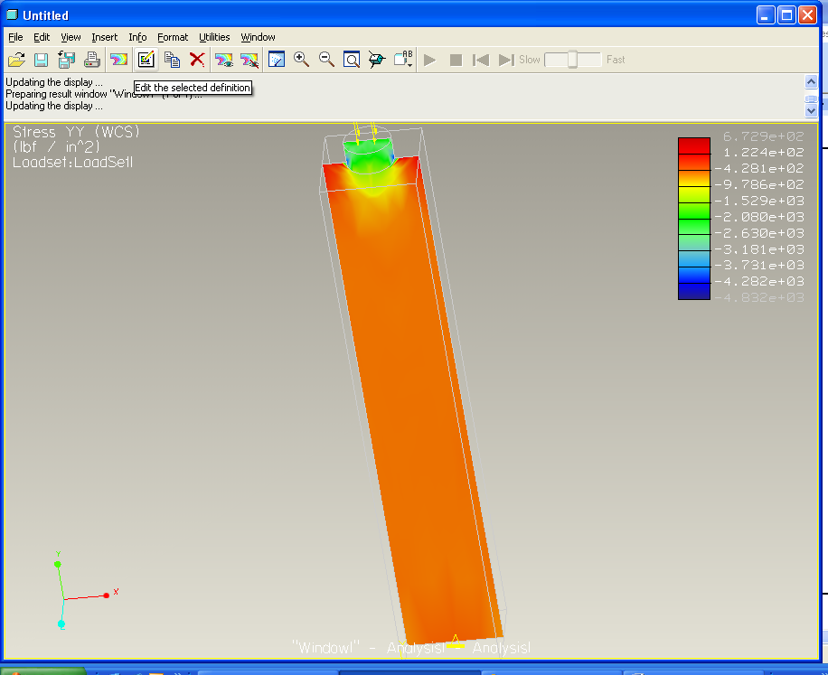
Figure 4. Cross-Sectional view of member with a circular boss showing axial bearing loading. (Screen image from Pro/Mechanica software).

Students explored model accuracy and convergence by creating and running two analyses on the same model. Model convergences of 10% and 1% were selected for two analyses to demonstrate how results vary, depending on the effective resolution of the model. Note: Pro/Mechanica employs non-linear P-elements with automeshing. Using higher order polynomials for element stress and strain functions increases model accuracy. Convergence is the relative difference between results of successively higher order polynomial functions. The resulting maximum principal stresses of these two analyses demonstrates the principle clearly; the 1% convergence results exhibits a more consistent and uniform stress field, as one would expect. Visually the model with increased convergence/accuracy exhibited a smoother, more contiguous stress field. A brief discussion of the finite element method was included in the lesson to illuminate how accuracy/solution convergence can be increased by using a finer mesh with traditional H-elements or using higher order polynomial fits for the P-elements [14].

Homework for the module repeated the axial loading stress and deflection analyses, but with a cylindrical cross-section. Two different materials were used for comparison of deflection and stress. Students were also asked to explain the results of a combined loading of axial force and shear force. Since beam bending had not been introduced in class, students were creative in their explanations. Students were encouraged to work in groups for peer-to-peer collaboration.

Table 2. summarizes the specific student learning objectives for module 1.

Table 2. Specific Learning Objectives of Module 1.

- Become familiar with basic solid modeling and finite element software (Pro/Engineer and Pro/Mechanica).
- Create a axial beam model having a single feature and multiple features.
- Better understand the application of units, materials, constraints, and loading.
- Perform stress and deflection analysis.
- Visualize the difference between average stress and average bearing stress.
- Visualize and explore two-axis loading

Module 2 Description
Module 2 is titled Beam Bending Stress and Deflection Analysis. The second in-class module began with students exploring a pre-existing model of a standard I-beam solid model (S3 x 7.5). A simple cantilever support with uniform loading was initially analyzed for static loading of 1,000 pounds (uniformly distributed). Students were asked to calculate the deflection and maximum stress by hand for a comparison, and discuss the limitations of the FEA approach. The primary benefit of the detailed beam model (Figure 5) is that students can readily visualize the induced bending stresses and deformations from the results (Figures 6 and 7). Compressive and tensile stresses, as well as the relationship to the deflections of the beam are easily observed with the graphical results.

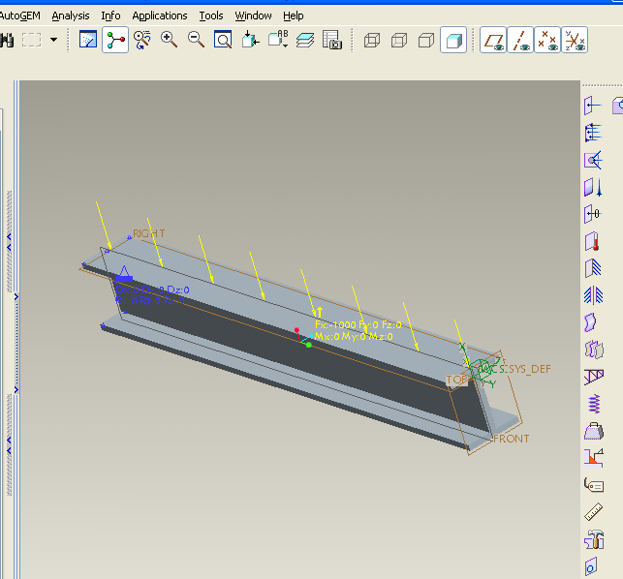
Figure 5 Detailed I-beam model with cantilever support and uniform loading of 1,000-lbs. (Screen image from Pro/Mechanica software).

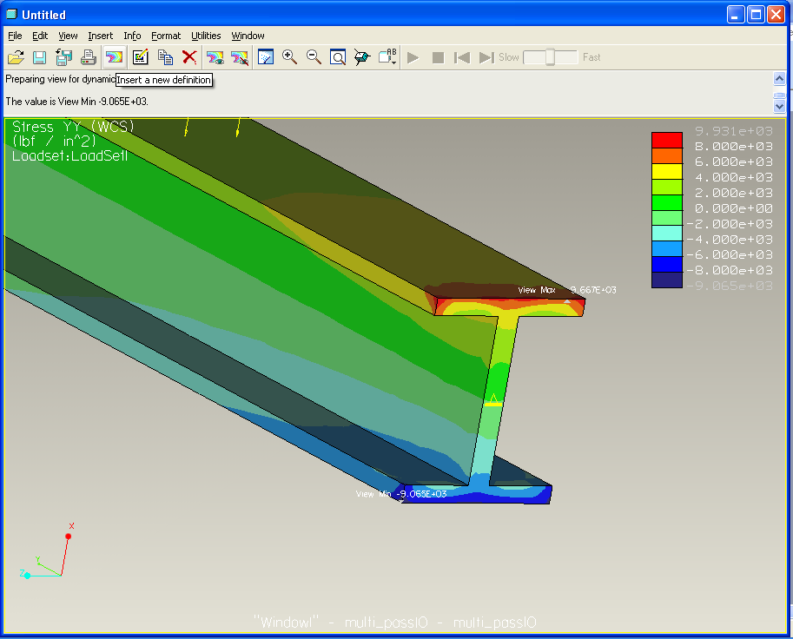
Figure 6. Detailed I-beam resulting stress field. (Screen image from Pro/Mechanica software).

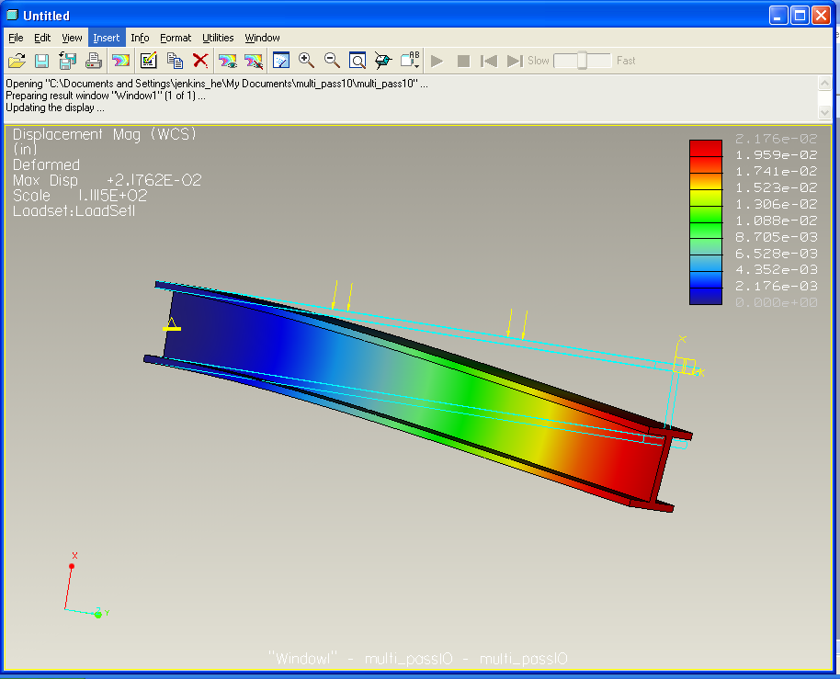
Figure 7. Detailed I-beam resulting deflection.
(Screen image from Pro/Mechanica software).

Students were then introduced to idealized beams for additional analyses. The computational time and results were compared for the solid element FEA model composed of many elements to an idealized FEA model using just two beam elements (Figure 8). Clearly, students were able to grasp that the alternative modeling of idealized beams was the most efficient and accurate of the two model forms for the case examined. Additional end conditions, loads, and beam shapes were investigated by students for beam bending using an idealized beam model with three nodes, because of the high convergence and accuracy achievable. Distributed loads and concentrated loads were analyzed with simple, cantilever, and fixed-simple (statically indeterminate) supports.

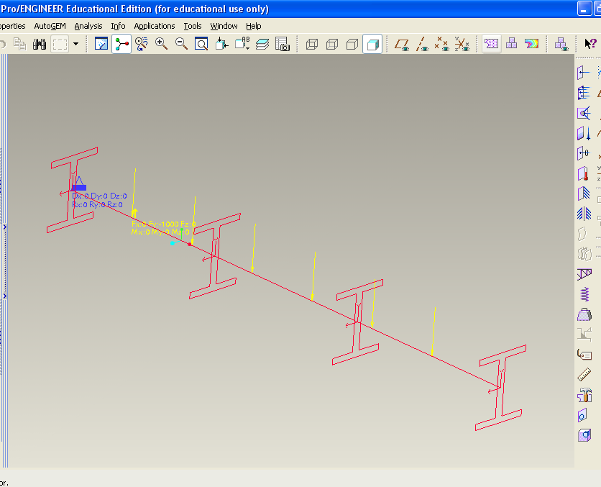
Figure 8. Idealized I-beam, using beam elements, 3 nodes.
Screen image from Pro/Mechanica software).

For homework, students analyzed the changes in maximum stress and deflection caused by 20% and 50% reductions in the flange thickness and the web thickness for the cantilever beam case with uniform loading. This highlighted the effects of changing area moments of inertia on results. Clearly, the students observed that the changes in the web thickness had significantly less effect on stress and deformation, as compared to similar changes in the flange.

Another homework problem was design-related using a different material from the tutorial. Students designed an aluminum I-beam cross-section to obtain similar or less deflection, as compared to the steel example from class. Most students realized that larger moments of area could be achieved with taller webs. Comparisons of weight, stress, and factors of safety were made between the student’s design and the original steel I-beam.

As can be seen in Table 3, the specific learning objectives of Module 2 built upon Module 1’s objectives and emphasized analysis based on the more complicated geometry.

Table 3. Specific learning objectives of Module 2.
- Improve software familiarization with additional solid modeling and finite element alternatives (Pro/Engineer and Pro/Mechanica).
- Model more complicated 3-D geometry. (3-D wide-flange beam model.)
- Perform stress and deflection analysis for distributed and concentrated loading in bending.
- Understand design in action: Effect of changing geometry (beam dimensions), materials, and loading on the beam.
- Visualize local stress and deflections in beam bending.
- Visualize combined 2-D and 3-D loads and resulting stresses and deformations.
- Understand how modeling assumptions affect solution results.

Assessments Methods
Assessments of the modules’ effectiveness were obtained from several vehicles. Results from conceptual quizzes, student surveys, and relevant coursework components were used to evaluate the modules.

Participants
The participants in this study were students enrolled in two sections of EGR 232 during the fall 2004 term. All students who earn a BSE degree at Mercer, regardless of specialization, must successfully complete this course. There were 29 students in one section and 23 in the other. Students were self-enrolled in the course; there was no attempt to randomly assign students to the two sections. Twenty-five percent of the students were female; one section had seven females and the other had six.

Conceptual Quizzes
The design for evaluating this quasi-experiment most closely follows the control group interrupted time series model originally popularized by Campbell [10]. The general form of the design is to administer the treatment (independent variables represented by Xs in Table 4) to the experimental group and collect data on the dependent variables (represented by Os) both before and after the administration of the independent variable. Data was also collected from a control group that did not receive the treatment. In our case, Module 1 and Module 2 were the independent variables. The dependent variables included the conceptual quizzes, relevant exam questions, and relevant homework, which are described later. The design treatment schedule is summarized in Table 4.

Table 4. Interrupted time series design with control group
Group | O1 |  | X1 | O2 | X2 | O3 | O4
Experimental | Concept Quiz 1 | Exam | Module 1 | Concept Quiz 2 | Module 2 | Concept Quiz 3 | Final Exam
Control | Concept Quiz 1 | Exam | Not Given | Concept Quiz 2 | Module 2 | Concept Quiz 3 | Final Exam

Three conceptual quizzes were developed for this study by the first author. Typical questions are shown below. The quizzes were designed to measure students’ general understanding of basic concepts of stress and strain. Questions that required computation were avoided. Thus the intent was that quizzes were conceptual and visual, not numerical.

Figure 9 is an excerpt from one of the concept quizzes.

- Where is the highest compressive normal bending stress in plane ABCDEF of the cantilever beam above? Circle all correct points.
A B C D E F
- Where is the highest tensile normal bending stress in plane ABCDEF of the cantilever beam above? Circle all correct points.
A B C D E F

- Where is the highest shear stress in plane ABCDEF of the cantilever beam above? Circle all correct points.
A B C D E F

Figure 9. Excerpt from Concept Quiz 3.

Several criteria were used to develop the format of questions in the conceptual quizzes. All questions referred to a 3-D graphic of a static stress problem. The first two quizzes (O1 and O2, in Table 4) both had central themes of normal stress, shear stress, and the concept of bearing normal stress, while the third quiz (O3 in Table 4) focused on beam flexure stresses from traverse loading. The first four questions in Concept Quiz 3 involved the application of a single force (as shown in Figure 9); while questions 5 and 6 involved the visual superposition of two forces, a more advanced concept. For each conceptual quiz, responses to the questions varied from single or multiple correct answers.

Module 1 was presented immediately after students completed study and examination of material related to particle equilibrium (only forces, no moments), elasticity, normal stress and shear stress. The first conceptual quiz was administered before the completion of Module 1 and the related homework assignment; the second conceptual quiz was administered after Module 1. Module 2 on beam bending was presented after beam flexure had been studied and tested. The third conceptual quiz immediately followed completion of the Module 2 homework assignment. The entire timeline is summarized below in Table 5.

Table 5. Time line of treatments and observations.
Time Line | Treatments and Observations
9/9/04 | OB1 (Concept Quiz 1)
9/16/04 | Exam 1
9/21/04 | Module 1
10/4/04 | OB2 (Concept Quiz 2)
11/18/04 | Module 2
11/30/04 | OB 3 (Concept Quiz 3)
12/10/04 | Final Exam

Statistical Analysis
Combinations of descriptive and inferential statistics were employed to analyze the data. The subject-matter expert (Author 1) and the assessment-expert (Author 2) collaborated on the development of appropriate hypotheses. T-tests and one-way analyses of variance were performed on hypotheses that involved the entire data set. Non-balanced, two-way (between subjects) analysis of variance creates several statistical issues in testing the main effects and the interaction effects [15]. Therefore, balanced subsets of data were developed to test hypotheses based on two factors simultaneously.

The focus of this statistical study was to determine the extent to which participation in the previously described modules would help students visualize and understand basic concepts. Thus, the independent variable, module participation, had two levels: participation in both modules and participation only in Module 2, as noted in Table 4. The students enrolled in the experimental section received instruction in both modules; the control section only experienced Module 2. The first author was the instructor for both sections.

Results and Discussion
Several hypotheses dealt with the entire population of participants in this study (n = 52).
Since we chose not to assign students randomly to each of the two sections of EGR 232, the validity of our statistical analysis was dependent on the assumption that the two groups would be equivalent at the beginning of the study. A two-sample t-test was used to compare the two groups on the basis of percentage correct responses on Concept Quiz 1 and found no significant difference in performance between the two groups (p > 0.05). Additionally a comparison of the groups on the basis of right-minus-wrong responses showed no significant difference (p > 0.05). Thus the two groups were statistically equivalent in terms of knowledge of Statics and Mechanics of Materials concepts before the first module was delivered.

We hypothesized that students who participated in both modules would perform better than those who participated in only one module. The performance measures for this hypothesis included relevant components of Concept Quiz 2, Concept Quiz 3, Module 2 homework, and Problem 7 (a relevant problem) on the final exam. Of these measures Problem 7 of the Final Exam was the only measure that indicated a strong effect on performance. Problem 7 on the final exam involved a combination of axial stress and bending stress, thus requiring assimilation of two concepts. It was postulated that correct solution of this problem would also draw upon students’ visualization skills. However, unlike the conceptual quiz questions, Problem 7 included specific values and required students to calculate the appropriate value for full credit. Thus, high Problem 7 scores would be a good indication of higher level thinking. For this design, we conducted a 2x2 ANOVA with Factor 1 based on Module 2 homework performance (high or low) and Factor 2 based on module participation (only Module 2 or both Module 1 and Module 2.). To ensure a balanced design, each cell consisted of only six students. While no conclusive significant module participation effect was found, the effect of performance on Module 2 homework was strong (p = 0.055).

Next, we hypothesized that students who showed early mastery of basic statics principles would be able to benefit from module participation more than those who were still struggling with the basic course concepts. In other words, we postulated module effects would be more apparent for those who showed early proficiency in basic statics. Our reasoning was that these students would be more receptive to a well-planned module. Therefore, we developed a subset that included 16 students from each class who scored 80% or better on the first hourly exam. This exam was administered after Concept Quiz 1, but before either of the modules. We labeled these students “Exam 1 High Performers”.

With respect to performance on Concept Quiz 2, the data did not support this hypothesis at the 0.05 significance level. However we did find support for hypotheses related to high performers’ scores on Concept Quiz 3. This was most evident in the questions relating to normal bending stress and shear stress as a result of a single force application (questions 1 and 3). Using the conservative Bonferroni adjustment to significance levels yielded an individual alpha of 0.0167 (0.05/3) for each of the ANOVAs.

Successful Hypothesis A – For Exam 1 High Performers, module participation has a statistically significant effect on performance on Concept Quiz 3 questions related to normal bending stress or sheer stress. (p = 0.003)

Successful Hypothesis B – For Exam 1 High Performers, module participation has a statistically significant effect on performance on Concept Quiz 3 one-force questions. (p = 0.016)

The hypothesis that, for Exam 1 High Performers, module participation would have a statistically significant effect on performance on Concept Quiz 3 two-force questions was not supported.

The study reported here has several limitations. First, since this was a single-institution study, with only two comparison groups of limited size, the results may not be generalizable to students at other engineering schools. Second, since we used a time-series design, most of our measures did not capture student performance immediately after module participation. Thus we may have missed recognizing short term gains. Third, due to the small sample size, we were not able to administer sophisticated multivariate analyses of the data. Finally, by using only a subset of the participants for some of the analyses, we may have induced sample bias. Nevertheless, the in-depth analysis of student responses throughout the term allowed the subject-matter expert and the assessment expert to reevaluate and refine learning objectives and course content at a deeper level than has been done in the past.

Conclusions
The results of this research suggest that the computer-aided engineering modules designed and administered by Jenkins were effective for high-performing students in several areas (shear stress, normal stress, multiple directional loading). There was also some indication that those students who spent more time on task completing module assignments performed better than those who did not. For the entire set of students, the module effect was only documented for Concept Quiz questions that were similar to those directly addressed in Module 2.

Overall the first trial of the visualization conceptual quizzes went well. Conceptual Quiz 3 revealed a significant learning benefit from the software modules. This validates the comments of improved stress and displacement visualization by EGR 232 students [13]. Conceptual quiz and examinations content will continue to be developed and refined to further explore and improve the spatial visualization of our students. Instruction of EGR 232 will continue to include software modules, similar to those described in this paper. We believe it is also desirable to include additional multimedia/alternative materials where possible.

Inclusion of modules based on engineering analysis software with 3-D graphics addressed our two pedagogical concerns of providing alternative instruction and 3-D spatial visualization along with having students gain experience using professional engineering tools. The impetus for the module development by the subject-matter expert and assessment of learning by the assessment expert was provided by a grant from the Keck Foundation. The ultimate goal of the Keck Project is to develop a culture in which development, administration, and assessment of innovative course materials will continue to be an integral part of the engineering education experience at Mercer University. We believe that the study reported here serves as a model for building that culture in our school.

Future Work
As a result of this study, it is apparent that refinement or more extensive changes in the material content, presentation, homework and questions could be beneficial. Course topic scheduling will be evaluated in the next offering to bring the two modules closer together in time. Currently the topics of normal and shear stress from axial loads (Module 1) are separated from the topics of stress from beam bending (Module 2) by time (6 weeks) and several other topics (moments, area moments of inertia, frames, trusses). The next time the course is offered, the order of the material presented will be changed to bring the two modules closer together. This results in the course truly being separated into a statics portion and a mechanics of materials portion. It is hoped that the closer timing between the modules will enhance the student learning and performance. However, the segregation of the course content might also have negative learning ramifications. So, any effects must be closely scrutinized.

An additional module is also planned to address additional design content, buckling and combined bending and axial loading, as course time permits. Module homework will change to help students better comprehend their computer-generated work. Graphical presentation and plotting of analytical results will be incorporated, as well as a more detailed qualitative discussion.

Acknowledgments
The project described above was funded in its entirety by the W. M. Keck Foundation. We thank them for their support of this research.

References
- E. Rutz, , R. Eckart, J. Wade, C. Maltbie, C. Rafter, and V. Elkins, Student performance and acceptance of instructional technology: comparing technology-enhanced and traditional instruction for a course in statics. J. of Eng. Educ. 92, n. 2, 133-140 (2003).
- L.C. Brinson, T. Belytschko, B. Morgan, and T. Black, Design and computational methods in basic mechanics courses. J. of Eng. Educ. 86, n. 2, 159-166 (1997).
- J. Milton-Benoit, I.R. Grosse, C. Poli, and B.P. Woolf, The multimedia finite element modeling and analysis tutor. J. of Eng. Educ. 87, 511-517(1998).
- S. Hsi, M.C. Linn, and J.E. Bell, The role of spatial reasoning in engineering and the design of spatial instruction. J. of Eng. Educ. 86, n.2, 151-158 (1997).
- S. A. Sorby and B. J. Baartmans, The development and assessment of a course for enhancing the 3-d spatial visualization skills of first year engineering students. J. of Eng. Educ. 89, n. 3, 301-307 (2000).
- P.S. Steif and A. Dollár, Reinventing the teaching of statics. Int. J. Eng. Educ. 21, n. 4, 723-729 (2005).
- T. Ellis, Animating to build higher cognitive understanding: a model for studying multimedia effectiveness in education. J. of Eng. Educ. 93, n.1, 59-64 (2004).
- M. D. Gall, W. R. Borg, and J. P. Gall, Educational Research: An Introduction, 6th ed., Longman, White Plains, NY (1996).
- C. M. Judd and D. A. Kenny, Estimating the Effects of Social Interventions, Cambridge Univ. Press (1981).
- M. L . Leary, Introduction to Behavioral Research Methods, 3rd ed., Allyn and Bacon, Needham Heights, MA (2001).
- W. J. Popham, Educational Evaluation, 3rd ed., Allyn and Bacon, Needham Heights, MA (1993).
- J. Burtner, R. Rogge, and L. B. S. Sumner, Formative assessment of a computer-aided analysis center: plan development and preliminary results. Proc. IEEE Frontiers in Educ. Conf., Sess. T1A (2004).
- Keck Engineering Analysis Center at Mercer University, http://egrweb.mercer.edu/keck/, Sept. 27 (2005).
- P. Beckers, F. Cugnon, and L. Darnhaut, p and h elements, SAMCREF User Conf., Liege, France (1996).
- J. Jaccard and M. A. Becker, Statistics for the Behavioral Sciences, 3rd ed., Brooks-Cole, Pacific Grove, CA (1997).

Authors’ Biographies

Dr. Hodge Jenkins is an Assistant Professor of Mechanical Engineering in the Department of Mechanical and Industrial Engineering at Mercer University in Macon, Georgia. Prior to coming to Mercer, Dr. Jenkins had been in engineering and research for Lucent Technologies, Bell Laboratories in optical fiber development. He is a registered professional engineer, and with over 20 years of design and development experience in high-precision design, dynamic structural analysis, process automation, control, and robotics. Dr. Jenkins holds a Ph.D. in Mechanical Engineering from Georgia Institute of Technology in (1996), as well as BSME (1981) and MSME (1985) degrees from the University of Pittsburgh. His professional affiliations include ASME, IEEE, and ASEE.
Address: Mercer University, School of Engineering, Macon, GA, 31207; telephone: 478-301-2831; fax: 478-301-2331; e-mail: jenkins_he@mercer.edu.

Dr. Joan Burtner is an Assistant Professor of Industrial and Systems Engineering in the Department of Mechanical and Industrial Engineering at Mercer University in Macon, Georgia. She serves as the Keck Engineering Analysis Center Project Evaluator. Dr. Burtner is the current coordinator of the engineering statistics course, and the former coordinator of the engineering economy course and the freshman engineering design course. She also teaches statistical quality control, quality engineering, quality management, and industrial management case studies. She is a past recipient of the School of Engineering Teacher of the Year Award, and is a PI on engineering education and research grants that total more than $145,000. Her professional affiliations include ASEE, IIE, ASQ, and SWE. She is an ASQ Certified Quality Engineer.
Address: Mercer University, School of Engineering, Macon, GA, 31207; telephone: 478-301-4127; fax: 478-301-2331; e-mail: Burtner_J@Mercer.edu .

