ASQ Meeting
April 10, 2006

Mercer University School of Engineering

Dinner: Dean’s Conference Room 6:30 pm

Presentation: “Preparing for the ASQ Certified Quality Engineer Exam”

Speaker: Dr. Joan Burtner, CQE
Room 204 7:00 pm

Engineering Building

Room 204
Stairway
Elevator
Stairway

Dean’s Conference
Room (2nd Floor)

Stairway
Front Entrance

Construction

Construction
Parking
Parking
ASQ Meeting April 10, 2006
Mercer University School of Engineering

Dinner in the Dean’s Conference Room 6:30 pm

Presentation Room 204 7:00 pm
“Preparing for the ASQ Certified Quality Engineer Exam”
Speaker: Dr. Joan Burtner, CQE

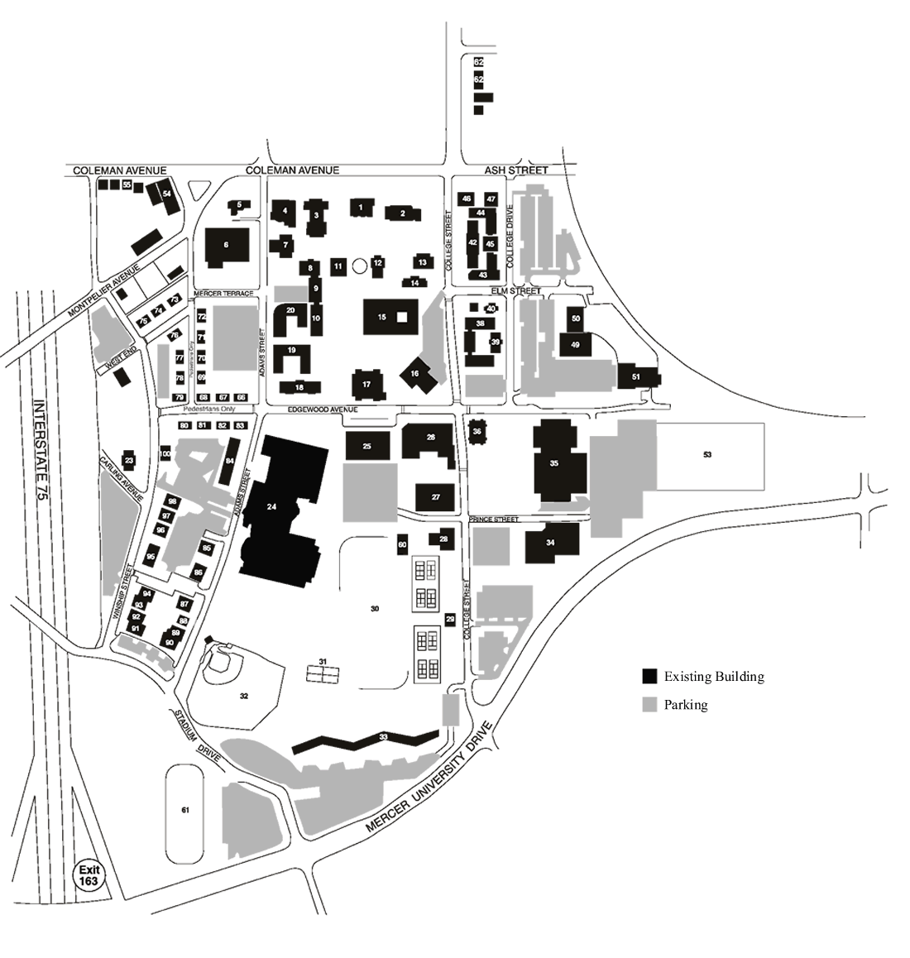
A. Take Interstate 75 Exit 163.
Travel East on Mercer University Drive.

B. Turn left at the second traffic light (College Street)

C. Pass the construction and turn right onto Prince Street. The Engineering Building will be on your right. Park in the lot behind the Engineering Building.

The meeting will be held in Room 204. Meeting announcement signs will be posted in the building.
A
B
C
ENG
X
X
Construction
Parking
Parking
X It is difficult to drive to the Engineering Building from this side of campus because College Street is blocked off.

