JMB ACCEPTANCE SAMPLING NOTES
ISE 428 ETM 528 Spring 2018
Nomogram Examples

Acceptance Sampling is a term that describes a process for inspection performed on an incoming shipment, in which samples are taken from the lot and inspected with regard to certain quality characteristics. The purpose of Acceptance Sampling is to determine a course of action (accept or reject the lot).

The acceptance quality level (AQL) is a level of lot quality which, if the vendor produces lots which are at least as good as this or better, the manufacturer would like to accept a high percentage of the time.

The lot tolerance percent defective (LTPD) is a level of quality such that if the vendor produces lots that are this bad or worse, the manufacturer wishes to reject them a high percentage of the time.

CQE Handbook - The producer’s risk refers to the probability of not accepting a lot the quality of which has a designated numerical value (AQL or p1) representing a level that is generally desirable. The terms alpha risk and the probability of a Type I error are sometimes used in place of producer’s risk.

CQE Handbook - The consumer’s risk refers to the probability of acceptance of a lot the quality of which has a designated numerical value (LTPD or p2) representing a level that is seldom desirable. The terms beta risk and the probability of a Type II error are sometimes used in place of consumer’s risk.

Using a Nomogram to Develop a Single Sampling Plan
Step 1. Specify α, ß, p₁ (the fraction nonconforming value for which the probability of acceptance is high), and p₂ (the fraction nonconforming value for which the probability of acceptance is low).
Step 2. Draw one line connecting p₁ and (1-α).
Step 3. Draw another line connecting p₂ and ß.
Step 4. Identify n and c. (The intersection of these two lines determines approximate values for n and c.)
When choosing, use smaller value for c.
Nomogram Examples

Plan A
AQL (p1) = 2%. LTPD (p2) = 8%. Alpha is 5% and beta is 40%.

Draw the p1 / 1-alpha line. Draw the p2 / beta line.
The intersection is close to n = 40 and c = 2.
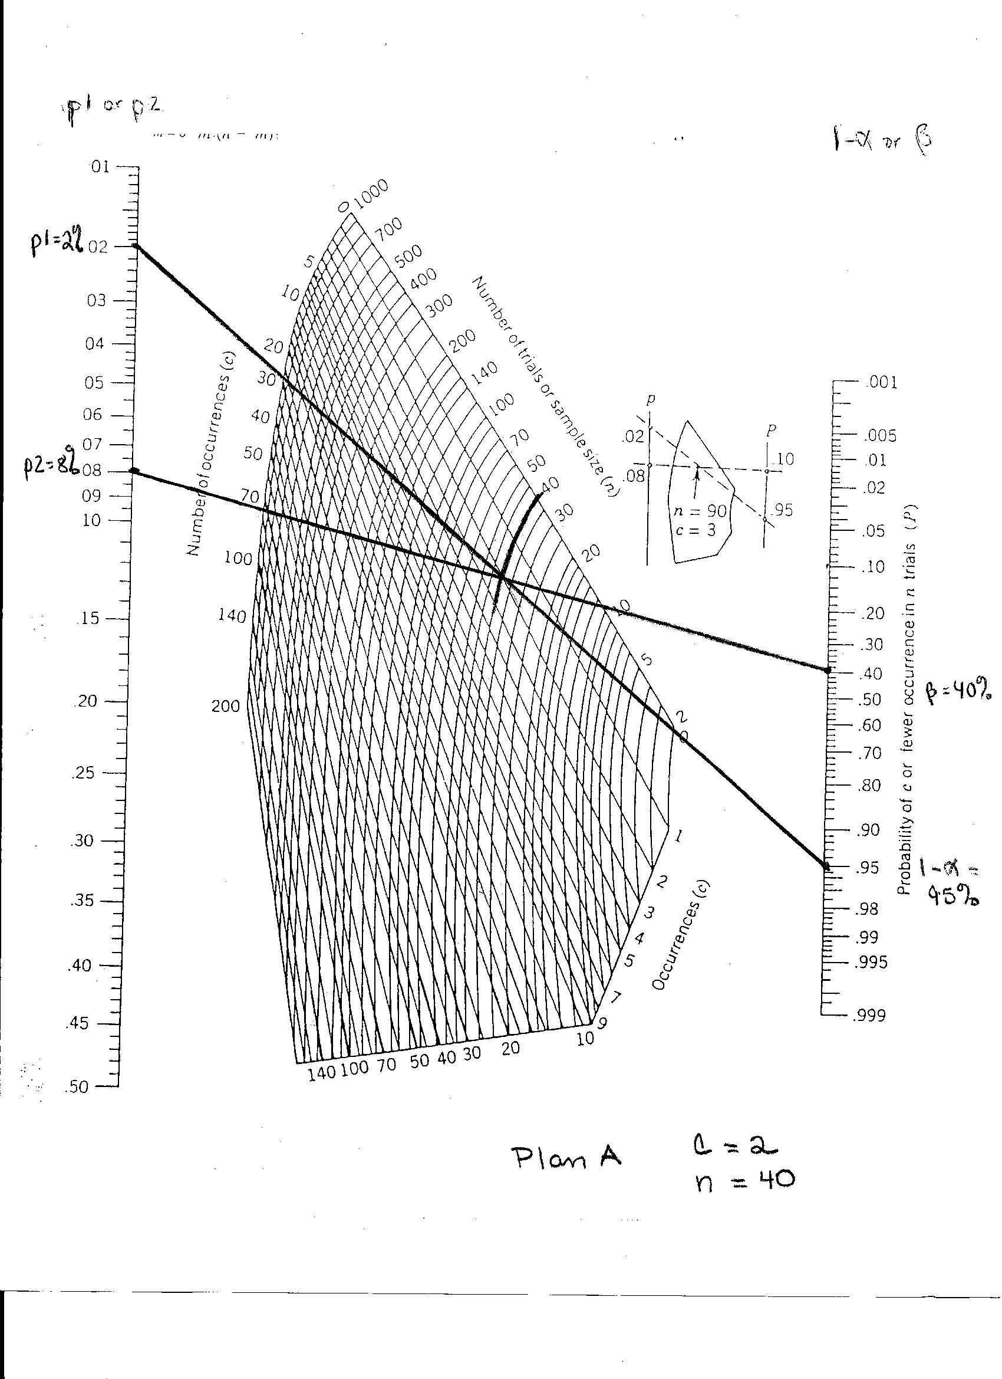
Figure 1. Nomogram for Plan A.

Plan B
Suppose you don’t have 40 items in each lot.
One solution is to keep the p1 / 1-alpha line the same (0.02 to 0.95).
We can change the p2 / beta line as follows.
Decide the LTPD (p2) is .10. Try beta = .60 The resulting p2 / beta line is shown on Figure 2. The intersection is close to n=10 and c is between 0 and 1. Choose the smaller c value. So decide c = 0.
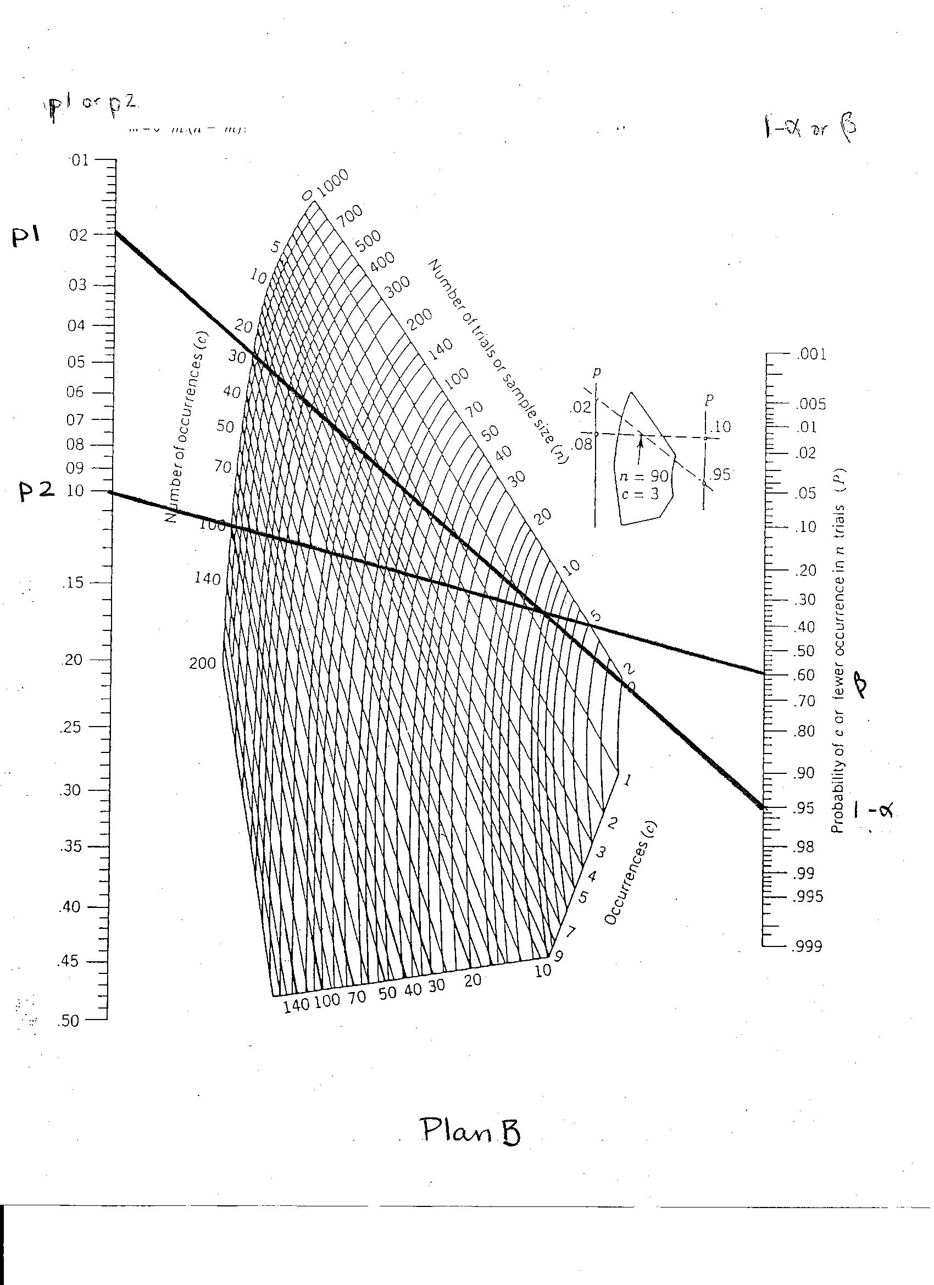
Figure 2. Nomogram for Plan B.

With this new plan, there will be fewer samples to inspect. However, we will be accepting “bad” product a higher percentage of the time. Is this good?

