ACCEPTANCE SAMPLING NOTES Fall 2010

Definition: Inspection performed on an incoming shipment, in which samples are taken from the lot and inspected with regard to certain quality characteristics.

Purpose: To determine a course of action (i.e., accept or reject the lot).

NOTE: The purpose of acceptance sampling is not to estimate or control the quality of incoming materials.

Situations where acceptance sampling might apply:

1. Destructive testing is required.
2. Cost of 100% inspections >> Cost of nonconforming item getting through.
3. Many similar items must be inspected.
4. Producer's quality information is not available.
5. Inspection is not automated.
6. 100% inspection is not feasible.
7. Supplier has excellent quality record and reduced inspection is desired.
8. Inspection is required for liability (or other) reasons, even though quality record is good.
Example:

An electronics manufacturer purchases a component for one of its products in lots of size N = 3000. Each component may be evaluated as either conforming or nonconforming on the basis of a test.

How could the disposition of each lot be determined?
• no inspection • 100% inspection • sampling inspection

(What are the advantages and disadvantages of each?)

In our example, suppose we decide to use a single sampling plan with sample size of n = 89, and an acceptance number c = 2.

Decision Rule: Take a random sample of 89 components. Count the number of nonconforming components (d).

If d > 2, reject the lot.
If d ≤ 2, accept the lot.

How effective is this procedure?

Evaluate using the Operating Characteristic (OC) curve, which shows the probability (P_{a}) of accepting a lot for a range of fraction nonconforming (p) values.

• Type A OC Curve: Used to evaluate the consumer's risk (ß), or the probability of accepting a bad lot.

• Assumes the sample was taken from an isolated lot of finite size (P_{a} follows a hypergeometric distribution).

$$P_{a}\text{ = }\underset{\text{i=0}}{\overset{c}{\sum{}}}\frac{\left(\begin{matrix}D \\ i\end{matrix}\right)\left(\begin{matrix}\text{N - D} \\ \text{n - i}\end{matrix}\right)}{\left(\begin{matrix}N \\ n\end{matrix}\right)}$$

• Type B OC Curve: Used to evaluate the producer's risk (α), or the probability of rejecting a good lot.

• Assumes a large lot size (N > 10n) (P_{a} follows a binomial distribution).

$$P_{a}\text{ = }\underset{\text{i=0}}{\overset{c}{\sum{}}}\left(\begin{matrix}n \\ i\end{matrix}\right)p^{i}{(\text{1 - p})}^{\text{n-i}}P_{a}\underset{\text{i=0}}{\overset{c}{\sum{}}}\frac{λ^{i}e^{−λ}}{\text{i!}}$$

NOTE: As the lot size increases relative to the sample size (over, say, about 10 times the sample size), the type A and type B OC curves are, for most practical purposes, identical. Therefore, type B OC curves are generally used.
The acceptance quality level (AQL) is a level of lot quality which, if the vendor produces lots which are at least as good as this or better, the manufacturer would like to accept a high percentage of the time.

The lot tolerance percent defective (LTPD) is a level of quality such that if the vendor produces lots that are this bad or worse, the manufacturer wishes to reject them a high percentage of the time.

For the sampling plan in our example, the AQL is 1% and the LTPD is 6%. The probability of accepting the AQL is 0.95. Therefore, 1-.95=.05 is called the producer's risk point on the OC curve. The probability of lot acceptance at the LTPD is 0.10, and this point is called the consumer's risk point on the OC curve.

Designing Single Sampling Plans

1. Specify AQL (p₁), 1-α , LTPD (p₂), ß

2. Solve
$\text{1 - }α\text{ = }\underset{\text{i=0}}{\overset{c}{\sum{}}}\left(\begin{matrix}n \\ i\end{matrix}\right){\text{AQL}}^{i}{(\text{1 - AQL})}^{\text{n-i}}$ $β\text{ = }\underset{\text{i=0}}{\overset{c}{\sum{}}}\left(\begin{matrix}n \\ i\end{matrix}\right){\text{LTPD}}^{i}{(\text{1 - LTPD})}^{\text{n-i}}$

for n and c.

• However, solving for n & c simultaneously with these nonlinear equations won't produce a simple, direct solution. A simpler method is to simply use the nomogram.

• Specify α, ß, p₁ (the fraction nonconforming value for which the probability of acceptance is high), and p₂ (the fraction nonconforming value for which the probability of acceptance is low).

• Draw one line connecting p₁ and (1-α) and another line connecting p₂ and ß. The intersection of these two lines determines approximate values for n and c.
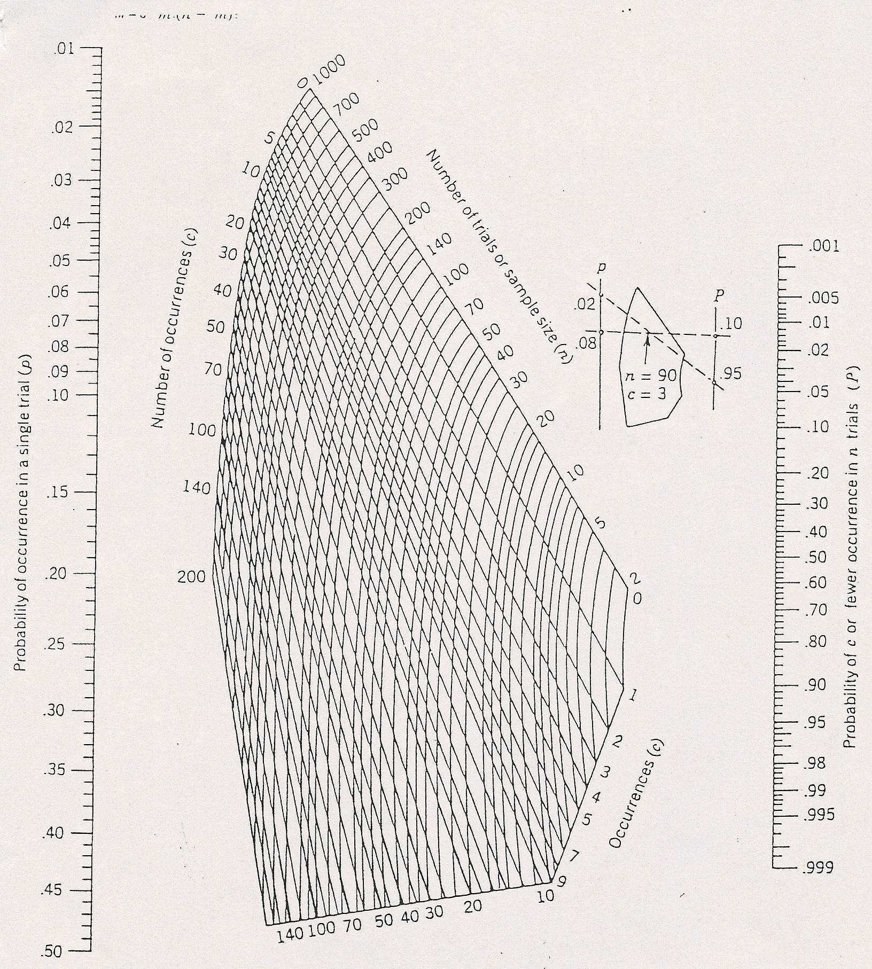

Figure 1. Nomogram for developing a sampling plan
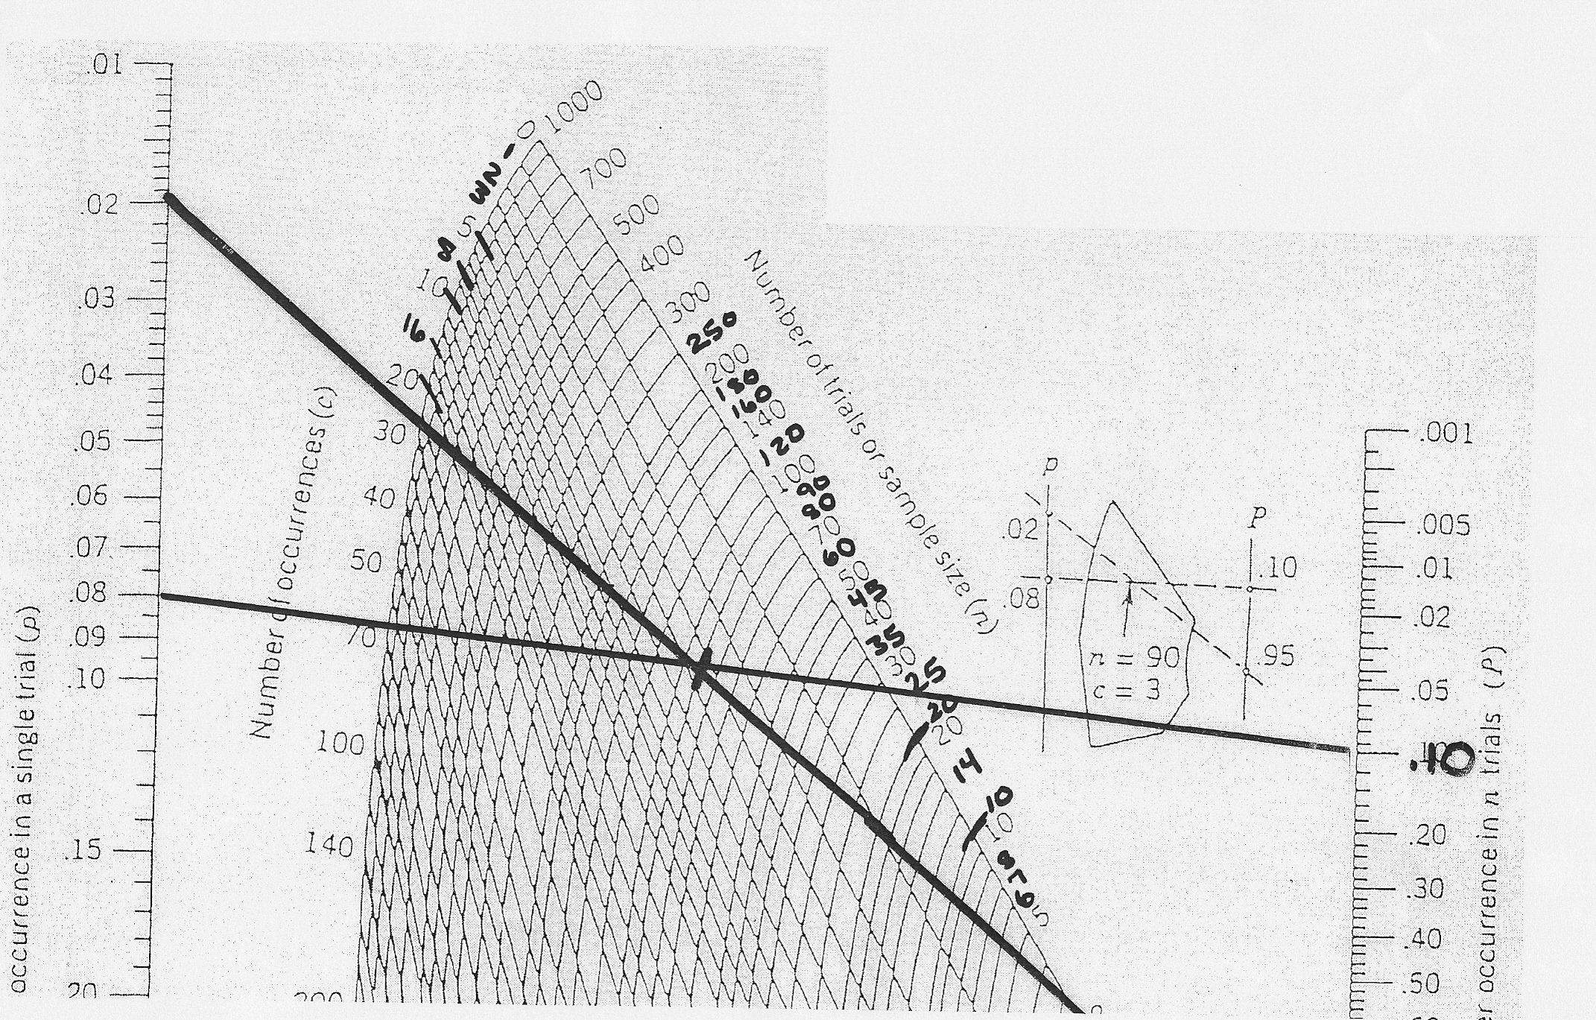

Figure 2. Nomogram with two possible sampling plans

Plan 1
AQL (p1) = 2%. LTPD (p2) = 8%. Alpha is 5% and beta is 10%.

Draw the p1 and 1-alpha line. Draw the p2 and beta line.
The intersection is close to n = 90.
Then c is between 3 and 4. Choose the smaller c value. So c=3.

Plan 2
Suppose you don’t have 90 items in each lot.

One solution is to keep the p1 and 1-alpha line the same.

We can change the p2 and beta line as follows.
Fix LTPD (p2)at .08. Try beta = .45 (dashed line).
Result: n=25 c=1.

There will be fewer samples to inspect. However, we will be accepting “bad” product a higher percentage of the time. Is this a good plan?

